**HAND-SIGN GESTURE DETECTION AND CONVERSION TO TEXT FOR**

**FILIPINO SIGN LANGUAGE USING CONVOLUTIONAL NEURAL**

**NETWORK ALGORITHM**

A Thesis Presented to the

Faculty College of Arts and Sciences

Eulogio “AMANG” Rodriguez

Institute of Science and Technology

In Partial Fulfillment

Of the Requirements for the Degree of

Bachelor of Science in Computer Science

By:

Arquelola, Shekinah Mae C.

Encarnacion, Ivanne Johanes D.

Macdon, Jhun Carlo F.

Orejenes, Angelo A.

Rasalan, Jerome B.

2023

**Abstract**

**Title :** Hand-sign Gesture Detection and

Conversion to Text for Filipino Sign

Language Using Convolutional Neural

Network Algorithm

**Researchers :** Arquelola, Shekinah Mae C.

Encarnacion, Ivanne Johanes D.

Macdon, Jhun Carlo F.

Orejenes, Angelo A.

Rasalan, Jerome B.

**Adviser :** Mrs. Melody L. Gabas

**Degree :** Bachelor of Science in Computer Science

**School :** Eulogio “Amang” Rodriguez Institute of

Science and Technology

This study aimed to Hand Sign Language (HSL) and introduce to the Filipino, The Sign Language (FSL) and used a Convolutional Neural Network Algorithm to convert the picture in to the word and words into hand sign. Sign language (SL) is a language which people use to communicate to mute people or deaf. In improvement of our society where technology is prevalent nowadays. Because the technology in other countries has a device that they used, in our country which is the Philippines, they still use plaque cards to learn hand sign language. Filipino sign language is the visual language for the deaf community and linguistically. This study is on traditional signs that they used to communicate to deaf people. Sign language is important because the deaf are unable to talk, sign language recognition is critical for communication and the development of human-computer interfaces. It is believed that studies like these would pave the way for sign language recognition systems in the future, promote a more complete syntactic knowledge of Filipino Sign Language, and motivate people to learn more about sign language. The importance of hand sign language (HSL) as humans give sympathy to people with disabilities which as deaf, some deaf people have no ability to speak because they were born speechless, on the other side some deaf people have no ability to hear. The “Hand-sign Gesture Detection and Conversion to Text for Filipino Sign Language Using Convolutional Neural Network Algorithm” that device to focus our fellow citizens to understand the deaf person. This mobile application used body and hand gestures by using a good quality camera to recognize the hand gesture and gesture and text to hand gesture for a typical person.

***Keywords****:* Hand Sign Language, Filipino Sign Language, Sign Language, Conversion, Convolutional Neural Network, Algorithm.

**APPROVAL SHEET**

This study on, “**Hand Sign Gesture to Filipino Language Translator System Using Convolutional Neural Network Algorithm**“preparedness and submitted by Arquelola, Shekinah Mae, Encarnacion, Ivanne Johanes, Macdon, Jhun Carlo, Orejenes, Angelo, Rasalan, Jerome in partial fulfillment of the requirements for **BACHELOR OF SCIENCE IN COMPUTER SCIENCE** has been examined and is recommended for acceptance and approval for **ORAL EXAMINATION.**

**MRS. MELODY L. GABAS**

Adviser

Approved in partial fulfillment of the requirements for the degree of BACHELOR OF SCIENCE IN COMPUTER SCIENCE by the committee ORAL EXAMINATION on **January 30, 2023** with the rating on_____.

**JEFFERSON A. COSTALES, MIT** **ERNANIE M. CARLOS JR, MIT**

Panelist Panelist

**MR. EDMUND S. ALMAZAN, LPT**

Chairman of the Panel

Accepted in partial fulfillment of the requirements for the degree of BACHELOR OF SCIENCE IN COMPUTER SCIENCE.

**HAZEL F. ANUNCIO, MIT ROEL P. BALAYAN, EDD**

Thesis Writing, Professor CAS Research Coordinator

**RODORA T. OLIVEROS, M.SC**

CAS, OIC DEAN

**ACKNOWLEDGEMENT**

The researchers would like to extend their deepest and sincere gratitude to the following person for their support in the completion of this study:

**Prof. Melody L. Gabas,** Thesis adviser, for giving the researchers the undying support and precious advice that improved this research study.

**Prof. Hazel Anuncio,** for her kindness and support in giving not only the researchers but the whole Bachelor of Science in Computer Science support and teaching them how to do the research properly.

**Prof. Jefferson Costales, Prof. Ernanie Carlos and Prof. Edmund Almazan** for their kindness and support in giving the researchers an intellectual challenge that gave direction to this study.

To the **respondents**, for their cooperation in conducting the study,

To **Mr. Ivan Goncharov,** a programmer content creator in the platform YouTube, for giving the researchers an idea for the system and how to use the **Custom Hand Gesture Recognition with Hand Landmarks Using Google’s Mediapipe + OpenCV in Python;**

To **Mr. Kinivi** for giving the researchers a reference for the hand gesture recognition using mediapipe in the platform GitHub;

To **Mr. Rai Zason** and **Mrs. Marie Charisse Jeremillos** for teaching the researchers a basic hand sign language into Filipino Language in terms of both video reference and actual teaching;

To **Ms. Hyacinth Joy Tomulto,** a student from Eulogio “Amang” Rodriguez Institute of Science and Technology, for helping the researchers gather initial respondents for their initial interview for data gathering and helping the researchers find a professor who specialized in hand sign language;

Most especially to all of the researchers’ parents and whole family for their moral and financial support; To all the researchers’ friends and loved ones, for their love, moral and spiritual support which served as researchers’ greatest source of motivation and inspiration.

Above all, to Almighty God that gives the researchers’ strength, knowledge and wisdom while conducting and formulating this study.

**A.S. M.C.**

**E.I.J.D.**

**M.J.C.F.**

**O.A.A.**

**R.J.B.**

**DEDICATION**

The researchers sincerely devoted this thesis to the individual below:

**First and foremost**, to our beloved parents who made this study possible through moral support that helped the researchers the most and providing the finances needed. **Second**, to their **friends and relatives** who encourage them to continue when the researchers are in the point of struggles and pressures. They served as an open book to the researchers by giving an ideas, thoughts and guides.

**Third**, to all respondents both non experts and expert who cooperated in answering the survey questionnaire given by the researchers to fulfil this successfully. **Fourth,** to our beloved thesis adviser, **Prof.** **Melody L. Gabas** for guiding to complete this study during conducting and making this research study. Without her help, the researchers will not be able to fully understand the process on how to make an effective this study. And lastly, to **Almighty God** who serve as a shoulder to the researchers during the hard time in their journey. He made this research study possible with the strength, hard works and perseverance the researchers get.

**A.S. M.C.**

**E.I.J.D.**

**M.J.C.F.**

**O.A.A.**

**R.J.B.**

**Table of Contents**

**Abstract ii**

**Approval Sheet**i**v**

**Acknowledgement vi**

**Dedication viii**

**Table of Contents**x

**List of Tables..............................................xiii**

**List of Figures..............................................xv**

**List of Appendices...........................................xvi**

Chapter

1 The Problem and Its Background

Introduction1

Statement of the Problem6

Theoretical Background7

Conceptual Framework10

Objective of the Study12

Significance of the Study13

Scope and Delimitation 15

Definition of Terms 18

2 Review Related Literature23

Synthesis of Related Works42

3 Research Methodology43

Research Design45

Methodology46

Requirement Analysis47

Population, Sample Size and Sampling Technique49

Respondent of the Study50

Description of the Respondents 51

Research Instrument53

Data Gathering Instruments and Techniques51

Data Gathering Procedures53

Preparation of Instrument 54

Statistical Treatment58

**System Requirements61**

Hardware61

Software61

Network62

4 Result and Discussion

Assessment of Respondents in Pre-Survey Questionnaires64

Presentation, Analysis and Interpretation of Data74

Result994

Presentation of the Mobile Application 103

5 Summary of Findings, Conclusion and Recommendations

Summary of Findings110

Conclusion 118

Recommendation 122

**References** 123

**Appendices** 125

**Curriculum Vitae**151

**List of Tables**

Table

1 Distribution of type of respondents in pre-survey in

terms of their gender 63

2 Distribution of type of respondents in pre-survey

in terms of their age …………………………………………………………………………………..

3 Likert’s Scale 58

4 Distribution of Respondents According to their Gender 63

5 Distribution of Respondents according to their Age 64

6 Distribution of type of respondents in Pre-Survey in

terms of their Sex 66

7 Distribution of type of respondents in Pre-Survey in term of their Age 65

8 *Assessment of Respondents in Pre-survey* 64

List of Figures

Figure

1 The Agile Software Development Life Cycle, SDLC 10

2 IPO (Conceptual Paradigm)11

3 Percentage of respondent’s Gender 75

4 Percentage of Respondent’s Age 76

5 *Respondents who answered survey questionnaire* 77

6 *Survey Questionnaire Number Two* 78

7 *Survey Questionnaire Number Three* 79

8 *Survey Questionnaire Number Four*  80

9 *Survey Questionnaire Number Five*  81

10 *Survey Questionnaire Number Six* 82

11 Survey Questionnaire Number Seven 83

12 Survey Questionnaire Number Eight 84

13 *Survey Questionnaire Number Nine* 85

14 *Survey Questionnaire Number Ten* 86

15 Survey Questionnaire Number Eleven 87

16 *Survey Questionnaire Number Twelve* 88

17 *Survey Questionnaire Number Thirteen* 89

18 *Survey Questionnaire* *Number Fourteen* 90

19 *Survey Questionnaire Number Fifteen* 90

20 *Survey Questionnaire Number Sixteen* 91

21 *Survey Questionnaire Number Seventeen* 92

22 Survey Questionnaire Number Eighteen 93

23 Survey Questionnaire Number Nineteen 94

24 *Survey Questionnaire Number Twenty* 95

25 *The Users Interface* 103

26 The API Checker 104

27 Nursery Rhyme 105

28 *Filipino Syllabication ABAKADA Real Time* 106

29 ABAKADA Image 107

30 Figure 30 The update of the system to follow the

Recommendation 108

31 *Text to Gesture Feature* 109

32 How to use 136

33 Continuation 137

34 Unified Modeling Language125

35 Fishbone Diagram Fishbone Diagram 126

36 Entity Relationship Diagram 127

37 Flowchart of the system 128

38 Plagiarism Test Result 129

List of Appendices

Appendix

A Unified Modeling Language 125

B Fishbone Diagram Fishbone Diagram 126

C Entity Relationship Diagram 127

D Flowchart of the system 128

E Plagiarism Test Result 129

F Communication Letters 133

G User Manual for the Mobile Application136

H Acceptance of Thesis adviser 138

I Adviser Consultation 139

J Proposal title 144

K Endorsement for Thesis final Oral Defense 147

L Certificate of Grammarian 148

M Letter of Grammarian 149

N Statistician Letter 150

**CHAPTER 1**

**The Problem and Its Background**

**Introduction**

Sign language (SL) is a language which people use to communicate to mute people or deaf. In improvement of our society where technology is prevalent nowadays. Because the technology in other countries has a device that they used, in our country which is the Philippines, they still use plaque cards to learn hand sign language. Filipino sign language is the visual language for the deaf community and linguistically. This study is on traditional signs that they used to communicate to deaf people. Sign language is important because the Deaf are unable to talk, sign language recognition is critical for communication and the development of human-computer interfaces. It is believed that studies like these would pave the way for sign language recognition systems in the future, promote a more complete syntactic knowledge of Filipino Sign Language, and motivate people to learn more about sign language.

The importance of hand sign language (HSL) as humans give sympathy to people with disabilities which as deaf, some deaf people have no ability to speak because they were born speechless, on the other side some deaf people have no ability to hear. The “Hand Sign Language conversion into Filipino (ABAKADA) text” that device to focus our fellow citizens to understand the deaf person. This mobile application uses body and hand gestures by using a good quality camera to recognize the hand gesture and gesture and text to hand gesture for a typical person.

Therefore, sign language is not commonly learned by the non-mute people, thus deaf people have problems communicating. Usually, they learn hand sign language because having a child born to be deaf people, they learn hand signs to speak to their children. It does not mean being a deaf person is exempted from communicating still a human and part of living place.

Since there are only few people in the Philippines who knew that FSL or Filipino Sign Language is already exist, there are also few people who are willing to teach this kind of sign language to deafs and typical person, since the foundation of other language in sign language is ASL or American Sign Language, society will always rely in it and few people will only took interest in learning the locale’s sign language such as FSL if it is required or if it is needed to be learned. The researchers then wanted to create an application not only to promote the said sign language but also to help others that are struggling in learning sign languages. According to the initial interview that the researchers made, a lot of students that studying special needs education in Eulogio Amang Rodriguez Institute of Science and Technology wanted ASL more than FSL, it is because there are a little knowledge to FSL even though they wanted to use it also but there are only a little information about the said language. This is why the researchers are expected to create an application implying the available learning materials that can be learned in Filipino Sign Language.

The researchers use Convolutional Neural Network to train and process the certain Filipino Sign Language hand gesture, convolutional neural network or commonly known as CNN algorithm is known to be the faster algorithm in the field of image processing training and training the neurons for the image training. It is also known as a deep learning algorithm that can take an input image (Saha.S.,2018). Furthermore, the researcher used Keras as their architectural framework to be used as one of the CNN algorithm’s architectural frames. Keras is known as the high-level application programming interface of Tensorflow 2. It is an approachable and highly productive interface for solving machine learning problems that focuses on modern deep learning. The researchers decided to use Keras rather than Tensorflow 2 because Keras is more user-friendly because it’s a built-in Python. Another information as to how the researchers would train the image. First is that the researchers used mediapipe. MediaPipe used for heavy lifting in all throughout the process. In mediapipe, the researchers also decided to use their holistic model as holistic model is one of the pipelines that contains optimized face, hands and pose components that allows the using for holistic tracking. Thus enabling the model to detect hand and body poses along with the face. One of the main uses of MediaPipe holistic is to detect the face and hands of the user then extract the key points to pass in the vision model. (GeeksforGeeks, 2021).

Furthermore, the researchers used soft max function and rely activation function to use as these two can maintain the images between 1 and 0. The references that the researcher uses in creating a program is with both Kinivi and Nicknochnach. In summary, the researchers will first open the mediapipe and then use the holistic model for keypoints and detecting the left and right hands, after that is the classification model of keypoints and after that would be the output.

This study aimed to generate a mobile application system that would help not only deaf people but also a normal human without disabilities to communicate with those impaired one using a Hand Gesture that would translate a certain hand-sign to Filipino language. The researchers will use Convolutional Neural Network as their algorithm to train the image and would used Keras as the CNN Algorithm’s architectural framework to train. The researchers are expected to create a mobile application for hand-sign gesture translating into Filipino language with features of Nursery Rhyme (Filipino version) and Vowels. It is also implicated that the researchers would create ABAKADA features and Nursery Rhyme as one of their features in the System. Furthermore, the researchers wanted to add that Filipino Sign Language is still being implemented so the syllabication of ABAKADA and AEIOU is still not complete. The nursery rhyme as the researchers’ feature in the system are still few so the researcher would only choose one as their sample through the system.

**Statement of the Problem**

Deaf are having a hard-time communicating as their disabilities are often misunderstood by many. Some of those without disabilities are not quite familiar with the deaf and are not quite knowledgeable with those. That’s why in news outlet you can often see people translating the news with sign language but it is too fast for normal people to learn. In this study, the researchers are tasked to do a study about improving and use of Filipino language translation in hand-sign language.

1. What accuracy of the system in hand-sign gesture to the selected Filipino language using CNN algorithm in terms of.

1.1. Basic Nursery Rhymes;

1.2. vowels like “A-E-I-O-U”; and

1.3 Filipino Syllabication like “A-BA-KA-DA”?

1. What accuracy of the system translating the selected Filipino language using CNN algorithm to hand-sign gesture.

2.1. Trained Images;

2.2. Text to Image; and

2.3. Image to Text?

1. What is the average age that is capable of using this system in terms of:

3.1. Toddlers ages from 3 to 6;

3.2. A teenager with the age ranges from 10 to 18;

3.3. An adult with the age ranges from 21 and above with or without experience; and

3.4 Flexible to all ages both deaf and typical person with or without experience?

1. What is accuracy of CNN algorithm in fetching the image processing training using:

4.1. Keras API as architectural framework; and

4.2. MediaPipe?

**Theoretical Background**

Aly, W., Aly, S., and Almotair, S (2019), stated that Sign language is the most natural and effective means for deaf and hearing people to communicate. Due to the challenges in hand segmentation and appearance differences among signers, ASL alphabet recognition (i.e., fingerspelling) with a marker-less visual sensor is a difficult process. Many problems plague existing color-based sign language recognition systems, including complicated backgrounds, hand segmentation, and high inter-class and intra-class variances. They provide a novel user-independent recognition method for the American sign language alphabet based on depth images collected by the low-cost Microsoft Kinect depth sensor in this work. Exploiting due to their durability against light and backdrop fluctuations, depth information rather than color pictures solves several difficulties. A simple preprocessing procedure may be applied to a depth picture to segment the hand region. Instead of employing the traditional method of learning features by manually, convolutional neural network topologies are used.

Crafted approaches for extracting features a basic unsupervised Principal Component Analysis Network (PCANet) deep learning architecture are used to learn local characteristics retrieved from the segmented hand. Two learning methodologies for the PCANet model are proposed: training a single PCANet model from all user samples and training a distinct PCANet model for each user. A linear Support Vector Machine (SVM) classifier is used to recognize the extracted features. The suggested method's performance is assessed using a publicly available dataset of real-time depth photographs recorded by diverse users. The suggested technique outperforms state-of-the-art recognition accuracy utilizing a leave-one-out assessment strategy, according to experimental data.

Li et al. [31], concept and sparse auto-encoder (SAE) were utilized component analysis to learn hand gesture characteristics images in RGB-D. Using two different sparse auto-encoders color and depth channels are used to train features in convolutional neural networks. Multiple PCA layers were used to integrate the characteristics from both channels. However, they only demonstrated experimental findings on an ASL dataset for signer-dependent scenarios, with no consideration of the method's suitability for solving signer-independent problems.

Image Processing concentrates on mathematical and physical models that inherit the processing operations. The image representation and sampling aspects are followed with the various processing techniques including point by point operations, filtering and deconvolution techniques, tomographic image, edging and line detection (WJ Hossack).

For image preprocessing training, Adhinga Fredrick (2021) used Keras’s Image data generator class to augment his data. It is because Keras provides a quick and easy way to augment the images. It also supports the augmentation techniques such as flips, rotations, the brightness changes etc.

**Conceptual Framework**

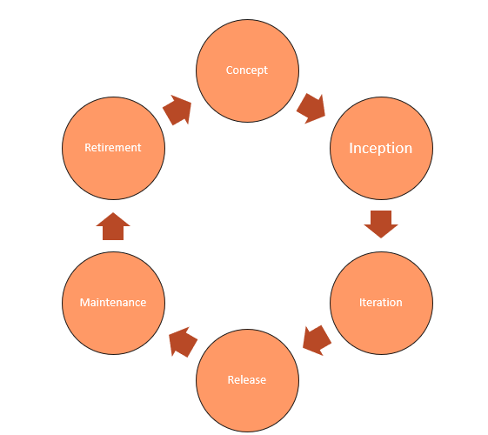

*Figure 1* *The Agile Software Development Life Cycle, SDLC*

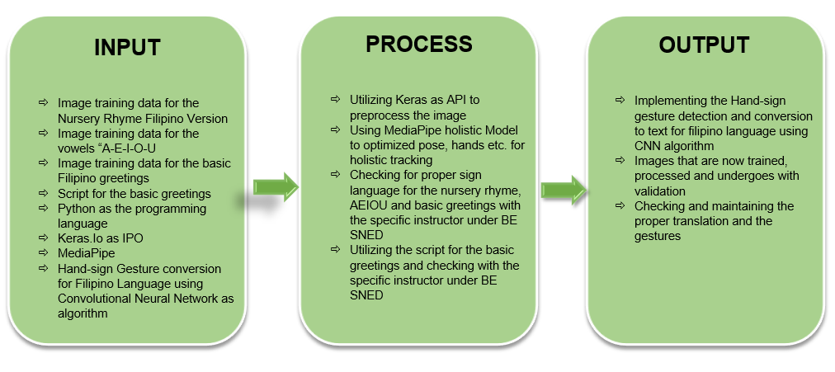**Input, Process and Output**

*Figure 2* *Conceptual Paradigm*

The input-process-output model, as shown in Figure 2, served as the study's conceptual framework. The IPO model provided the overall framework and direction for the study. The above model was created by researchers by plugging the variables from this study into the IPO model.

**Objective of the Study**

Throughout the study, the researchers are expected to answer the problem stated within the study. The researchers aim to follow the objectives below:

1. Develop a mobile application for deaf and typical person with a toddler level and above of sign-language and for teaching purposes

2. Help typical person and deaf people to communicate with each other

3. Hand pose is defined with a bare hand and clear background and not occluded by other objects. If outdoor make sure that the background is not overlapped with the other movements

4. The system or the device can be used indoor and

outdoor

5. Add a Filipino version of Nursery Rhyme and VOWELS

6. Use the Keras API as preprocessing image training.

7. Use MediaPipe

8. Use the Convolutional Neural Network Algorithm to train the hand gesture input for the mobile application.

9. Filipino Hand Sign language is still new. So the researcher will only include nursery rhyme song entitled: “Ooh-Lan” and Filipino syllabication ABAKADA and AEIOU that is in the said statement of the problem as their partial representation of Filipino sign language to prove that convolutional neural network is faster with the image training by translating Filipino Hand Sign Gesture CONVERTING into TEXT.

**Significance of the Study**

This study would benefits the user and reader who have difficulty communicating and understanding deaf people. Plus, the content of this research could change the perception regarding communicating to mute people. This would provide extensive knowledge to the readers, especially the students and professionals that are in the field of technology if they need to have support or guides regarding “Hand Sign Language”.

This study would also benefit specific groups in our society such as:

**To School** The student should understand the struggle of a being mute person.

**To Student** Having an idea of the struggle of being a mute person and giving respect to who the person is mute.

**To Community** The community will be aware of the existence of deaf people.

**To Teacher/Professor** To gain more knowledge about the study and be aware of the existence of deaf people. The application will help them to guide their future students.

**To Parents** Be prepared if having a deaf child and understand when they communicate. This application could help them communicate with their children and vice versa.

**To the Future Researchers** This study can provide the information that produces a device to use in communicating with deaf people, and also can help them study that is related to their topic. They also want to pursue a career and want to continue their study.

**Scope and Delimitation**

This study focused on the Hand-sign Gesture Detection and Conversion to Text for Filipino Sign Language Using Convolutional Neural Network Algorithm. The data collection would be conducted to 47 non-expert and expert students of Bachelor of Education major in Special Needs Education – 2 (BE SNED-2) of Eulogio “Amang” Rodriguez Institute of Science and Technology for the School year 2021-2022 who will represent the population.

This study did not cover other problems that are not considered as one of the hand-sign gestures such as other disabilities of human society. Each of the respondents was given the same questionnaires to answer. The result of this study will only be applicable to the respondents of the study and would not be used as a measure of the result of this study. The main source of data will be the questionnaires and the script for nursery rhyme Filipino version and vowels to be translated in sign language. Those sign languages would be processed and to be trained with Keras as API and CNN as the algorithm.

The researchers would used Keras as architectural library to preprocess the data that the researchers utilized with the both respondents and the instructor, the researchers used Keras because it is a python friendly and is concised with its simplicity based on the architecture than any other architectural frameworks that Convolutional Neural Networks have. Furthermore, Keras is better for the smaller data sets, since this study can consist of bigger and smaller data that is why the researcher chose the Keras. This study also used Convolutional Neural Network for their algorithm because CNN is the fastest algorithm in terms of image processing training.

The Convolutional Neural Network and Keras processed the images input to the researchers’ particular data set, the CNN algorithm trained, processed and validated with the help of the architectural framework the images that the researcher has input with the database. CNN algorithm also tested the accuracy of the translated text images to Filipino Translation and the researchers proved if the CNN is really fast in terms of the image processing training.

Lastly, the delimitation of the study include the technicalities like the image needed to be trained must be in bare hands and not occluded with the other objects, movements and should have clear background. The camera should catch the hand of the user attentively and in high resolution. Furthermore, upon the process of creating the system, the researchers wanted to include the following limitations of this study:

1. The angle of the camera can affect the accuracy of the image gesture that the user wanted to input. The image should be in flip image otherwise the accuracy of the output will decrease.
2. The system requirements needed to be in a high-resolution camera with 4gb and above RAM for less lag.
3. The researchers image training was slow since the researchers only used free API for the image training, also the lighting of the data that has been collected must be lighter and with clearer movements.
4. Filipino Sign Language is still new so the researchers had a hard time collecting the data needed for the system input such as how to use the sign language in a Filipino syllabication without involving the American Sign Language to the data output.
5. During the process, the internet connection speed may affect the accuracy of the said output.
6. The Filipino Syllabication ABAKADA and AEIOU wre only limited with A-BA-KA-DA-E-GA-HA-I-LA-MA-NA-NGA-O-PA-RA-SA-U-WA-YA as a partial representation of Filipino Sign Language since it is not fully complete yet.

**Definition of Terms**

**Android Studio – It** is an integrated development environment for Google’s Android operating system, built on JetBrains’ IntelliJ IDEA software and designed specifically for Android development.

**Convolutional Neural Network Algorithm (CNN) -** A type of artificial neural network used in image recognition and processing that is specifically designed to process pixel data.

**Convolutional Neural Network as an Algorithm for Sign Language -** CNN is the best algorithm for image processing. It is a powerful algorithm. CNN is currently the best algorithm for the automated processing of images. That is why the researchers utilized CNN for image processing for sign language, as it is more accurate, efficient and fastest for the image processing training, testing and validation.

**Deaf (adjective) -** is lacking the power of hearing or having impaired hearing.

**Human Disability (adjective) -** is any condition of the body or mind (impairment) that makes it more difficult for the person with the condition to do certain activities and interact with the world around them.

**Jupyter Notebook Environment (Google Colab) –** Also known as Google Colaboratory is a free Jupyter Notebook Environment that runs entirely in Google Cloud. The researchers used this to train, validate and collect datasets for the system.

**Keras -** is an API designed for human beings, not machines. Keras follows best practices for reducing cognitive load: it offers consistent & simple APIs.

**Keras as preprocessing API for Sign Language -** Keras is part of the Convolutional Neural Network’s best architectural frameworks, it is a deep learning library that provides the method to load, prepare and process the images, it has the ability to convert image into an array and vice versa, it can also change the color of the image according to the team’s dataset and lastly to process the image dataset. With this information, to use Keras as an API for sign language is very applicable in this research because Keras could process the image for sign language more efficiently.

**Mobile Application (software) -** is an application developed specifically for use on small, wireless computing devices, such as smartphones and tablets rather than desktop or laptop computers.

**Ngrok -** is a cross-platform application that enables developers to expose a local development server to the Internet with minimal effort. The software makes your locally-hosted web server appear to be hosted on a subdomain of ngrok.com, meaning that no public IP or domain name on the local machine is needed

**Principal Component Analysis Network (PCANet) -** refers to use to study multistage filter banks. Block histograms and straightforward binary hashing for indexing and pooling are then used. The PCA network (PCANet) is the name given to this architecture, which can be created and taught very quickly and effectively.

**Python –** is a programming language created by Guido van Rossum. It can be used on a server to create web applications.

**Sign-Language (noun) -** A system of communication using visual gestures and signs, as used by deaf people.

**Software Development Life Cycle (SDLC) -** is the process of creating software applications using established business principles. Planning, Requirements, Design, Build, Document, Test, Deploy, and Maintain are the traditional six to eight processes.

**TensorFlow -** Data sets that are arranged in graph shape as computational nodes are handled by TensorFlow software. Tensors are created when the edges connecting the nodes in a network reflect multidimensional vectors or matrices.

**Translator (noun) -** A program that translates from one programming language into another**.**

**Visual Sensor -** A network of spatially dispersed smart camera devices, also known as a visual sensor network, smart camera network, or intelligent camera network, is able to process, exchange data, and combine photographs of a scene taken from various angles into a form that is more valuable than the individual photos

**VSCode or Source code Editor –** Is a source code editor made by Microsoft for windows, Linux and macOS. Features include support for debugging, syntax, highlighting, intelligent code completion, snippets, code refactoring and embedded Git.

**CHAPTER 2**

**Review Related Literature**

The Forest classifier was created to recognize ASL signs. Using publicly available datasets. They were able to recognize all static ASL alphabet signs with 70% and 90% accuracy using “leave-one-out” and “half-half” experimental tests, respectively. (Dong et al. and Pu, Zhou & Li (2016), after they did a pre-training using an isolated SLR dataset, all weights are fixed and the last SoftMax and fully-connected layer are removed. CNN is terminated at the first fully connected layer during the testing phase and each test video is segmented into 16-frame clips using a temporal sliding window and then fed into the two-steam 3D CNN. The shortened 3D CNN’s 4096-dimensional output is the intended global-local feature representation for this 16-frame video clip. As a result, each video is represented by a series of 4096-dimensional feature vectors. It is stated in the study of Sincan, O.M., & Hakeles, H.Y., (2020) that many studies in the SLR sector have lately conducted research utilizing deep neural networks, after the success of deep learning-based models in other fields. Convolutional Neural Networks (CNNs) are used efficiently in these techniques instead of hand-crafted feature extraction. In order to find the hand area, R-CNN and Faster R-CNN were used.

Saleh Aly & Walaa Aly (2019), mentioned that American Sign Language (ASL) alphabets were developed ASL Alphabet recognition systems consisting of three stages: hand segmentation, feature extraction and classification. Although there are many research works toward solving ASL fingerspelling problems, few works have been presented to tackle user-independent scenarios since the amount of variations among signers were very large.

Li et al. to learn features of hand motions from RGB-D photos, researchers employed a sparse auto-encoder (SAE) and principal component analysis. Color and depth channels are learned separately using two distinct sparse auto-encoders with convolutional neural networks. Multiple PCA layers were used to integrate the characteristics from both channels. However, they only demonstrated experimental findings on an ASL dataset for signer dependent scenarios, with no consideration of the method's suitability for solving signer-independent problems. Dong et al. the hand region is split into pieces by using a depth contrast feature and a per-pixel classification approach. They devised a method for locating hand joint positions under kinematic limitations using hierarchical mode-seeking. From the collected joint angles, a Random Forest (RF) classifier was created to recognize ASL signs. Using publicly available datasets, they were able to recognize all static ASL alphabet signs with about 70% and 90% accuracy using "leave-one-out" and "half-half" experimental tests, respectively. Faster R-CNN (Girshick 2015) is a common object detection method that we use in our suggested gesture detection and tracking method. On the VOC20071 person-layout dataset2, we pre-train a faster R-CNN with two output units representing hands versus backdrop. Pu, Zhou, and Li (2016) said that after pre-training using an isolated SLR dataset, all weights are fixed, and the last SoftMax and fully-connected layer are removed. This CNN is terminated at the first fully connected layer (as a feature extractor) during the testing phase, and each test video is segmented into 16-frame clips using a temporal sliding window and then fed into the two-steam 3D CNN. The shortened 3D CNN's 4096-dimensional output is the intended global-local feature representation for this 16-frame video clip. As a result, each video is represented by a series of 4096-dimensional feature vectors. Tran et al. 2015, explained that the upper stream is used to extract global hand locations and motions from input video frames that have been scaled (227 224). The smaller where the input is cropped (see 227227), tracked image patches having tight bounding boxes of hands, stream concentrates on local, detailed hand gestures. As multi-channel inputs, the left and right-hand patches are combined. Each stream uses the same C3D network structure, which includes eight convolutional layers and five pooling layers. To merge global and local information from the upper and lower streams, two fully connected layers act as fusion layers.

Zhang, & Yang (2021) clarified that the faster R-CNN detection can fail if the hand shape varies hugely or is occluded by clothes. To localize gestures in these frames, compressive tracking is utilized. There is a student that transferred to the Marlton School for the Deaf, a public school in the Los Angeles Unified system, where the teachers encourage the school to use sign language. Teachers there wanted their students to become bilingual, and fluent in speaking English as well as ASL or American Sign Language.

K.Stokes (LAist,2022). Forward out that the student is in 10th grade, she could remember that her teacher would always tell her: “No hands”, “Just pay attention”. The current 10th grade student is deaf. Back when she was in kindergarten, would wear hearing aids. With devices like hearing aids, she can hear sounds, but the side effect of the hearing aids would give her headaches and couldn’t process spoken language fast enough to keep her from listening to the discussion which discourages her to use ASL or American Sign Language. She said, “It was like silence all the time. I would finish my work, and then at home it was silent. I had no communication with my parents so I was alone.” Earlier in June 2022, the Unified school board members of Marlton School for the Deaf voted to expand the use of the bilingual approach.

In 1880, the conference of educators in Milan declared: “The incontestable superiority of articulation over signs in restoring deaf people to society.”. Teachers urge their students from Deaf community to learn spoken language. Today, the majority of LAUSD’s deaf and hard-of-hearing students learn the mainstream classrooms and are encouraged to learn to rely on technology such as hearing aids or cochlear implants. Supporters of the said approach say examples like those told by Marlton 10th graders are common, and that the LAUSD board’s vote withdrew at the deep-seated bias in public education against teaching American Sign Language. “What L.A Unified School District is doing is groundbreaking. I think it’s historical,” said Wyatte Hall (2022), an assistant professor of the University of Rochester Medical Center, who is also deaf. He continued: “I was expecting it to be voted down because that’s what happens historically.” Many of the Deaf consider ASL to be their natural language, to them ASL suppressing tantamount to suppressing Deaf culture. They said that a bilingual approach helps them affirm that culture in school. Yet, the majority of children that are deaf are also born outside Deaf culture, to hearing parents, and many of them fear that they will be unable to communicate with their own kids. Many said parents who don't speak ASL preferred intensive training in “listening and spoken language” for fear that they will deprive their children of exposure to any language during their early years of life. According to Marcela Aquino whose two daughters were born deaf. “I thought my baby was only going to be able to communicate with sign language, my family - they didn’t even speak English so I knew it was going to be hard.”. Goldberg defended setting a bilingual program as LAUSD’s default offering, saying that without strong, clear directives in their resolution there will be no guarantee that the parents will be informed of the bilingual option. Critics said that there should be no default offering at all. According to Melinda Davis-Gilinger, a consultant that helps families to navigate the special education process, “Either default, whether it’s ‘Your baby’s deaf, let’s listen and speak or Your baby’s deaf, let’s sign’ both of those defaults are a violation of the parent’s right to choose.”

Sylvia Rotfleisch, an audiologist. “If the parents don’t know what their choices are because they’re being pushed to what the school district has, they won;t know how to make that choice” , Consider the obstacles that Marcela Aquino had to overcome in caring for her two deaf daughters. Aquino’s first language is Spanish, but she drilled her children into speaking English. Both of her daughters required multiple surgeries to receive working cochlear implants. Aquino had to quit her job to take care of her two daughters, one of her daughters prepares to graduate and Aquino had to resume working. Initially, Aquino remembered scrambling to find advice about how to receive the district’s Deaf, all during a critical developmental period. When it comes for the parents of the deaf will likely depend on how LAUSD educators implement the new resolution’s language requiring parental consent for placement in bilingual programs, that worries Sylvia Rotfleisch, an audiologist who opposed the recent resolution. Students in LAUSD’s deaf span the spectrum of hearing loss. According to a veteran LAUSD teacher, 1700 of the program’s 2,100 students learn in mostly hearing classrooms including students that are hard-of-hearing in just an ear or have relatively mild hearing loss. Compare this to around 200 students who are currently learning ASL. These numbers have raised some concern among opponents that the resolution represents overreach by advocates for minorities within the program. But those advocates from the Deaf community say that bilingualism is not an attempt to cloister students from a wider world, instead, it is an attempt to ensure more students are able to integrate into that world. In Marlton School of Deaf, which is tucked into a neighborhood in Baldwin Hills, a teacher repeated in sign language, that ASL is the default language during their class time since most of the students are wearing hearing devices, but assistant principal Lauren Maucere explains that the students worked on their spoken language skills during center time. Maucere said that “Students are not marginalized because they are deaf and they are not their own isolated group within a hearing campus. They don’t feel that way here, they feel like it’s a whole community here.”, an 8th grader Fredi Ovalle said, “The hearing and the deaf people. We hang out together.”. “We have two languages: American Sign Language and English,” added Jezel Duran, who is in 12th grade. “We’re learning English to be able to relate to the world out there. So through this experience, we’re being prepared for the external world.”

Sincan, O.M., & Hakeles, H.Y., (2020) found out that early studies utilized handcrafted features, such as scale-invariant feature transform (SIFT) histogram of gradient (HOG). After feature extraction, features are fed into a classifier such as a support vector machine (SVM). K-nearest neighbor (K-NN), or sequence models such as Hidden Markov Models (HMMs). Also, some studies use dynamic time warping (DTW), a time series matching algorithm, for recognition. Many studies in the SLR sector have lately conducted research utilizing deep neural networks, after the success of deep learning-based models in other fields. Convolutional Neural Networks (CNNs) are used efficiently in these techniques instead of hand-crafted feature extraction While some of these research do not require any segmentation methods, others, such as Fast, prefer to employ neural networks. In order to find the hand area, R-CNN and Faster R-CNN were used.

According Oudah M., Naji, A.A., & Chahl, J. (20200), “This approach works by extracting picture features and comparing them to features derived from the input image frames in order to represent visual appearances like hands. Without any prior segmentation, the features are computed straight from the pixel intensities. Because of the simple 2D picture characteristics gathered, the approach runs in real-time and is deemed easier to implement than the 3D model method. This approach can also detect a variety of things. colors of skin It may divide into two models: a motion model and a 2D static model, using the AdaBoost learning method, which preserves fixed features such as key points for a piece of a hand and can tackle the occlusion issue.

Chen et a.l “proposed two approaches for hand gestures, the first approach The AdaBoost learning technique was utilized to speed up the performance and hence the rate of classification for posture identification utilizing Haar-like features, which can adequately represent the hand posture pattern. The second approach is based on the identified postures, employing context-free grammar to assess the syntactic structure Another research by Kulkarni and Lokhande employed three feature extraction methods, including a histogram methodology, to segment and examine photos with a high number of motions, and then advised employing edge detection techniques, such as Canny, Sobel, and Prewitt operators [49,50] are used to identify edges with varying thresholds.”

Feng et al. “the use of an extended AdaBoost method for hand detection and combined optical flow with the color cue for tracking”. He added also “To characterize hand color in HSV color space, a single Gaussian model was used to collect hand color from the vicinity of features' mean location. Where multi-features were extracted and gesture identification was done using palm and finger decomposition, then scale-space feature detection was used to overcome the aspect ratio issue that most people have while learning hand gesture methods' '. Yin et al. offered a comparable hand gesture identification methodology using the DTW method, which used a training-free method that did not require training data. The extraction of features is followed by a sophisticated template-matching mechanism in the gesture recognition process. Galka et al. Also proposed an accelerometer. The glove was made up of seven parts for recognizing sign language. five active three-axis acceleration sensors on the body one on each finger, one on the arm, and one on the head around the wrist A paradigm for sign recognition were specified by a parallel HMM approach and an HMM approach. Wu et al. Used a similar method that had four sEMG and an inertial sensor worn on the wrist to measure movement of the 40 most frequent ASL terms. According to the research, only one sEMG channel situated on the wrist is required. Demanding the recognition of ASL Wu et al. did the same thing, data from an inertial sensor and a surface EMG sensor were worn on a system that recognizes 80 regularly used words ASL signs with a subset of features chosen and processed by a vector machine classifier with support. Simone Benatti, S., Casamassima, F,. Milosevic, B,.Elisabetta Farella, E., , et al. (2015) mentioned that the Cerebro AFE multichannel device makes up this gadget. Which is connected to an ARM microprocessor via SPI used for data collection and gesture recognition on-board SVM. This design combines the performance of a specialized AFE with the flexibility of a general-purpose microcontroller, allowing it to be used in a variety of biomedical applications. Inertial and pressure sensors have been added to enable sensor fusion in future generations' approaches for precise gesture and motion recognition tracking.

Cerna et al. pointed that Visual sensors are the most frequent way of capturing sign motions because they can capture fine-grained information including facial expressions and body postures, which is vital for comprehending sign language. In, a Kinect sensor [14] was used to record a multimodal dataset comprising Brazilian sign language while concurrently capturing RGB pictures, depth, and skeletal information. Kosmopoulos et al. Clarified that using sign language, recorded actual real-life circumstances making use of the Kinect sensor Isolated and continuous sign language recordings with RGB, depth, and skeleton information, as well as annotated hand and facial characteristics, are included in the collection. Unlike prior approaches that used a single Kinect sensor, this work uses two. For sign demonstration, a machine vision camera and a television screen are also used. Sincan et al. isolated Turkish sign language glosses that were acquired utilizing Kinect sensors with a wide range of interior and outdoor backdrops, demonstrating the usefulness of video capture with a diversity of backgrounds. Mittal et al. stated that Leap Motion, which can record 3D positions of hand and fingers without needing to operate close to the subject, is another sensor that has been used for sign language capturing. This sort of sensor was used to record sign language motions. For sign language recognition, several setups with antennae and readers of radio-frequency identification (RFID) signals have been used. Galea et al. a wearable hand sensor for recording sign language motions Electromyography (EMG) were used to record electrical activity that was created by arm movement.

A multitude of approaches from several fields were used to recognize sign language. I present previous work on Sign Language Recognition in this chapter. The user's symbols are captured in the first phase of Sign Language Recognition. To do so, I look at sensors that give the optimal balance of frame rate, accuracy, and cost. I show a collection of sensors that span a wide range of capturing devices and their features. After capturing the scene using sensors, the next step is to track and analyze it. The user's body and various elements of it, such as the face, arms, and hands, are recognized. Methods for identifying bodies and bodily parts have been extensively researched, and several applications have been developed. For image processing, neural networks (NN) are frequently utilized as recognition models. I describe a basic NN model as well as several modifications that have been applied to various sectors. I concentrate on one form of network, the Convolutional Neural Network (CNN), which is a popular NN in image processing due to its ability to recognize local characteristics. Due to shifting environmental conditions, scientists and engineers are still having difficulty detecting human bodies in single photos or sequences of frames. The weather has a significant influence depending on the camera types employed to record photographs or movies. Sunny days provide vibrant photos, but gloomy or rainy days reduce their brightness and contrast. Such constantly shifting pictures necessitate strong surveillance systems that can cope with a variety of lighting situations. People wear a variety of garments in a range of colors, textures, and forms, and move in a variety of positions, making human body identification more challenging. A study of low lighting conditions in videos detected and segmented was presented. The authors presented a technique for separating the top human bodies from the backdrop. The system must first understand how the backdrop appears. When the system receives an input image, it computes the subtraction (difference) from the backdrop, yielding a shape. The shape's features are used to feed a Support Vector Machine (SVM) that determines whether the form relates to a human body or not. The second method is based on sensing the contour of the object providing the region an energy function and reducing the error.

Arooj Ahmed (2022) stated that ASL was a native from America, it's a kind of visual language that is expressed by gestures as well as non-verbal movements. These clever Lens use augmented reality technology to teach you the American Sign Language Alphabet's emotions while also putting your recognition to the test in a variety of social gaming and community involvement activities. In summary, Alphabet Lens would be able to fingerspell most words utilizing Artificial Intelligence and powerful computation, such as Thanks, Have Fun, Love, and so on. This will also improve users' understanding of the fundamentals of ASL. Snapchat has released an AR-based sign language in collaboration with Sign-All, a Hungarian startup that aims to establish a communication bridge between those who are deaf and those who are not. Hand-tracking technology is built into Sign all, allowing it to transform fingerspell into spoken words. The hearing-impaired employees of the company. They launched a mechanism by which they can easily communicate with each other. Engineer of Snapchat, it was extremely difficult to include AR lenses into the program to assist hard-of-hearing persons and raise awareness about hand gestures and sign language through games and workouts within Snapchat. A similar series of lenses was released last year to inspire deaf individuals and others to fingerspell a limitless number of alphabets and phrases. This feature appears to be intriguing since it will allow Snap-chatters to play various games in order to put their new talents to the test, as well as learn sign language so that they may type their names with their fingers. Alphabet Lens helps advertisers stay in contact with their target audiences, among other benefits to the community.

Aashni et al., (2017) said that with the advancement of modern technology, and since humans naturally use hand gestures to express their intentions in communication, hand gestures can play an essential role in information exchange between humans and computers. Rosalina et al. (2017), stated that the contour collected from the picture segmentation is evaluated using a glove worn by the speaker to obtain hand motions. Aditya et al. (2017), indicated that a hand gesture recognition spotted on top-view hand pictures at A Times of Flight (ToF) camera in an automobile was proposed enabling touchless interactions within the vehicle. Gestures can theoretically be divided into static and dynamic types. While dynamic gestures are often defined in terms of hand motions, static gestures are typically characterized in terms of hand forms.

Mitra et. al. Our paper adds to past surveys in the area of HGR by providing an overview of several gesture recognition techniques, including those for body, head, and facial motions, as well as hand and arm gestures. Hidden Markov Models (HMM), particle filtering and condensation algorithms, and artificial neural networks were the only HGR techniques examined in the survey (ANN). reviews approaches for hand modeling and position estimation based on 3D motion (ignoring the gesture classification schemes). In concerns pertaining to the automated recognition of sign languages are examined, along with an examination of sign languages and grammatical processes in sign gestures. The most recent of the aforementioned articles tracked advances up until 2005. The review came to the conclusion that the methods investigated are experimental and can only be used in lab settings. In order to create an HGR system, Ramamoorthy et al. used HMM-based

a static form recognition system with a temporal characterization technique. They combined a hand contour tracker with a Kalman filter to provide the temporal properties of the gesture. A classifier based on contour discrimination is used to identify shapes. These gesture descriptions are symbolic, and they are used to train the HMM. Despite motion and discrete changes in hand positions, the system is able to detect dynamic motions with high accuracy. The algorithm can also recognize the beginning and end points of gesture sequences.

According to Chan et al. the RESNET combination performed better than HMM or RNN used alone. Fourier-based shape characteristics are employed, and they serve as the inputs to an initial pose classification radial basis function (RBF) network.

**Synthesis of Related works**

This chapter provides an overview of previous research on knowledge sharing and intranets about the Hand-sign Gesture Detection and Conversion to Text for Filipino Sign Language Using Convolutional Neural Network Algorithm. from the past up to the present and which serves as the researchers' guide in developing the project. Those that were also included in this chapter help in familiarizing information that is relevant and similar to the present study.

1. FSL or Filipino Sign Language recognition systems detect Filipino syllabication “ABAKADA” and vowels like “A-E-I-O-U’.
2. An application consisting of basic greetings will be present to tackle user-independent scenarios since the number of variations among users was very large.

1. The hand sign has two features for typical people and deaf people. The device or application is a method to recognize hand signs translated to text and the other feature is text to image of hand signs.

**CHAPTER 3**

**Research Methodology**

This chapter is concerned with the different research methodology, which includes the following: the method used, requirement analysis, population, sample size, sampling technique, research instrument, data gathering procedure and statistical tools, system Requirements, hardware, software, peopleware, network, and data ware to be used in utilizing this study.

**Research Design**

This study intended to describe the research entitled: The Hand-sign Gesture Detection and Conversion to Text for Filipino Sign Language using Convolutional Neural Network Algorithm. Aimed to create an application intended to help deaf and typical people in Deaf community. This research is about hand-gestures that will be translated to Filipino Sign Language or FSL. The researchers utilized a Mixed-Method to collect the quantitative data and findings needed for this study. Any recognition process's first step, segmentation, involves dividing the collected picture into useful sections or segments. The picture is merely divided during the segmentation process; the areas' meanings are not taken into account. There were just two areas in the simplest scenario (binary pictures), the foreground (object) region and the background region. Images with a gray level may contain a variety of regions or classifications. For instance, areas of clouds, ground, buildings, and trees may exist in a segmented natural picture. Once the application's items of interest have been separated, the segmentation process should be terminated. The alphabet signs are captured by using a single that was external or a built-in camera to capture the image in a real time manner with the view of the person that hand that performs the gesture.

**Methodology**

Researchers conducted a survey using questionnaires to conduct a data-gathering particularly to study and know the relationships between variables. A survey questionnaire was used to gather data and information by communicating in a verbal or non-verbal form (written form). The Survey Method is said to be one of the methods that the researchers should utilize to gather valid information yet with efficiency. Through this method, the researchers gathered the data that the study needs conveniently using the survey questionnaire made. Furthermore, the researchers conducted an initial interview with the students of Eulogio “Amang” Rodriguez Institute of Science and Technology to gather information and viewpoints regarding the study.

The researchers also used Keras as their API for image preprocessing training. The researchers gather specific data for the beneficiary for the translation of the specific Filipino greetings, the ABAKADA and vowels on how it will do in the sign language; those captured images will be trained using Keras and processed it using the CNN algorithm. Under Keras.Io as API, the researchers used ResNet as their architectural framework to train, process and validate the image processed of every hand sign gesture that is checked by the researchers’ instructor and beneficiary.

**Requirement Analysis**

The researcher’s conducted study a “Hand-sign Gesture Detection and Conversion to Text for Filipino Sign Language Using Convolutional Neural Network Algorithm.” This system used Convolutional Neural Network Algorithm for it to process various images that helped the system train the said images in the particular data set. This system will allow the user to learn sign language into Filipino Language for the deaf community and for the typical people. Deaf people would perform a certain hand gesture in front of their camera and the translated text into Filipino would appear into the screen. There are also other features for the deaf people that they could use as a starter like the translation of syllabication like ABAKADA and the Filipino vowels.

On the other hand, the typical people can use the text box to write simple sentences like Filipino greetings and the said texts will translate into images on how to perform the certain hand gesture. It is to help the typical people to communicate to other deaf people and would not be left behind.

For the application, quick design and analyzation to be finished, the following objectives must be met:

* The Application must be free to use.
* Use Keras.Io to preprocess the images into the particular data set.
* Using ResNet as architectural framework, the researchers will use this framework to train, process and validate the certain images that needed to be trained
* An instruction for the beginners on how to use the Application
* The application must be informative
* Applying the Convolutional Neural Network to the process of the application

**Population, Sample Size, and Sampling Techniques**

The method of purposive sampling was used to develop the sample of the research under discussion. According to this method, which belongs to the non-probability sampling techniques, sample members are of their knowledge, relationships, and expertise regarding a research subject (Freedman et al., 2007). In the current study, the sample members who were selected had a special relationship with the phenomenon under investigation, sufficient and relevant interest, or experience in the field of Technology. A total of fifty respondents were purposely selected as participants in a pre-survey. The objective of pre – survey is to provide information about the respondents that can be used later to determine whether these respondents have changed with respect to the factors measured by the survey. To measure the amount of change, a post-survey that measures the same factors was administered to the subject population. A purposive sampling a non-probability sample that is selected based on population characteristics and the study's objective.

The College of Education, Bachelor of Education major in Special Needs has approximately 200 students in the Academic Year 2021-2022. Of the 200 students, the researchers selected one intact section who is Bachelor of Education major in Special Needs (BE SNED) which has 200 students. Out of 200 students, the researchers chose 50 students. The purposive and stratified random sampling technique was employed in this research. The researchers decided based on the experience and knowledge of the chosen population. The researchers used Slovin’s formula. It is an analysis tool used in statistics that is used to calculate an appropriate sample size from a population.

**Respondent of the study**

Fifty (50) non-expert and expert students from Bachelor of Special Needs Education are the respondents in this study. (six) fifteen males and (forty four) females both non-expert from Bachelor of Education major in Special Needs Education from “Eulogio Amang Rodriguez Institute of Science and Technology (EARIST)” who are enrolled in S.Y. 2021-2022. These respondents partook in the data gathering processed. They were the source of data to know and to validate findings in regards to the study “Hand-sign Gesture Detection and Conversion to Text for Filipino Sign Language using Convolutional Neural Network Algorithm”.

**Description of the respondents**

The respondents were be picked from Bachelor of Education major in Special Needs Education of Eulogio “Amang” Rodriguez Institute Science and Technology. These students were chosen as they have the most experience and knowledge in Deaf community.

|  |  |  |  |
| --- | --- | --- | --- |
| **Sex** | **Frequency** | **Percentage** | **Rank** |
| Male | 6 | 12.0 | 2 |
| Female | 44 | 88.0 | 1 |
| Total | 50 | 100.0 |  |

*Table 1 Distribution of type of respondents in*

*pre-survey in terms of their gender*

Table 1 shows the profile of respondents in terms of their sex. It exposes that there are 44 females (88%) and there are 6 males (12%). Thus, the majority of the respondents in the pre-survey are female.

|  |  |  |  |
| --- | --- | --- | --- |
| **Age** | **Frequency** | **Percentage** | **Rank** |
| 19-20 | 16 | 32.0 | 2 |
| 21-22 | 30 | 60.0 | 1 |
| 23-24 | 3 | 6.0 | 3 |
| 25-26 | 1 | 2.0 | 4 |
| Total | 50 | 100.0 |  |

*Table 2 Distribution of type of respondents in*

*pre-survey in terms of their age*

Table 2 displays the profile of respondents in terms of their Age. Age bracket 21-22 got a frequency of 30 (60%) at rank 1, while age bracket 19-20 got a frequency of 16 (32%) at rank 2. On the other hand, age brackets 23-24 and 25 – 26 got a frequency of 3 (6%) and 1 respectively in lower ranks. Thus, the majority of the respondents aged 19 – 22 since the students are currently enrolled were at the ages of 20’s and the fresh educator major in special needs.

**Research Instrument**

This study materialized based on the previous study that relevant and related to this research. The researchers were able to come up with a survey draft. They have listed and provided different situations where the respondents must answer the survey questionnaire. Using google form, the researchers conducted the research. Through the online platform using google form, the researcher conducts the research using social media. Through this manner, considerate and reliable responses from the respondents regarding “Hand-Sign Gesture to Filipino Language Translator Using Convolutional Neural Network Algorithm”.

**Data Gathering Instruments and Techniques**

For this project study, data were be gathered. The need for constructing the suggested system was recognized after extensive analysis and data collection. Data gathering is essential since it shows how to apply the suggested method properly, accurately, and effectively.

The researchers used Survey Questionnaire, Observation, and Existing Data as a way for data gathering instruments.

* **Questionnaire-** The questionnaire is one of the instruments used to process and collect data from respondents, and it consists of a series of questions. The survey is critical to the current research since it will collect information essential in designing the appliance, and by using it, researchers will be able to acquire a large amount of knowledge in a much shorter period. Furthermore, by using the survey as a method for data collection, there is less chance of bias and impartiality in the data collected.

In this study, researchers used Google Form to distribute the survey surveys. Google Forms allows researchers to collect data in a variety of ways. A form can be inserted in the body of an email that allows respondents to submit comments directly from their Inbox. A link can be created that allows responders to respond to the questions using a web-based form.

* **Existing Data-** The secondary quantitative research approach employs secondary data or data that has already been collected. Existing data is summarized and collated to improve the overall effectiveness of study. Conducting research studies on existing systems and applications to identify the processes and features that will be improved as the new application is developed.

**Data Gathering Procedures**

The researchers conducted research on the internet for numerous literatures and studies to enrich the process. The researchers also consulted four students of BSNED (Bachelor of Education major in Special Needs Education) and conducted an initial interview and a professor in Eulogio “Amang” Rodriguez Institute of Science and Technology to have a clearer comprehension of the whole process and deeply understand the Deaf and Typical people.

Before the start of this study, the researchers acquired the number of students in the Eulogio “Amang” Rodriguez Institute of Science and Technology, Department from College of Education Bachelor of Education Major in Special Needs Education, with the number of 200 students.

**Preparation of Instrument**

Survey-questionnaire was used to collect the data for this study. This instrument was chosen because it allows researchers to get all completed replies from respondents efficiently. Respondents provided data, which researchers used to evaluate present processes and made recommendations about how to enhance the research process. This is more effective and has the potential to simultaneously reach a substantial number of individuals. In addition, to answer concerns regarding the usage of the current system, the researchers conducted the survey utilizing the system's standards, criteria of ISO /IEC, including functionality, reliability, usability, efficiency, maintainability, and portability.

The questionnaire was designed by the researchers called "Hand-sign Gesture Detection and Conversion to Text for Filipino Sign Language Using Convolutional Neural Network Algorithm" in this study. The content of the instrument was based on the information gathered during the literature review to know the accuracy of Hand-sign Gesture Detection and Conversion to Text for Filipino Sign Language Using Convolutional Neural Network Algorithm.

The questionnaire was divided into two (2) sections and three (3) sets of questions:

1. Section 1: Data Privacy Consent
2. Section 2: Set of Questions
3. Set 1: Respondents Profile
4. Set 2: Assessment

**Statistical Treatment**

The following statistical tools were used in the interpretation of the results according to sub-problems. In the study, the following statistical methods were used:

1. Frequency- It is the respondent's actual response to a certain item/question in the questionnaire, where he or she checks his or her option.
2. Likert Scale- Right after the data were collected from the field, it was analyzed with the scale, range, and verbal interpretation.

Table 3. Likert’s Scale to evaluate the result and its Descriptive Interpretation

|  |  |  |
| --- | --- | --- |
| Scale | Range | Verbal Interpretation |
| 5 | 4.50-5.00 | Strongly Agree (SA) |
| 4 | 3.50-4.49 | Agree (A) |
| 3 | 2.50-3.49 | Minimal Agree (MA) |
| 2 | 1.50-2.49 | Disagree (D) |
| 1 | 1.00-1.49 | Strongly Disagree (SDA) |

*Table 3 Likert’s Scale*

Table 3 shows the descriptive interpretation of evaluation in Likert Scale. The Likert scale was interpreted as “5” strongly agree, “4” as agree, “3” minimally agree, “2” as disagree, and “1” as strongly disagree.

1. Ranking- This was used to reinforce the percentage to show the proportional importance of an idea considered.
2. Percentage- Used to describe descriptive statistics or parts of a whole.

$$\%f=\frac{f}{n}×100$$

Where:

%ƒ – relative frequency

ƒ- frequency

- number of observations or sample size.

1. Weighted Mean- It was used to represent the respondents’ midpoint answer of the qualitative response. This was a criterion for determining the status.

The weighted mean was used as follows:

$$\underline{wx}=\frac{∑wx}{∑w}$$

Where:

- weighted mean

- any value

- number of observation or sample

- summation symbol means to “sum up”

1. Independent Sample Testing- An independent sample test is a statistical test that determines if two groups differ significantly in terms of a variable of interest. The researchers want to investigate the gap between user ratings and expert ratings for each system function.

$$t=\frac{{\underline{x}}_{1}-\underline{x_{2}}}{\sqrt{\frac{s_{1}^{2}}{n_{1}}+\frac{s_{2}^{2}}{n_{2}}}}$$

where:

- t value

$${\underline{x}}_{1}- mean of the first group$$

$\underline{x_{2}}- mean of the second group$

$$s_{1}^{2}-variance of the first group$$

$${ s}_{2}^{2}- variance of the first group squared$$

$n_{1}-sample size of the first group$

$n_{2}-sample size of the second group$

**System Requirements**

**Hardware**

**Mobile Hardware**

|  |  |
| --- | --- |
| **Display Size and Resolution** | 6.5” 720x1600 pixels |
| **Camera Photo and Video** | 13 megapixels 1080p |
| **RAM and Chipset** | 4GB RAM Helio G35 |

**Software**

**Mobile Software**

|  |  |
| --- | --- |
| **Camera** | **13 megapixels** |
| **Features** | **LED flash, HDR** |
| **Video** | **1080p@30fps** |

|  |  |
| --- | --- |
| **Operating System** | **Android** |
| **Version** | **7 or later** |

**Network**

|  |  |
| --- | --- |
| **WLAN** | Wi-Fi 802.11 b/g/n, hotspot |

**CHAPTER 4**

**Result and Discussion**

In this chapter, the researchers presented the analysis, interpretation, and explanations of general tables and data based on the sequence of the problem stated. This survey result was conducted for the additional information for the accuracy of the system of this study: “**Hand-sign Gesture Detection and Conversion to Text for Filipino Sign Language Using Convolutional Neural Network Algorithm**”. This chapter presents the results, analysis, and interpretation of data which were organized according to the sub-problems stated in Chapter 1. Findings from the related studies were utilized to support the outcome of this research.

**Table 4**

**Distribution of Respondents According to their Gender**

|  |  |  |  |  |  |
| --- | --- | --- | --- | --- | --- |
| **Gender** | | | | | |
| Gender | | Frequency | Percent | Valid Percent | Cumulative Percent |
| Valid | Female | 44 | 88.0 | 88.0 | 88.0 |
| Male | 6 | 12.0 | 12.0 | 100.0 |
| Total | 50 | 100.0 | 100.0 |  |

*Table 4 Distribution of Respondents According to their Gender*

**Table5**

**Distribution of Respondents according to their Age**

|  |  |  |  |  |  |
| --- | --- | --- | --- | --- | --- |
| **Age1** | | | | | |
| Age | | Frequency | Percent | Valid Percent | Cumulative Percent |
| Valid | 19-20 | 16 | 32.0 | 32.0 | 32.0 |
| 21-22 | 30 | 60.0 | 60.0 | 92.0 |
| 23-24 | 3 | 6.0 | 6.0 | 98.0 |
| 25-26 | 1 | 2.0 | 2.0 | 100.0 |
| Total | 50 | 100.0 | 100.0 |  |

*Table 5 Distribution of Respondents According to their Age*

**Assessment of Respondents in Pre – survey questions**

The respondents will be picked from Bachelor of Education major in Special Needs Education of Eulogio “Amang” Rodriguez Institute Science and Technology Department of College of Education. These students are chosen as they have the most experience and knowledge in Deaf community.

|  |  |  |  |
| --- | --- | --- | --- |
| **Sex** | **Frequency** | **Percentage** | **Rank** |
| Male | 6 | 12.0 | 2 |
| Female | 44 | 88.0 | 1 |
| Total | 50 | 100.0 |  |

*Table 6* *Distribution of type of respondents in Pre-Survey in terms of their Sex*

Table 6 shows the profile of respondents in terms of their sex. It exposes that there are 44 females (88%) and there are 6 males (12%). Thus, the majority of the respondents in the pre-survey are female.

**Table 7**

**Distribution of type of respondents in Pre-Survey in term of their Age**

|  |  |  |  |
| --- | --- | --- | --- |
| **Age** | **Frequency** | **Percentage** | **Rank** |
| 19-20 | 16 | 32.0 | 2 |
| 21-22 | 30 | 60.0 | 1 |
| 23-24 | 3 | 6.0 | 3 |
| 25-26 | 1 | 2.0 | 4 |
| Total | 50 | 100.0 |  |

*Table 7 Distribution of type of respondents in*

*pre-survey in terms of their age*

Table 7 displays the profile of respondents in terms of their age. Age bracket 21-22 got a frequency of 30 (60%) at rank 1, while age bracket 19-20 got a frequency of 16 (32%) at rank 2. On the other hand, age brackets 23-24 and 25 – 26 got a frequency of 3 (6%) and 1 respectively in lower ranks. Thus, the majority of the respondents aged 19 – 22 since the student currently enrolled were at the ages of 20’s and the fresh educator major in special needs.

|  |  |  |
| --- | --- | --- |
| Questions | **Weighted Mean** | **Interpretation** |
| 1. Does Hearing Aids help the Deaf people to listen and communicate throughout the lesson (12 hour class)? | 4.04 | Agree |

**Table 8** **survey Questionnaire**

|  |  |  |
| --- | --- | --- |
| 2. Does learning basic greetings hand sign gesture is a big help to typical person to communicate with the deaf people? | 4.76 | Strongly Agree |
| 3. Does learning syllabications like ABAKADA and VOWELS can help the beginners to learn hand sign language as starters? | 4.38 | Agree |
| 4. Do visual aids like plaque cards can help the deaf people to learn hand sign language mostly those who are toddlers (ages 4 to 7 years old)? | 4.36 | Agree |
| 5. Learning hand sign gesture translating into Filipino Sign Language can help Pilipino deaf people to communicate with fellow citizen? | 4.60 | Strongly Agree |
| 6. FSL is new but, do you agree that FSL should be taught in school using a free site application where everyone can access? | 4.62 | Strongly Agree |
| 7. Does FSL have ABAKADA and VOWELS? If so, is it accurate? | 3.88 | Agree |
| 8. As a future teacher or tutor of deaf people. Do you agree that as a typical person you must understand and learn the basic greetings, basic syllabications before communicating with deaf people? | 4.80 | Strongly Agree |
| 9. Do you agree that typical universities like Eulogio "Amang" Rodriguez Institute of Science and Technology must have an application wherein deaf people can use to learn basic sign language that is translated to Filipino Sign Language? | 4.64 | Strongly Agree |
| 10. As a typical person, do you agree that application for learning basic hand gesture to Filipino Sign Language can help you learn basic sign language to communicate with deaf people? | 4.58 | Strongly Agree |
| 11. This research have "Text to image" feature running as main process of the system, do you agree that this feature can help typical people to type anything on the text box that will translate into hand sign gesture, but it is only limited for basic greetings, vowels and syllabication. Do you agree that these are enough for beginners? | 4.22 | Agree |
| 12. The researcher's target age from this study are ages from 3 to 21 and above, because not everyone are fluent on performing the hand sign language, do you agree that this range of age is enough? | 3.86 | Agree |
| 13. Do you agree that BESNED (Bachelor of Education major in Special Needs Education) curriculum must add a subject where they will teach basic sign language into Filipino sign language? | 4.52 | Strongly Agree |
| 14. Do you believe that it is about time to develop a new way of teaching hand sign language using technology? | 4.46 | Agree |
| 15. Do you agree that experts need to focus on deaf people? | 4.04 | Agree |
| 16. Are you aware that there is Filipino Sign Language that is existing? If so. Do you agree that using Filipino sign language is easier to deaf people to communicate with each other rather than other language? | 4.06 | Agree |
| 17. Does Hand sign language application is helpful to typical person and deaf person? | 4.52 | Strongly Agree |
| 18. Do you agree some of people must prefer "Filipino" instead English hand sign language? | 3.72 | Agree |
| 19. Is it easy to approach and understand the deaf people to typical person using traditional hand sign language? | 4.06 | Agree |
| 20. Can hand sign gesture language application benefit deaf community? | 4.50 | Strongly Agree |

*WM=Weighted Mean

Legend

4.50-5.00 Strongly Agee

3.50-4.49 Agree

2.50-3.49 Neutral

1.50-2.49 Disagree

1.00-1.49 Strongly Disagree

*Table 8* *Assessment of Respondents in Pre-survey*

Table 8 portrays the assessment of respondents in pre-survey questions. The respondent strongly agreed with the following questions “As a future teacher or tutor of deaf people. Do you agree that as a typical person you must understand and learn the basic greetings, basic syllabications before communicating with deaf people?” (WM= 4.80), “Do you agree that typical universities like Eulogio "Amang" Rodriguez Institute of Science and Technology must have an application wherein deaf people can use to learn basic sign language that is translated to Filipino Sign Language?” (WM=4.64), “FSL is new but, do you agree that FSL should be taught in school using a free site application where everyone can access?” (WM=4.62), and “Learning hand sign gestures translating into Filipino Sign Language can help Filipino deaf people to communicate with fellow citizens?” (WM=4.62). This result greatly helped the researchers as per reference that Filipinos need to learn and be aware of the deaf community and as a typical person, people need to learn and adjust for deaf people to communicate. As per K.Stokes (LAist,2022), as it is said that there is a 10th grader who transferred from L.A Unified School District that this student is having a hard time communicating and is hardly able to catch up in any lesson in his previous school.

Furthermore, the respondents also strongly agreed with the following questions: “As a typical person, do you agree that application for learning basic hand gesture to Filipino Sign Language can help you learn basic sign language to communicate with deaf people?” (WM= 4.58), “Do you agree that BESNED (Bachelor of Education major in Special Needs Education) curriculum must add a subject where they will teach basic sign language into Filipino sign language?” (WM=4.52), Does Hand sign language application is helpful to the typical person and deaf person?  (WM=4.52), “Can hand sign gesture language application benefit deaf community?” and (WM=4.50). This gathered data only proves that Filipinos need to learn hand gestures not just for deaf people but also to typical people.

On the other hand, the respondents agreed with the following questions: “Do you believe that it is about time to develop a new way of teaching hand sign language using technology?” (WM=4.46), “Does learning syllabications like ABAKADA and VOWELS can help the beginners to learn hand sign language as starters?” (WM=4.38), “Do visual aids like plaque cards can help the deaf people to learn hand sign language, mostly those who are toddlers (ages 4 to 7 years old)?” (WM=4.36), “This research has "Text to image" feature running as main process of the system, do you agree that this feature can help typical people to type anything on the text box that will translate into hand sign gesture, but it is only limited for basic greetings, vowels and syllabication. Do you agree that these are enough for beginners?” (WM=4.22), “Are you aware that there is Filipino Sign Language that is existing? If so, Do you agree that using Filipino sign language is easier to deaf people to communicate with each other rather than other languages?” (WM=4.06), and “Is it easy to approach and understand the deaf people compared to a typical person using traditional hand sign language?” (WM=4.06).

Lastly, the respondents agreed with the questions: “Does Hearing Aids can help the Deaf people to listen and communicate throughout the lesson (12 hour class) ?” (WM = 4.04), “Do you agree that experts need to focus on deaf people?” (WM=4.04), “Does FSL have ABAKADA and VOWELS? If so, is it accurate?” (WM=3.88), “The researcher's target age from this study is ages 3 to 21 and above, because not everyone is fluent in hand sign language, do you agree that this range of age is enough?” (WM=3.86), and “Do you agree some people must prefer "Filipino" instead of English hand sign language?” (WM = 3.72).  According to K.Stokes(LAist, 2022). “With devices like hearing aids, she can hear sounds, but the side effect of the hearing aids would give her headaches and couldn’t process spoken language fast enough to keep her from listening to the discussion which discourages her to use ASL or American Sign Language” The student of the 10th grader narrated. From age 3 to 21, the gathered data gained 3.86 as a result, meaning a 10th grader like the one in researcher’s literature review can be scoped in the ongoing research. Furthermore, the FSL in the Philippines is new and it will help not just typical people to understand hand sign language but also the deaf people. Hearing aids on the other side gained 4.04 as a result which is pretty high, it is highly recommended to use hearing aids but not all deaf people can afford it, so creating an application that can be used as an alternative will greatly help them.

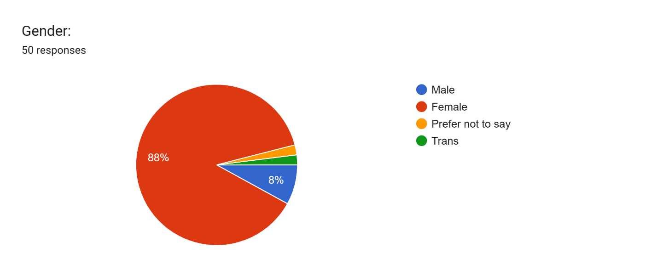**Presentation, Analysis and Interpretation of Data**

*Figure 3* *Percentage of respondent’s Gender*

As shown on figure 3, 88% of students who’s studying BE SNED at Eulogio “Amang” Rodriguez Institute of Science and Technology are female, while the remaining 8% are male. 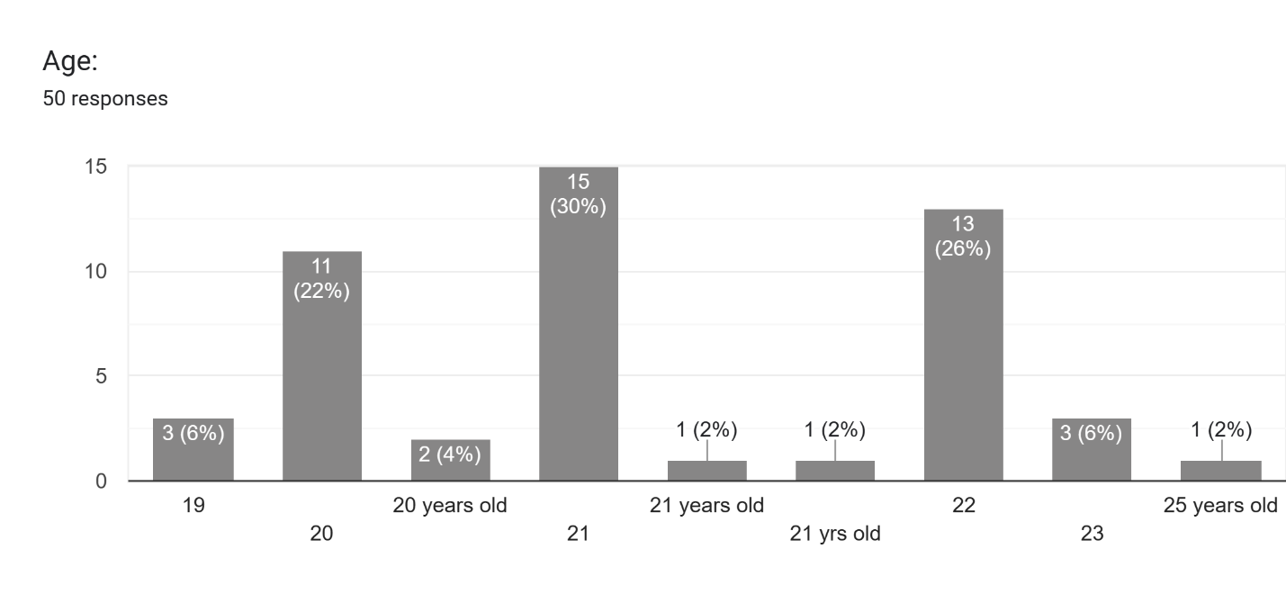

*Figure 4* *Percentage of Respondent’s Age*

As shown in figure 4, out of 50 respondents who answered the researcher’s survey, 17 students answered that they are 21 years old while 13 students answered that they are 22 years old, aside from that, 13 students also answered that they are 20 years old, below 20 years old, 3 students (6%) answered that they are 19 years old. 3 students answered that they are 23 years old while only one student answered that he or she is 25 years old. Meaning, with this gathered data, their age can use the researcher’s system without consent as all of the gathered respondents are legal in age.

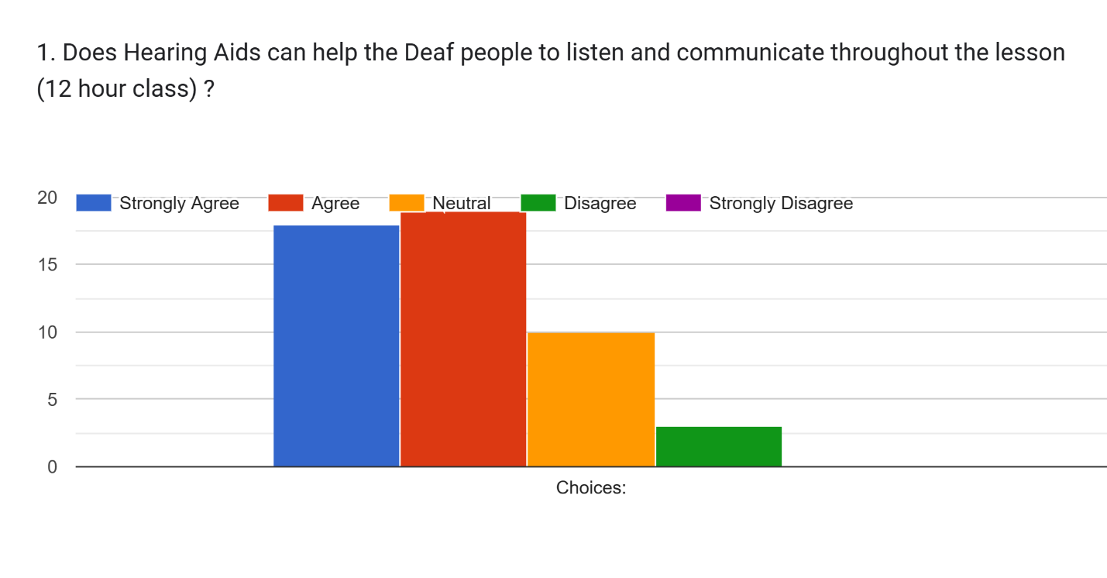

*Figure 5* *Respondents who answered survey questionnaire*

As shown in figure 5, a lot of respondents responded that they strongly agree of the thought that hearing aids can help the deaf people to listen and communicate throughout the lesson with 12-hour class, but a lot of respondents, 17% said that they only agree with the thought of a deaf person using hearing aids to listen and communicate throughout the lesson. 10 respondents said that they are neutral with the thought while only 3 people disagree with the thought of deaf people can listen and communicate throughout the lesson with a 12-hour class using hearing aids.

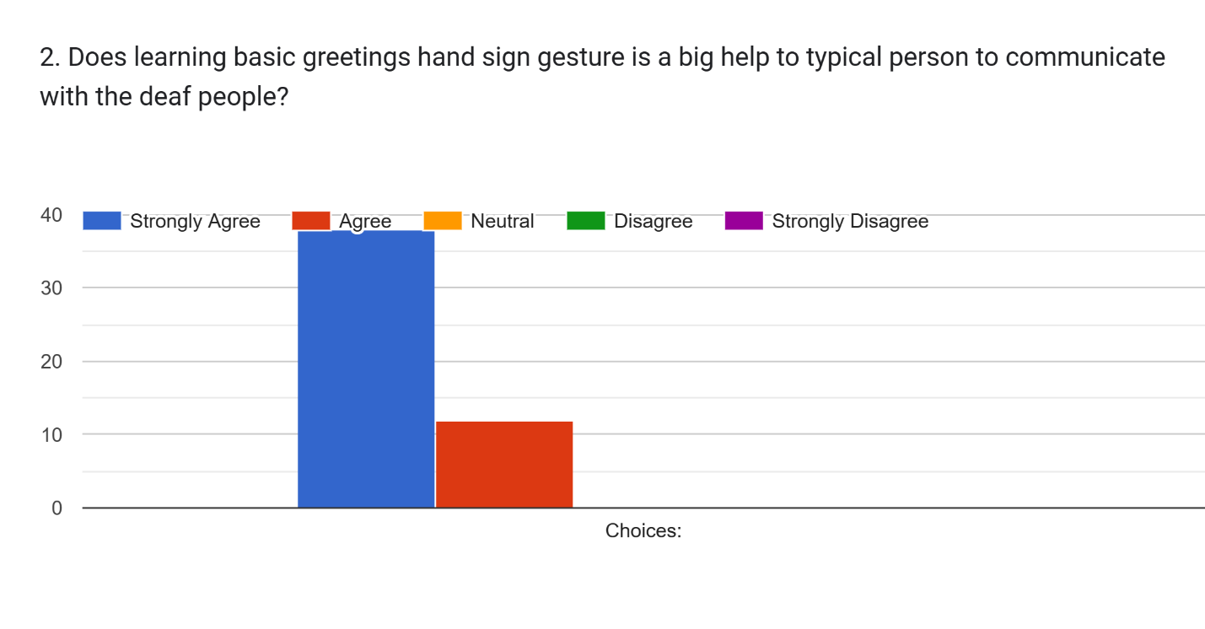*Figure 6* *Survey Questionnaire Number Two*

Almost 40 respondents strongly agree that learning basic greetings and sign gestures is a big help to a typical person (a person that can hear) to communicate with the deaf community, while 11 respondents agree. Overall, 50 respondents completely agree that learning basic greetings using hand sign gestures can help both sides to communicate with each other.

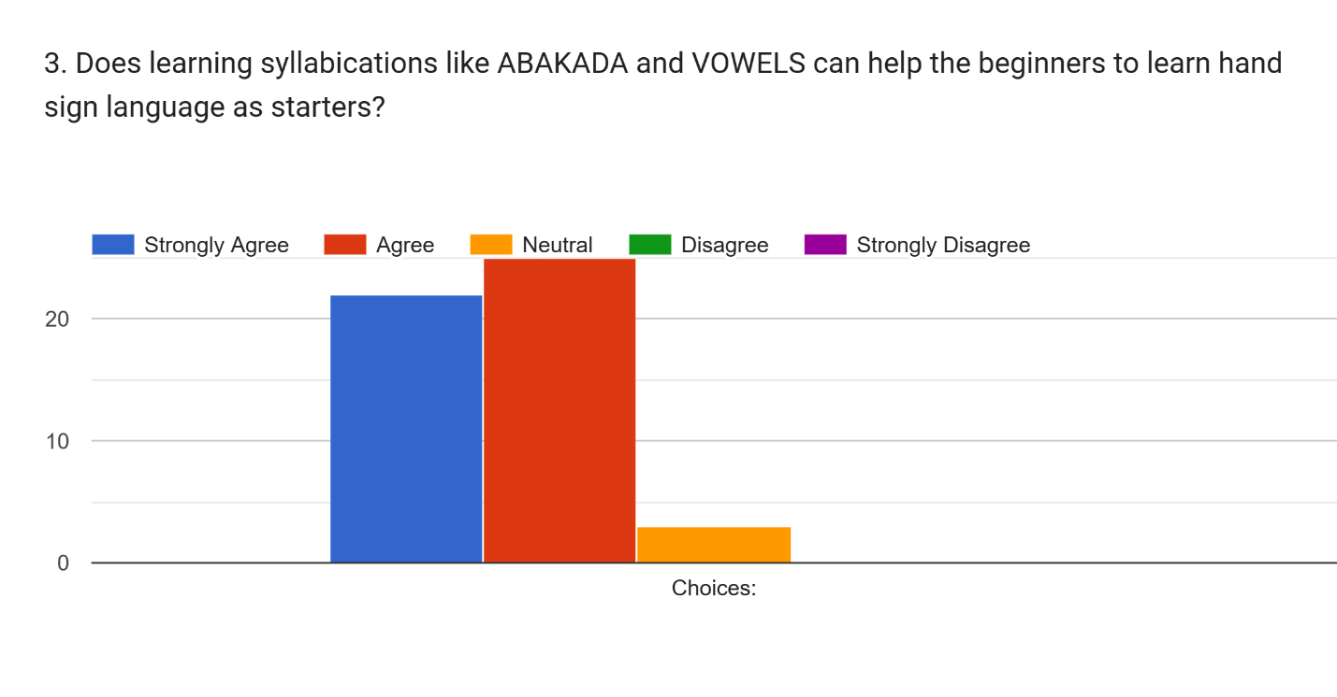*Figure 7 Survey Questionnaire Number Three*

Almost 30 respondents agrees that learning syllabications and vowels can help the beginners to learn hand sign language as starters, meanwhile almost 25 respondents strongly agree with the thoughts, leaving 5 respondents to neutrally said that learning vowels and syllabications can help the beginners to learn sign language as starters.

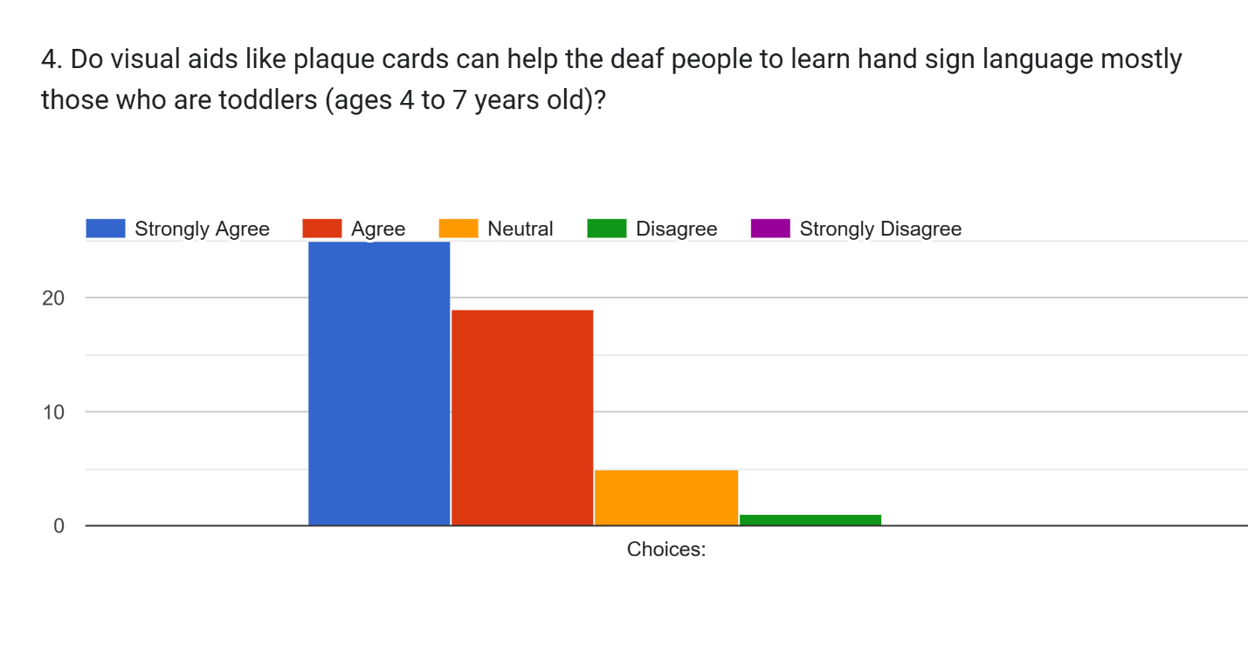*figure 8* *Survey Questionnaire Number Four*

  A lot of respondents strongly agree that visual aids like plaque cards can help the deaf people to learn hand sign language, mostly the toddlers that range from 4 to 7 years old. Meanwhile, 19 respondents said that they only agree that visual aids can help toddlers and deaf people to learn hand sign language, 5 people are neutral while only 1 person said that he or she disagrees with the question stated.

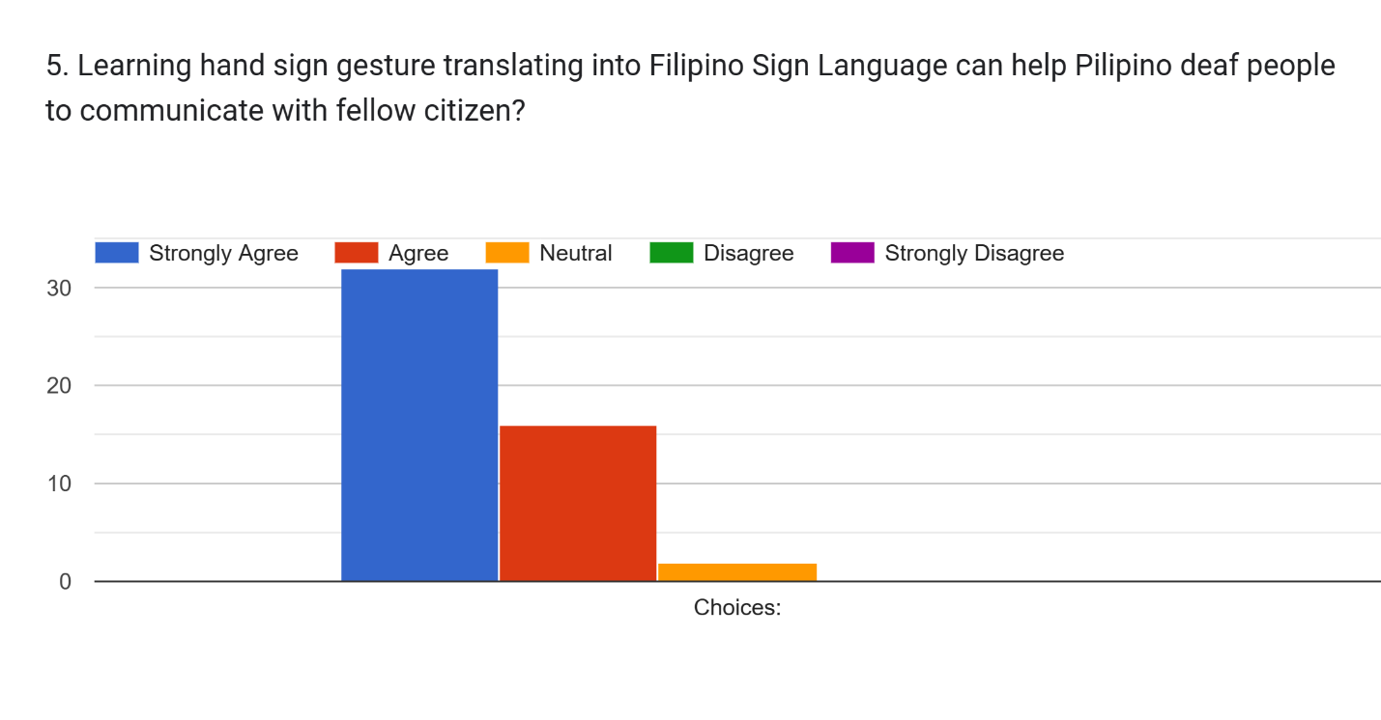*Figure 9* *Survey Questionnaire Number Five*

30 respondents agreed that learning hand sign gesture translating to Filipino Sign Language can help Filipino deaf people to communicate with fellow citizens both deaf and typical, while 18 people agreed with it and only 2 respondents said that they are neutral with the question stated.

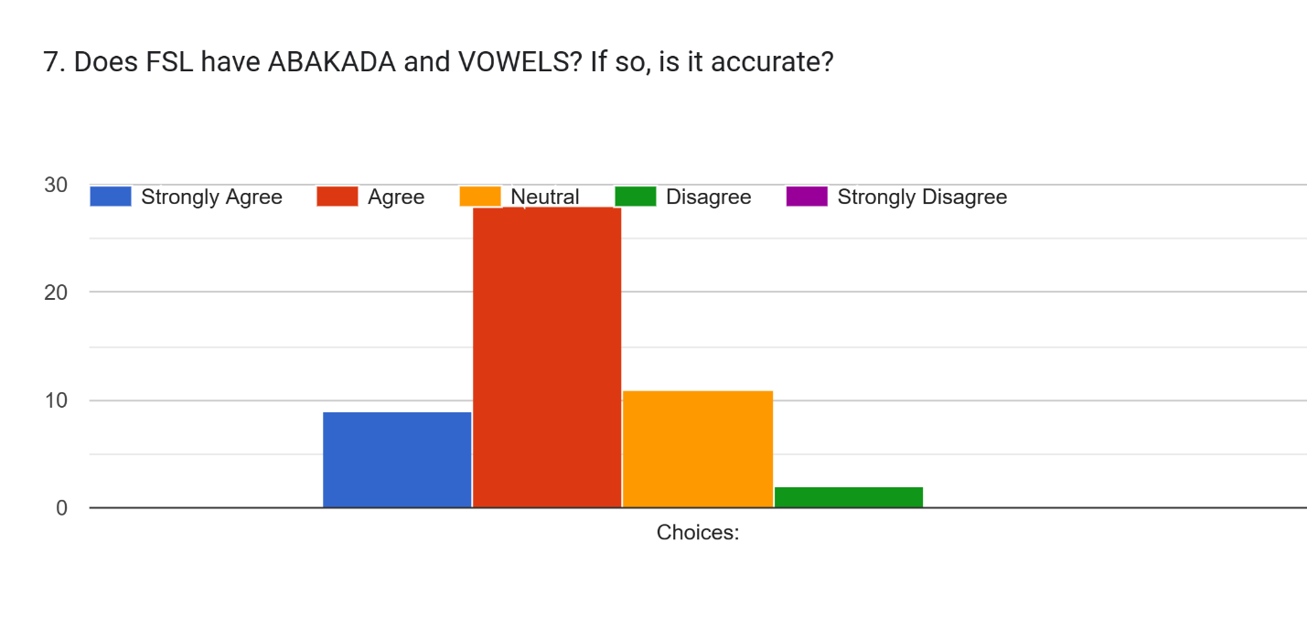*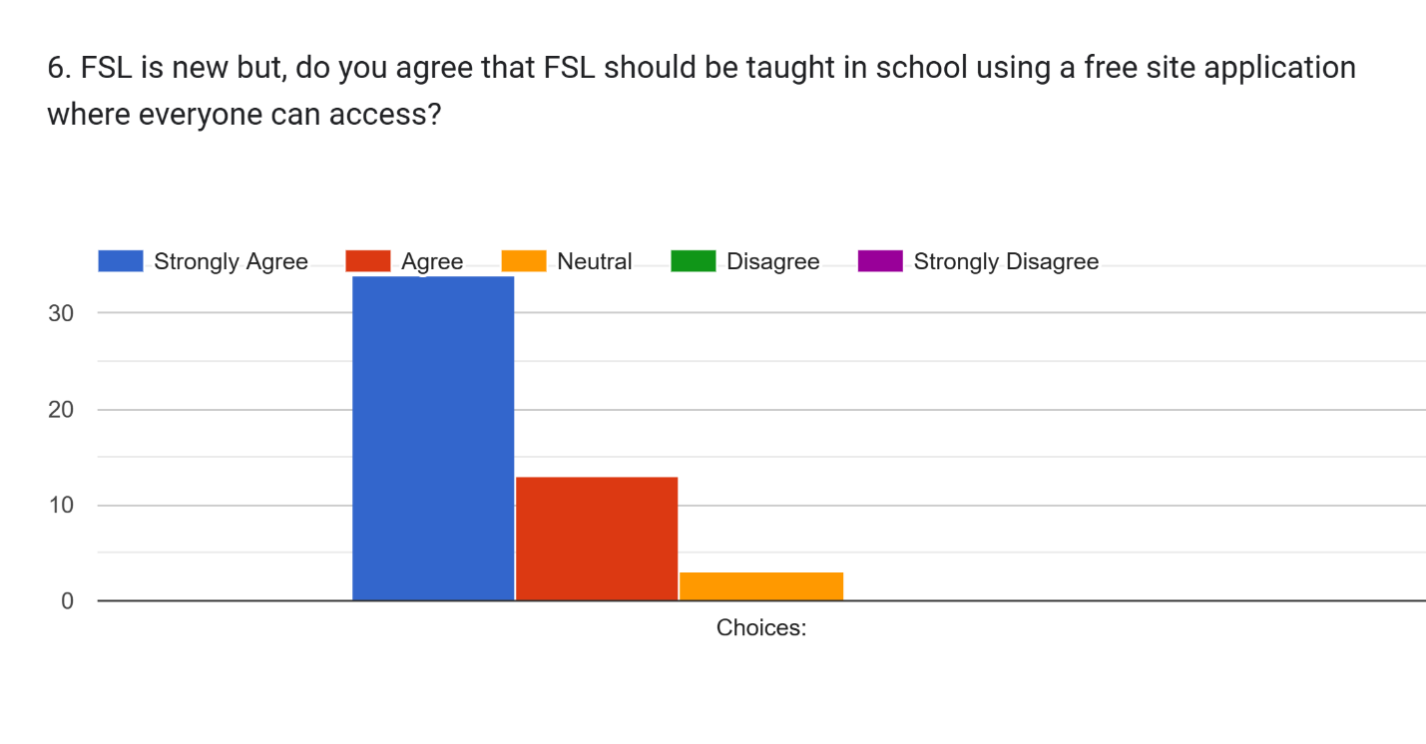Figure 10* *Survey Questionnaire Number Six*

Almost 35 people strongly agree that despite the fact that Filipino sign language is new, this sign language should be taught in school using a free site application that everyone can access. Almost 15 people agree with it while almost 5 people are neutral.

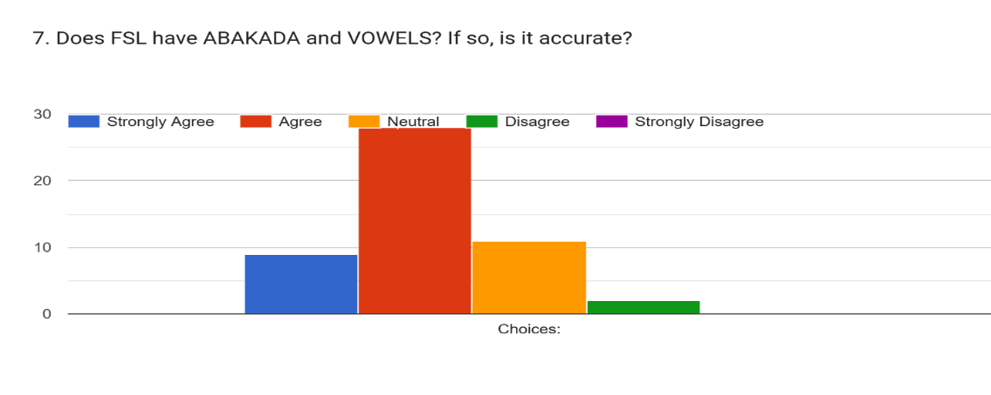

*Figure 11* *Survey Questionnaire Number Seven*

Only 9 respondents strongly agreed that Filipino Sign Language had ABAKADA and Vowels that are accurate, meanwhile 28 respondents strongly agree to it and only 11 people are neutral while 2 people disagree with this question. The researchers did some research and the researchers confirmed that despite FSL having vowels, this sign language doesn’t have ABAKADA, they also consulted to one of the professors they interviewed and confirmed that it doesn’t have syllabication of ABAKADA.

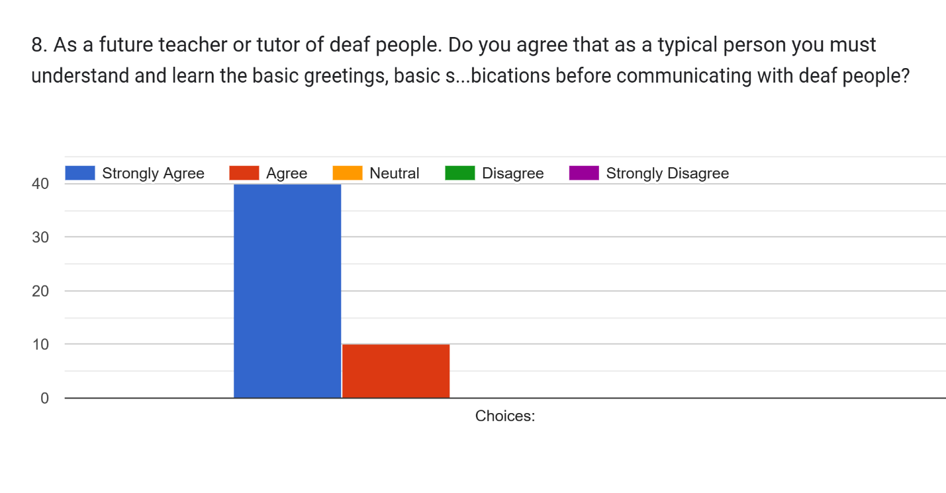Figure 12 *Survey Questionnaire Number Eight*

As shown in the result of survey questionnaire number 8, 40 respondents from BE SNED said that they strongly agree that a typical person must understand and learn the basic greeting, syllabications before communicating with deaf people. 10 of the remaining students said that they agree with the idea.

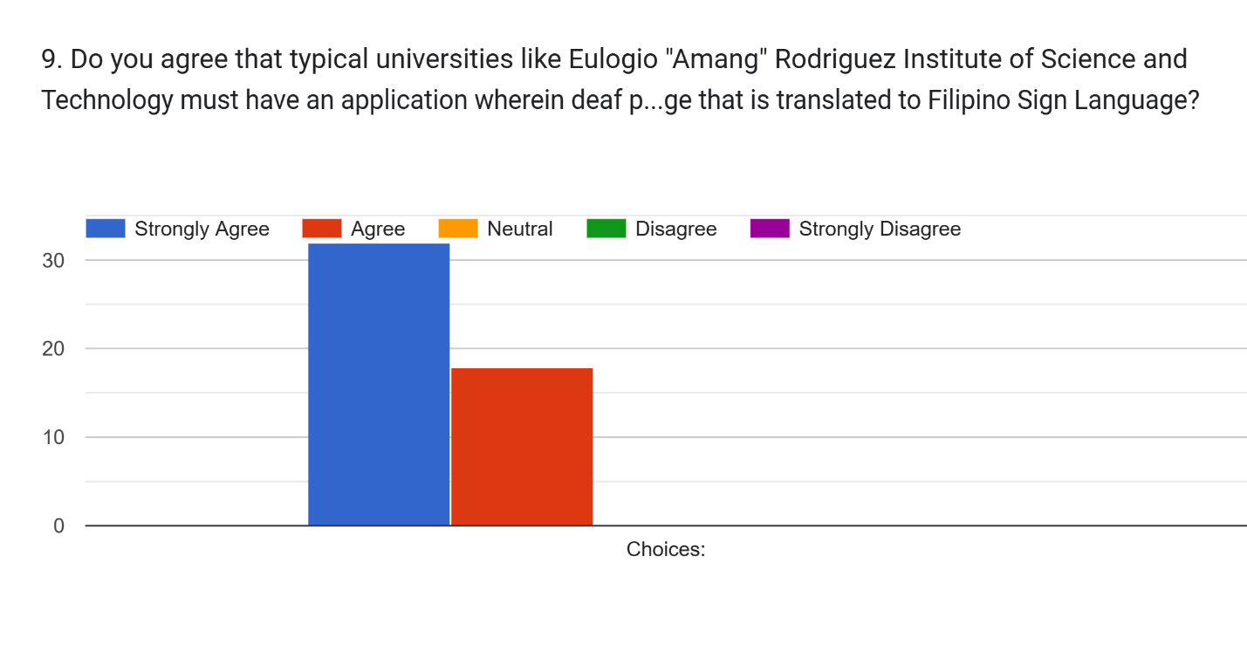*Figure 13* *Survey Questionnaire Number Nine*

32 respondents from Bachelors of Education major in Special Need Education strongly agree that universities like Eulogio “Amang” Rodriguez of Institute of Science and Technology must have an application for deaf people to use while learning basic sign language that translates to Filipino Sign Language.

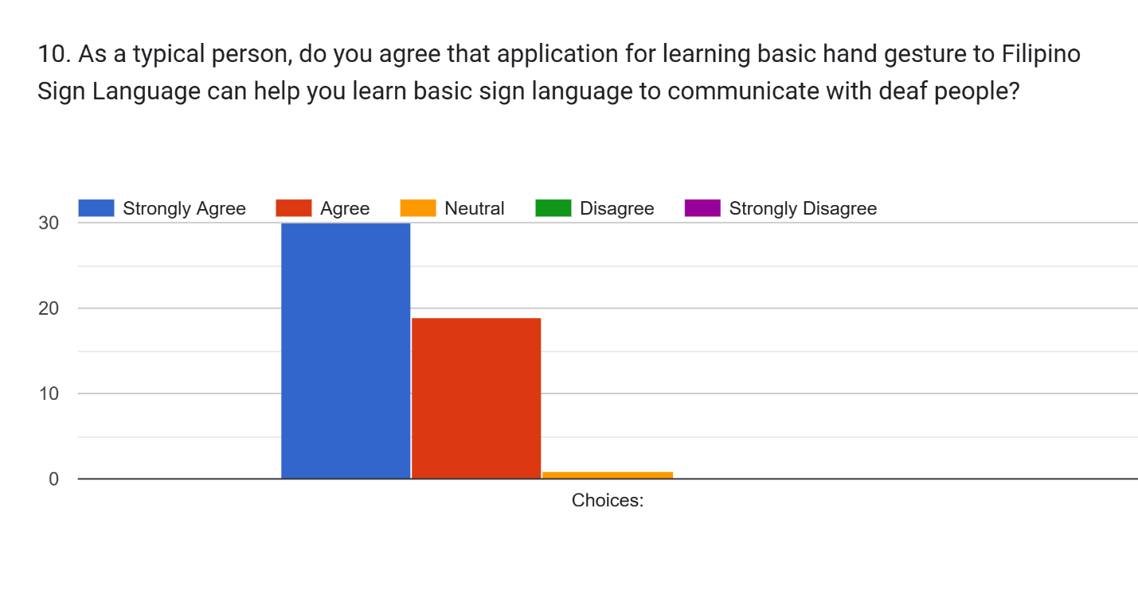*Figure 14* *Survey Questionnaire Number Ten*

As a result of question number 10, 30 respondents strongly agree that the application of learning basic hand gestures to Filipino Sign Language can help a typical person to learn basic sign language to communicate with deaf community, 19 agree to the idea while only 1 person is neutral with the choices.

*Figure 15 Survey Questionnaire 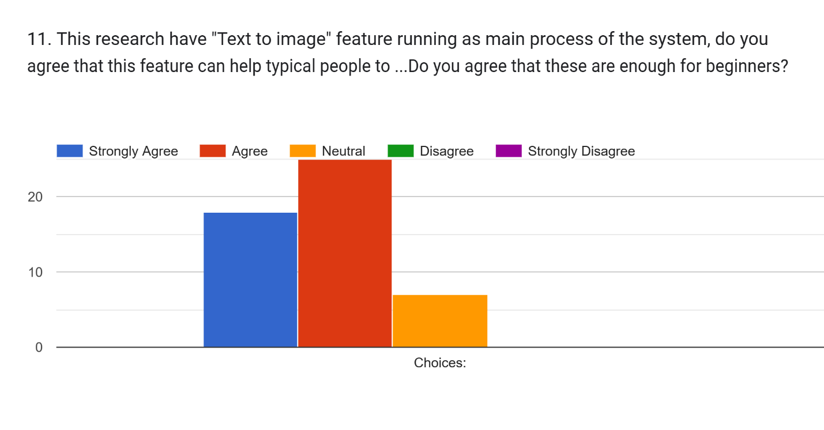Number Eleven*

Twenty-five respondents agrees that “text-to-image” feature in running as main process of the researchers’ system that this feature can help typical people to type anything on the text box and it will translate to hand sign gesture, but it is only limited for basic greetings, vowels and syllabication and is enough for beginners that wanted to learn, other than that 18 respondents strongly agrees that this feature can help beginners to learn basic hand gestures while 7 respondents said that they are neutral with the idea.

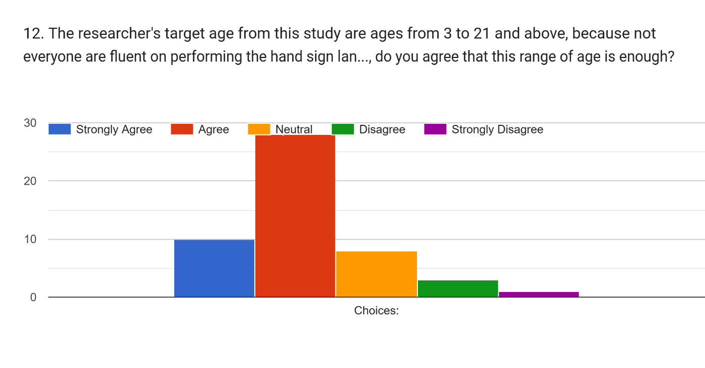 *Figure 16* *Survey Questionnaire Number Twelve*

Out of 50 respondents, 28 respondents agree that ages 3 to 21 is enough range for researchers’ target age in this research with the reason that not everyone are fluent in performing the hand sign language, therefore, 10 respondents strongly agrees while 8 respondents are neutral. 3 respondents said that they disagree with the target age while only 1 respondent disagree.

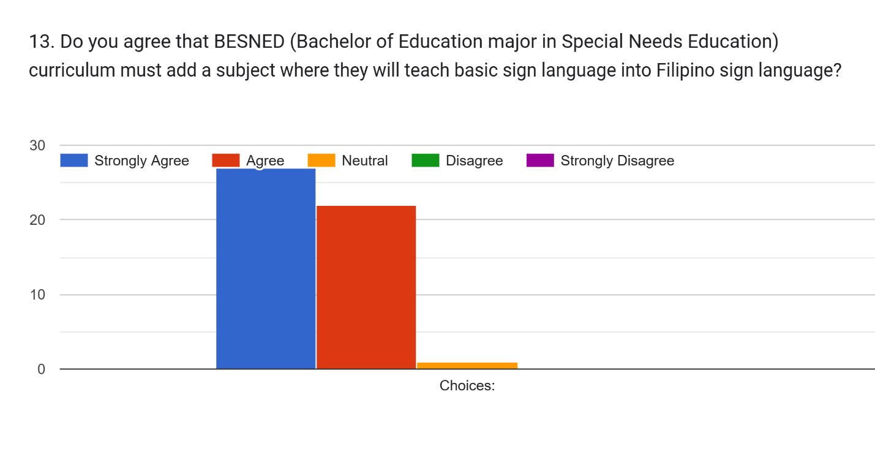 *Figure 17* *Survey Questionnaire Number Thirteen*

Out of 50 respondents from BE SNED, 27 of the respondents agree that curriculum must add a subject that involves the teaching of basic sign language into Filipino Sign Language. 22 respondents agreed while only 1 person is neutral.

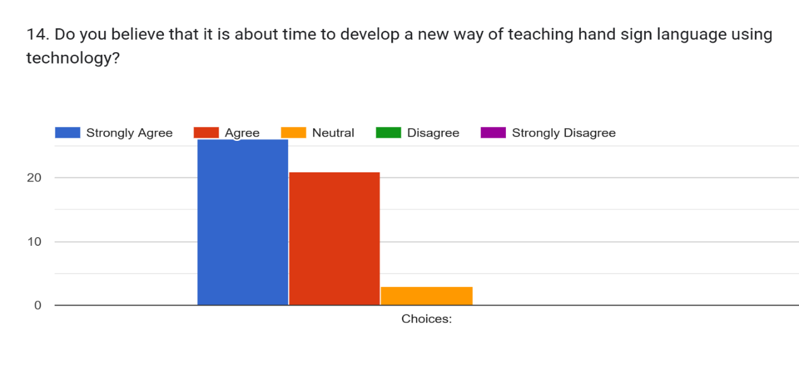*Figure 18* *Survey Questionnaire* *Number Fourteen*

26 respondents believed that it is about time to develop a new way of teaching hand sign language using technology, meanwhile 21 respondents agree with the idea while there are 3 respondents that are neutral with the matter.

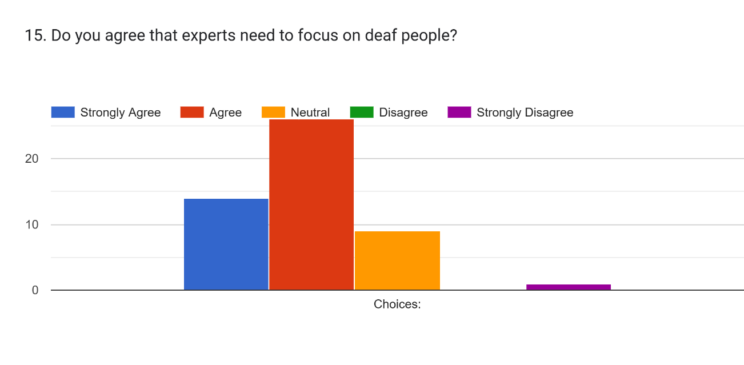

*Figure 19* *Survey Questionnaire Number Fifteen*

Out of 50 respondents that answered researchers’ survey questionnaires, in question 15, 14 respondents strongly agreed that experts need to focus on deaf community, 26 people only agree with the idea while 9 respondents are neutral, other than that there is one person that strongly disagrees that experts need to focus on deaf community.

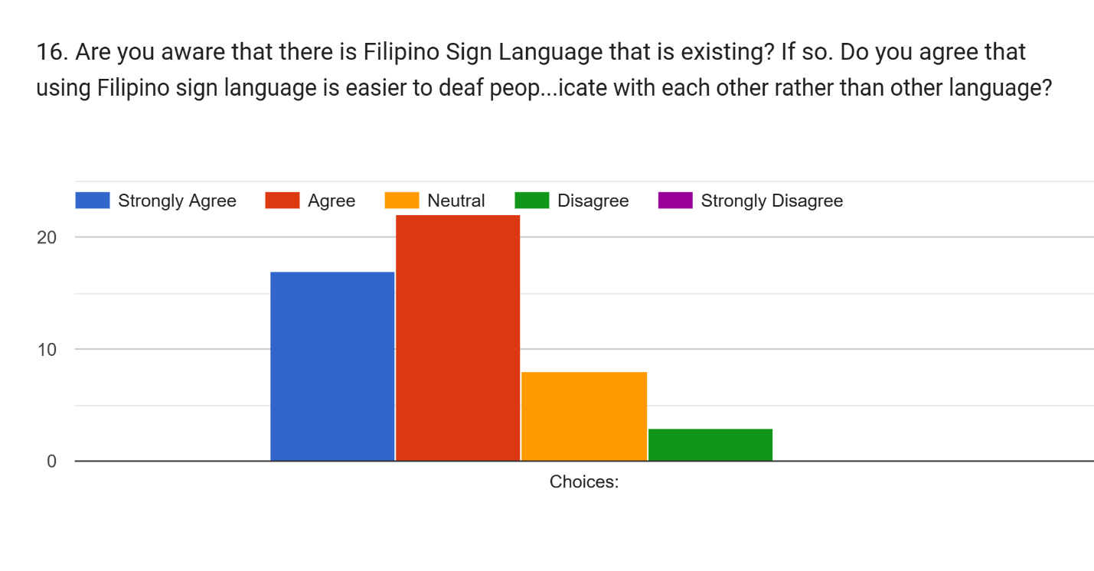

*Figure 20* *Survey Questionnaire Number Sixteen*

In question number 16, 17 respondents strongly agree that they are aware of FSL and that they strongly agree that using this kind of sign language is easier for deaf people to communicate with each other rather than using other language as sign language. 22 respondents agreed while 8 respondents were neutral, out of 50 respondents, only 3 respondents disagreed with this question given.

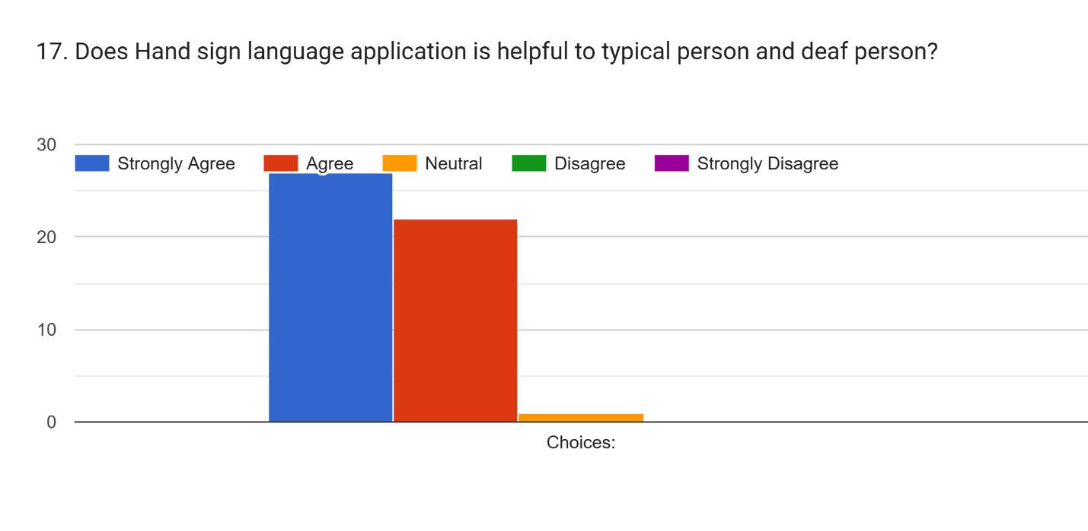*Figure 21* *Survey QuestionnaireNumber Seventeen*

In question number 17, 27 respondents that answered the survey questionnaire strongly agreed that hand sign language application is helpful to the typical person and deaf person while 22 respondents only agreed and out of 50 target respondents only 1 respondent answered that he or she is neutral.

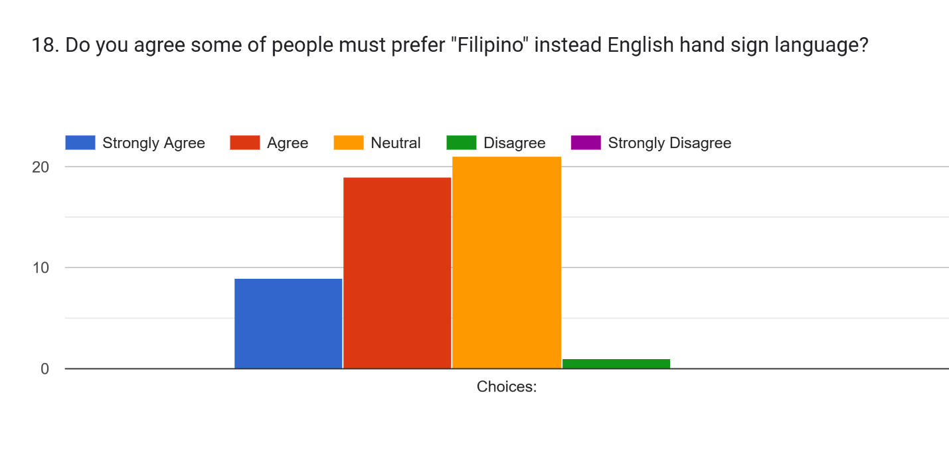

*Figure 22* *Survey Questionnaire Number Eighteen*

In question number 18 in the survey questionnaire, 21 respondents said that they are neutral in agreeing that some people must prefer Filipino instead of English sign language here in Philippines, 19 respondents said that they agreed and 9 respondents said they strongly agreed. Out of 50 respondents that answered this question only 1 person disagree with the idea. 

*Figure 23* *Survey Questionnaire 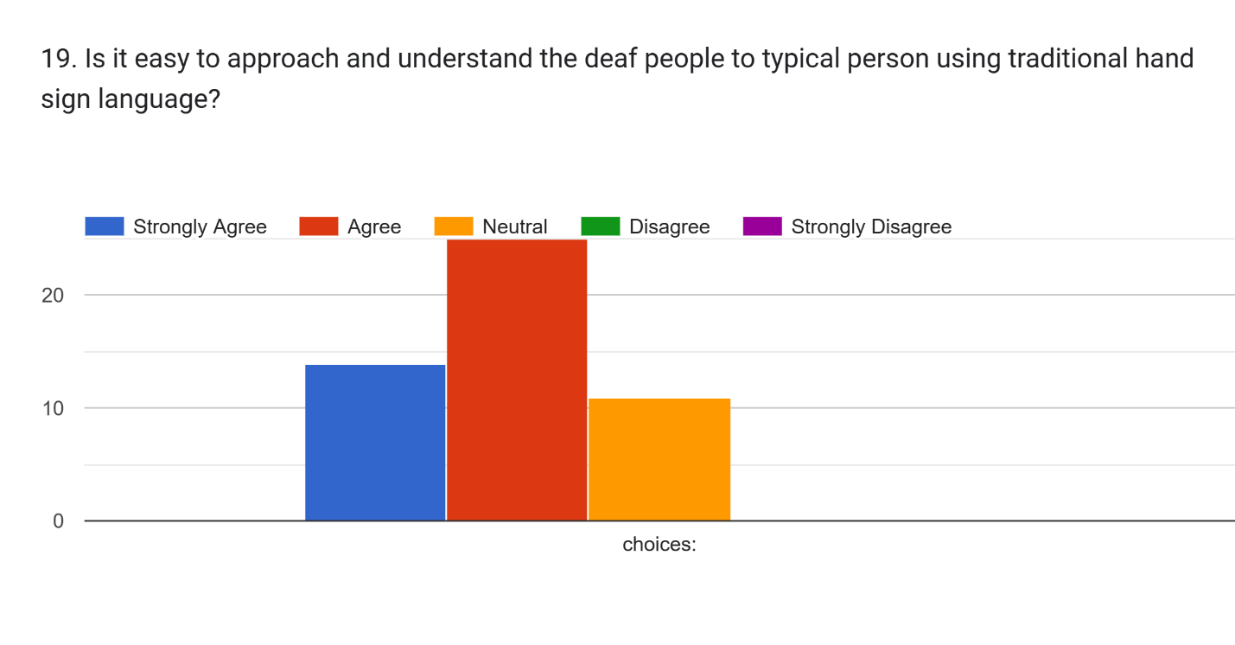Number Nineteen*

Out of 50 respondents that answered the survey questionnaire, in question 19. 25 respondents agree that it is easy to approach and understand deaf people to a typical person using the traditional hand sign language. While 14 respondents strongly agreed, 11 respondents said that they are neutral.

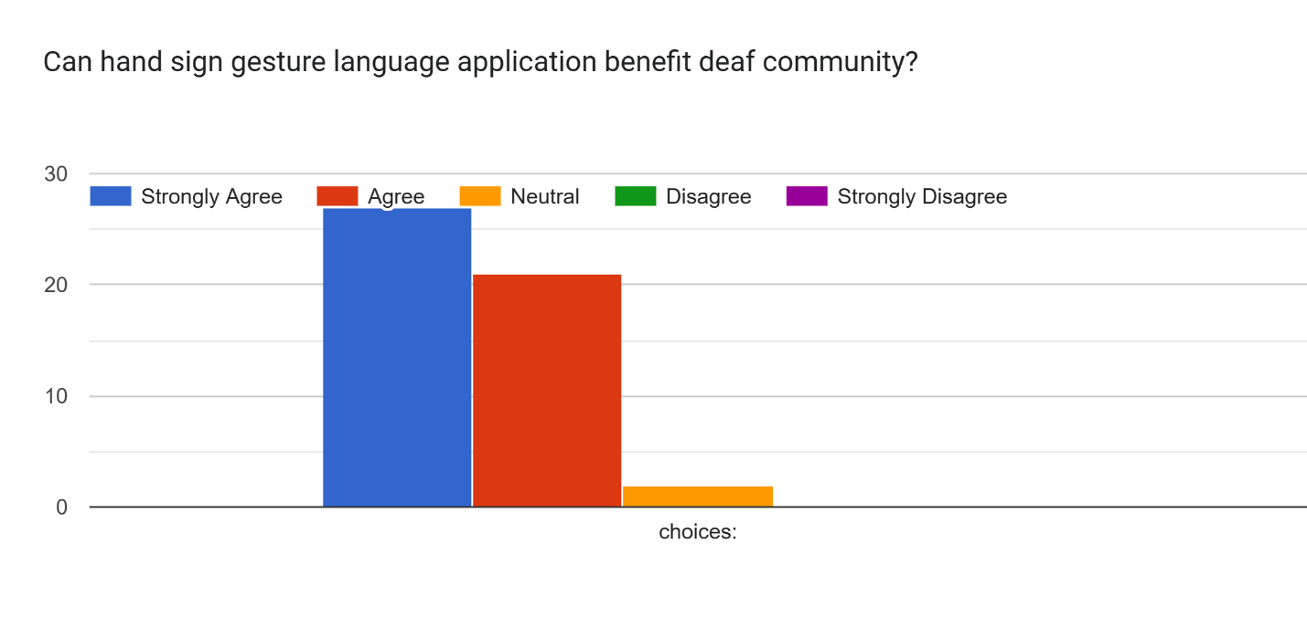

*Figure 24* *Survey Questionnaire Number Twenty*

For the last question in the survey questionnaire that the researchers given to 50 target respondents, 27 respondents strongly agrees that hand sign gesture application can benefit the deaf community, while 21 respondents agree with the idea and 2 respondents answered that they are neutral.

**Result**

The researchers would give appropriate results to each statement of the problem listed in Chapter one. The result of the study is summarized as follows:

* 1. **The accuracy of CNN Algorithm in fetching the image processing training using Keras API as architectural framework and MediaPipe**

There are a lot of procedure that the researchers did as they find out the accuracy of CNN algorithm in fetching the image trained from the Keras API and MediaPipe, first is that, the researchers also used NGROK API alongside with Keras to fetch the image from python raw file that the researchers’ trained to the android application, the researchers used mediapipe in collecting the data in A-BA-KA-DA and A-E-I-O-U by image capturing and mediapipe with holistic model in the nursery rhymes. In terms of the accuracy of CNN algorithm in fetching both the trained images is that it is based on the models that the researchers validated. In capturing the nursery rhymes word per word, the researchers took 1 second delay in capturing and 3 seconds time during the process of capturing using Keras and NGROK API, MediaPipe, OpenCV, VSCODE and Pyenv

* 1. **The average age that is capable of using the FHS application (The age ranges from toddlers of 3 to flexible of all ages of both deaf and typical people with or without experience.)**

There are varying answers from the respondents as to what age is capable of using the researchers’ mobile application but most of answered that they are strongly agree in various learning materials such as:

1. **Visual aids like plaque cards for hand sign language that are toddlers who ages from (4 to 7 years old)**

According to the pre-survey that the researchers conducted from 50 students of BESNED, more than half of the respondents agrees that a toddler from 4 to 7 years old can learn sign language by visual aids while 19 respondents agrees and 5 respondents are neutral with the thoughts

1. **If the respondents agree that the range of age is 3 to adult (21 and above) as the target users for the system.**

Out of 50 respondents that the researchers gave the pre-survey questionnaire, 28 respondents agreed that ages 3 to 21 and above is enough range for researchers’ target age as the target users for the system, and 10 respondents strongly agreed while 8 respondents were neutral.

* 1. **The accuracy of the system in translating hand-sign gesture to the “selected” Filipino language using CNN algorithm in terms of:**
  2. **Basic Nursery Rhyme with the title of Ooh-Lan**

The researchers’ decided to add the nursery rhyme entitled ooh-lan as a song for the mobile application, they studied the gestures and trained every movements using three models, first model is that the convolutional layers with very simple dense layer, second model is the LSDM, long short-term memory model because it is very good in sequential data with two convolutional layers and two LSDM so the result of the models that the researchers trained has been spiked up, the third model is the convolutional 3D.

The result of the following model as they trained it. First model has 231,633 parameters with an accuracy of 0.973, the second model has 950,993 parameters with an accuracy of 0.96 and the third model has 147,665 parameters with an accuracy of 0.974. The nursery rhyme that the researchers trained has 20 EPOCHS. The validation also showed that the first model that the researchers trained has .06 milliseconds while the second model has 0.120 milliseconds while the last model has .07 milliseconds. The researchers decided that they will choose the first model since it is faster than the other two models that they trained. The third model is slow in terms of picking up a convolutional 3D. The researchers’ gathered data is 960 data for each model. The accuracy of the Ooh-Lan nursery rhyme has been fixed from the past recommendation of the panelists, the updates is that it depends to the trained data that if it is the same with the gesture being recognized to the trained data then it is more accurate than those movements that has not been trained or the gestures that is not visible enough. The data collected from nursery rhyme is 16,092 while the frame is 15, the features of the nursery rhyme is 58 while key points is 3, the channels is 1 means that the researchers used grayscale.

**1.2 Vowels like “A-E-I-O-U” and the Filipino Syllabication like “A-BA-KA-DA”.**

The researchers trained the vowels and syllabication with two different models, the first model is the convolutional 2D with one convolutional layer and two dense fully connected layer, while the second model is the LSDM with long short-term memory. The total parameters are 237,844 parameters and the accuracy of the first model is 0.995 milliseconds while the second model’s accuracy is 0.994 milliseconds. The time execution comparison of each model is that the first model has 0.06-time execution while the second model has 0.23-time execution. The parameter comparison of two different models is that the first model has 46,865 parameters, while the second model has 217,844 parameters. ABAKADA and AEIOU used an image insertion, the researchers decided that the “baybayin” will be joined together to make a word out of the Filipino vowels and Filipino syllabication like ABAKADA, the second one that the researchers’ used as one of their features is the real time, user can make a gesture like “A” or “BA” then a text will appear in the text box. The updated version of this is that it is the same as in the image insertion, a user can make a move like “A” or “BA” then these two baybayin can be combined together to make a word. If the first capture that the camera has caught and there is no recognized gesture at all in the researchers’ trained models then the text will be a null result and nothing will be shown in the text box other than “NULL” message. The data collected from AEIOU and ABAKADA is 181,058 while the feature is 21, the length is 3 and the channels is 1 means, the model that the researchers’ used is grayscale.

* 1. **The accuracy of the system translating the selected Filipino language using convolutional neural network algorithm to hand-sign gesture in terms of:**
  2. **Trained Images**

The result of the trained images that the researchers collected is accurate. The researchers used different methods to train images and to collect the images that the researchers will be going to train. First one is that, the researchers used mediapipe to collect movements from the nursery rhyme and it is not accurate, the second one is that the researchers used mediapipe with holistic models to collect the movements and it is accurate and the last one is that the researchers used Keras, VSCode, MediaPipe, pyenv, NGROK to collect the data images that the researchers need in with the method of using their own application to capture the image from head to waist, to collarbone to arms and the result of this method is more accurate than before.

* 1. **Text to Image and Image to text**

The text to image result is also accurate since the researchers used this method in the ABAKADA and AEIOU features of the mobile application where the users can insert or upload an image where it can be translated to text while the feature can also be used in real time like the nursery rhymes. The accuracy of both features is more accurate since the researchers only trained an image without movements so it is easier than the other feature like nursery rhymes where the researchers need to train a movement per movements with each time.

**Presentation of the Mobile Application**

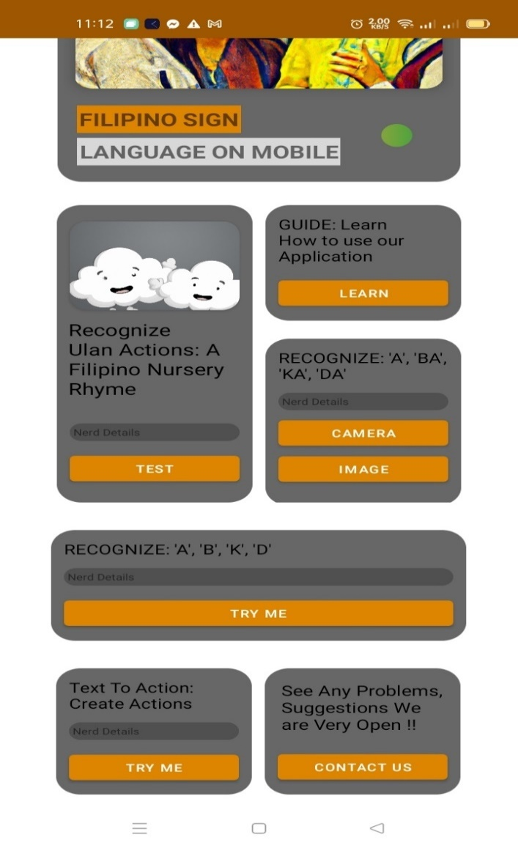

*Figure 25* *The Users Interface*

The researchers made the decision to make the users interface simpler with a hint of being a Filipino to represent the Filipino Sign Language. The users will see eight (8) buttons that can be interact with.

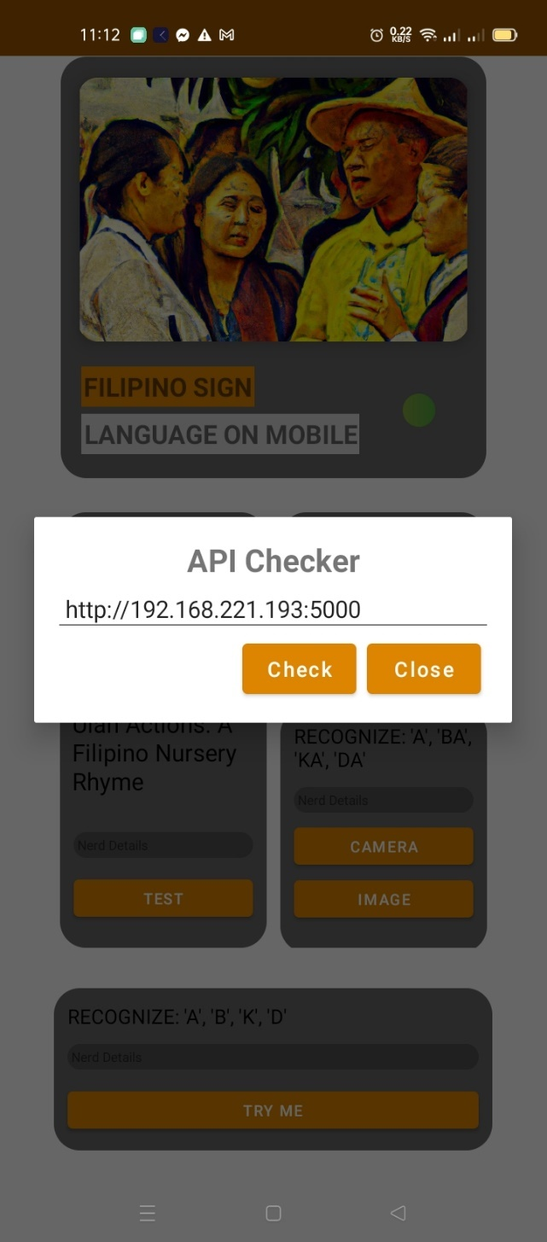

*Figure 26* *The API Checker*

In this figure26, the user would have to click the **First button**, it is in the right top corner that will indicate if the user connected to the server, then it will change to color green, while if the user is not yet connected then the color would change into red. The admin or the main proponent of the system would give the link to the API server for the user to connect before the user can check it or close it. This kind of feature would ensure the safety of the user since the allowing process is in the link server that is directly given of the programmers.

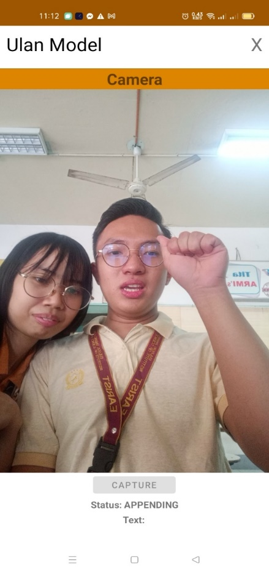

*Figure 27* *Nursery Rhyme*

In this figure 27, the researchers created a user interface where the user would have to use real-time performance to capture the gesture. First is that, the user would have to click the capture button below the screen, if the status is appending it means that the capturing time is finish and the text below would indicate what part of the lyrics in the nursery rhyme that the user gestured and the system has detected. The status will indicate that 3000 milliseconds is the capturing time, then it will turn to appending then the result will be written into text box below.

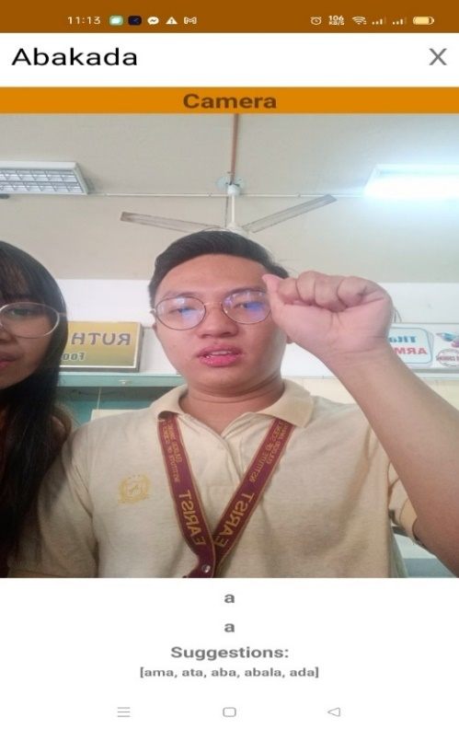

*Figure 28* *Filipino Syllabication ABAKADA Real Time*

In this figure 28, the researchers made two features for the ABAKADA feature, the first one is the real time, just like in the nursery rhyme, the user would do a gesture and the camera would detect it and convert it into text, while doing so, the system would also recommend some words to follow.

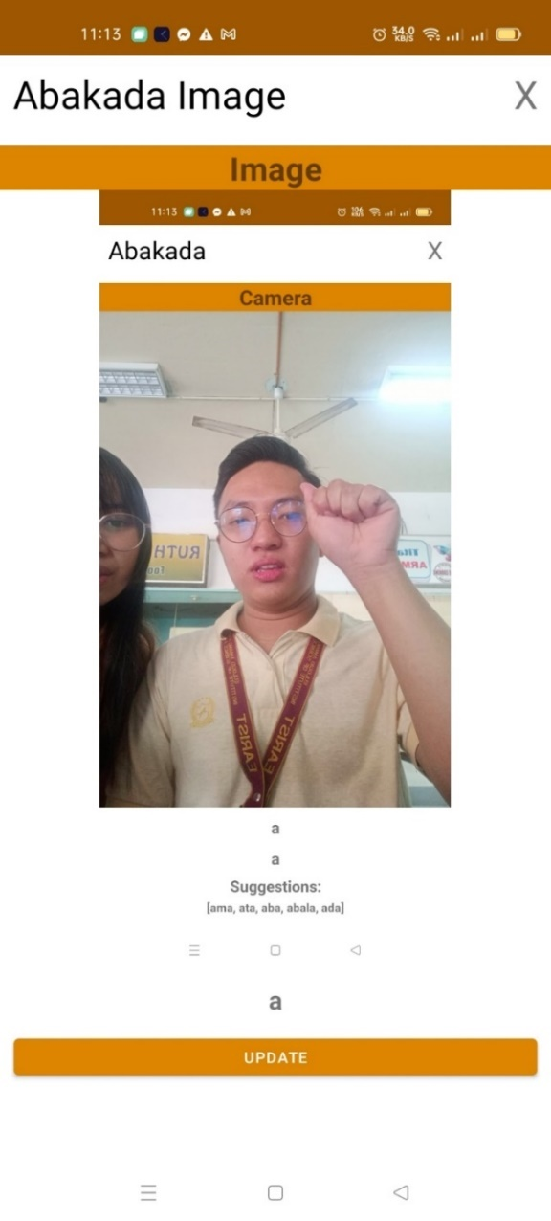

*Figure 29* *ABAKADA Image*

The second feature (see figure 29). The user will have to upload a clear image with the hand sign and the camera will detect it and convert it into text, if the user chooses to click the update button, then the user can extent the detection and convert it into word that suggested below.

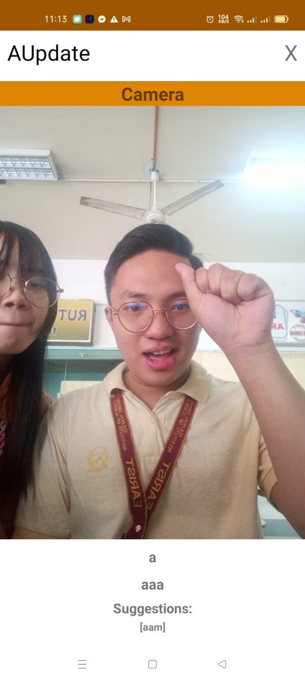

*Figure 30 The update of the system to follow the Recommendation*

In this figure, the “AUpdate” feature is a feature where you can create a word using Filipino Alphabet like A-B-K-D-E-G-H and so on. This update is to made the system more flexible to language that will be translated.

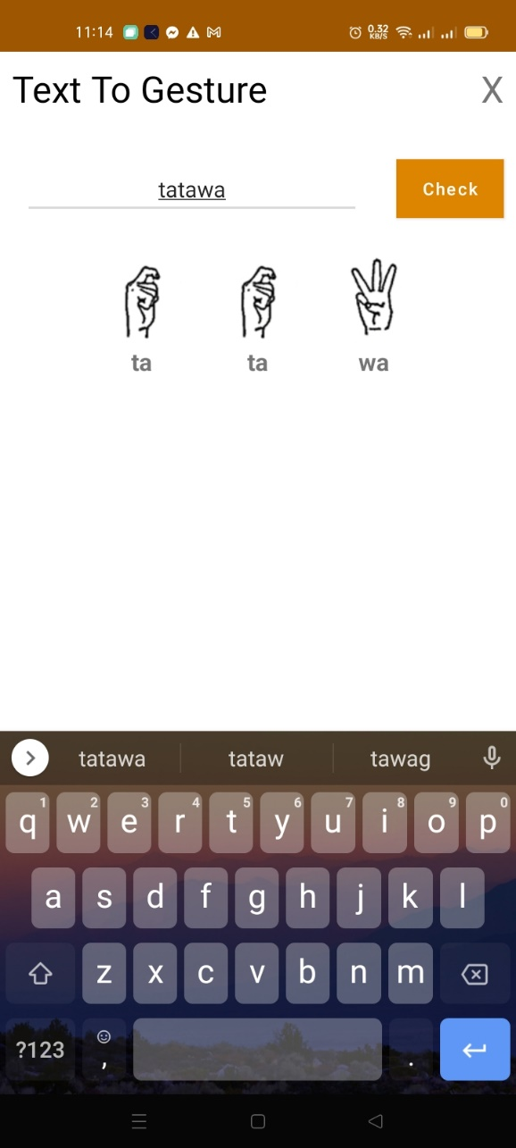

*Figure 31* *Text to Gesture Feature*

In this figure, the researchers made a feature where the user will type any specific words that is suggested below the suggestion box, write it in the text box and click the check button to see the hand-sign of that word, one by one.

**Chapter 5**

**Summary of Findings, Conclusions and Recommendations**

In this chapter, it deals with the summary of findings, conclusions and recommendations obtained from this study.

**Summary of Findings**

This study identified that the system is employed by the researchers of Information Technology Education department Bachelor of Science of Computer Science 4-C of Eulogio “Amang” Rodriguez of Institute of Science and Technology – Manila in the Hand Sign Gesture Detection and Conversion to Text for Filipino Sign Language Using Convolutional Neural Network Algorithm. This study focused on developing a mobile application to let the deaf people and typical people learn the basic hand sign language that translates to Filipino language.

The Agile as Software Development Life Cycle was followed with developing this mobile application. The proponents of this study used Keras and NGROK as Application Programming Interface, MediaPipe and its holistic model to train the datasets which is the image to train the model, Python as the programming language, JupyterLab as IDE. The researchers also used Google Colab, VSCode and Android Studio in creating the system. Data gathering from the respondents regarding the efficiency of the mobile application was done using a survey questionnaire verified by their research adviser. The researchers conducted this study on the academic year 2022 to 2023 wherein the researchers used purposive sampling and chose only 2nd year of Bachelor of Education Major in Special Needs Education students of Eulogio “Amang” Rodriguez of Institute of Science and Technology then used stratified random sampling among them.

Throughout the study, the researchers have identified the following problem statements in which they have discovered the following solution in each problem states:

**1. The accuracy of the system in hand-sign gesture to the selected Filipino language using CNN algorithm in terms of.**

**1.1. Basic Nursery Rhymes**

The accuracy of the Basic Nursery Rhymes in terms of image training using convolutional neural network algorithm is that convolutional layers with very simple dense layer is the most accurate model in training the movements of basic nursery rhymes since, the researchers gathered data needs to be a sequential movement, the accuracy of the convolutional layers with very simple dense layer is 0.973 while the parameter is 231,633 parameters, the researchers trained the 960 models of basic nursery rhymes in three different models in which shows that the first model which is convolutional layers with very simple dense layer is the fastest among them all.

**1.2. Vowels like “A-E-I-O-U”.**

The result of vowels in terms of image training using convolutional neural network is the same as the Filipino Syllabication like ABAKADA, it is because vowels like AEIOU includes in the 20 Filipino Alphabet of Filipino Sign Language, so the result of the accuracy in the problem stated is the same in the result of the Filipino Syllabication

* 1. **Filipino Syllabication like “A-BA-KA-DA”**

The result of the accuracy of Filipino Syllabication in terms of using convolutional neural network gained 0.995 milliseconds per image training with a total parameters of 237,844. The model that the researchers used in image training is convolutional 2D with one convolutional layer and two dense fully connected layer.

1. **The Accuracy of the system in the selected Filipino language using CNN algorithm to hand-sign gesture.**
   1. **Trained Images**

The accuracy of the trained images in both Filipino Syllabication and Nursery Rhymes are accurate, but it depends on the internet connection that one device have, the lightings, the angle and how accurate the user’s gesture are, since nursery rhyme uses sequential movements while the Filipino Syllabication is easier to trained since it doesn’t need to train frame by frame. Even though with the limitation of the study, the researchers may conclude that the accuracy of the image trained is accurate since the result of every movements in the system are 93% accurate with 7% margin of error.

* 1. **Text to Image**

The accuracy of the text to image feature of the FHS application is also accurate and successful, the researchers have decided to create an individual feature in which the user will type a text that has been in the applications trained images and the plaque cards will appear on how to do the movements in each “baybayin.”

* 1. **Image to Text**

The accuracy of image to text feature varies on the internet connection of the user since this feature is with the feature of real-time ABAKADA and the user will be the one to choose if they want to upload the image and convert it into text. Since the accuracy of real-time ABAKADA is accurate enough with good internet connection then the researchers can also guarantee that image to text feature is also accurate.

1. **What is the average age that is capable of using this system in terms of:**
   1. **Toddlers ages from 3 to 6, a teenager with the age ranges from 10 to 18; An adult with the age ranges from 21 and above with or without experience; and Flexible to all ages both deaf and typical person with or without experience?**

In terms of the capability of the toddlers who will use the researcher’s application varies on the answers of the respondents from the BE-SNED of Eulogio “Amang” Rodriguez Institute of Science and Technology, it is because they are the one who is the most knowledgeable in terms of these questions but the researchers made sure that the application is a flexible guide for all ages.

1. **Visual aids like plaque cards for hand sign language that are toddlers who ages from (4 to 7 years old)**

According to the pre-survey that the researchers conducted from 50 students of BESNED, more than half of the respondents agrees that a toddler from 4 to 7 years old can learn sign language by visual aids while 19 respondents agrees and 5 respondents are neutral with the thoughts

1. **If the respondents agree that the range of age is 3 to adult (21 and above) as the target users for the system.**

Out of 50 respondents that the researchers gave the pre-survey questionnaire, 28 respondents agreed that ages 3 to 21 and above is enough range for researchers’ target age as the target users for the system, and 10 respondents strongly agreed while 8 respondents were neutral.

1. What is accuracy of CNN algorithm in fetching the image processing training using:

**4.1. Keras API as architectural framework; and**

**4.2. MediaPipe?**

There are a lot of procedure that the researchers did as they find out the accuracy of CNN algorithm in fetching the image trained from the Keras API and MediaPipe, first is that, the researchers also used NGROK API alongside with Keras to fetch the image from python raw file that the researchers’ trained to the android application, the researchers used mediapipe in collecting the data in A-BA-KA-DA and A-E-I-O-U by image capturing and mediapipe with holistic model in the nursery rhymes. In terms of the accuracy of CNN algorithm in fetching both the trained images is that it is based on the models that the researchers validated. In capturing the nursery rhymes word per word, the researchers took 1 second delay in capturing and 3 seconds time during the process of capturing using Keras and NGROK API, MediaPipe, OpenCV, VSCODE and Pyenv

Overall, the researchers answered and found the solution in every statement of the problem that is existing in the study. All statements of the problem originate from the existing problem that students and instructors of EARIST's special needs education faces, so the study's findings are based on the researchers' initial interviews conducted before the study began. All of the results come from the survey, the system, and close analysis of the articles associated with this research.

**Conclusions**

In conclusion on the accuracy of CNN Algorithm in fetching the image processing training using Keras API as architectural framework and MediaPipe, along NGROK API, OpenCV, VSCODE and Pyenv the researchers took one second delay in capturing and three seconds process of capturing nursery rhymes word per word alongside with the Filipino syllabication and Filipino vowels.

The testing of models and its results were promising, allowing the researchers to create functional and practical applications to give assistance to deaf and mute individuals while utilizing the CNN algorithm. The researchers also concluded that CNN Algorithm is more accurate in image training without any movements than an image with movements since the result of fetching ABAKADA and AEIOU are easier, faster and more accurate than the researchers did in the nursery rhymes. Based on the conclusions that the researchers have been gathered, the following conclusions follows:

1. Filipino Sign Language (FSL) and American Sign Language (ASL) is ready to implement but the uniqueness of this study focuses only in both Filipino syllabication (ABAKADA) and Filipino vowels (AEIOU) with the nursery rhymes (Ooh-lan) to prove that Filipino Sign Language is ready to implement but there are still need some modifications since FSL is still relying some words to ASL since there are Filipino words that cannot be translated fully in Filipino.
2. The application that the researchers made will be used by downloading and installing the application using only smartphones, it is more accurate in android devices like Oppo with wide screens rather than phones with small screens.
3. The application that the researchers made proves that despite the language barrier between the deaf community and typical people, these two individuals can communicate with each other even though they have no knowledge about hand sign gestures. But the researchers also conclude that it is a lot harder if the specific deaf person doesn’t have hearing aids and the typical person is slow at picking up a normal gesture that doesn’t belong in sign languages.
4. By using smartphones’ camera, capturing the gesture that the user did will be converted into text thus the time that the application will suggest a word.
5. The accuracy of the images trained in the Filipino Syllabication and Filipino Vowels is more accurate using the Convolutional 2D with only 1 convolutional layer and 2 dense fully connected layers.
6. The researchers also conclude that the accuracy of image training varies with the camera positioning, how much data that will be trained and the lighting while capturing the data collecting procedure.
7. The researchers’ concluded that using convolutional layers with a very simple dense layer can make the nursery rhyme more accurate since the researchers’ approaches the image training with the process of using only mediapipe with different angle while capturing the data to using the mediapipe with holistic model while capturing the data with also different angle, and lastly capturing the data with a lighter surroundings capturing its face, the shoulder, the arms and the hands and half body feature while collecting the data thus the feature of the nursery rhyme spiked up to 58 features.
8. The researchers’ made that application user friendly since the mobile application is made without age restriction, meaning that all the ages in regards to the researchers’ target ages were capable of using this application.
9. The researchers also conclude that the application is pretty secure since when the user is capturing the image, there is no save feature thus no faces will be saved to the gallery. The researchers also checked the backend of the system if there are any faces that will be saved but there are none, thus the researchers conclude that the application is only for the detection of an image and converting it into text and nothing more.
10. Lastly, the “Hand-Sign Gesture Detection and Conversion” to Text for Filipino Sign Language Using Convolutional Neural Network Algorithm” mobile application is a huge contribution to the society, mostly to the community of the deaf people to avoid discrimination, misunderstanding and to both learn how to communicate with each other.

**Recommendations**

From the conclusions of this study, the following recommendations are hereby suggested:

1. Make a feature in the Filipino Sign Language Recognition mobile application that will translate the Filipino numbers from 1-100, that also will be converted from image to text and hand gesture to text.
2. Utilize the current accuracy rate of the models that are trained in the mobile application.
3. Create a feature that will translate certain Filipino dishes to sign language images to text and text to hand gesture.
4. Cross Validation for the models where the researchers can see three different results.
5. Another feature where an ABAKADA and AEIOU can be combined together to make a word.
6. During the process, the internet connection speed may affect the accuracy of the said output.

S

**REFERENCES**

Adithya V., Rajesh R.A. 2020 A Deep Convolutional Neural

Network Approach for Static Hand Gesture Recognition Gesture Recognition. 10.1016/j.procs.2020.04.255

Benatti, S., Casamassima, F., Milosevic, B., Elisabetta

Farella, M E., Philipp Schönle, P., Fateh, S., et al. B., 2015A Versatile Embedded Platform for EMGAcquisition and Gesture Recognition.https://doi.org/10.1109/TBCAS.2015.2476555

Chatzikonstantinou, C., Konstantinidis, D., Dimitropoulos,

K.,Daras, P. 2021 Artificial Intelligence Technologies for Sign Language.Sensors 2021, 21, 5843. https://

doi.org/10.3390/s21175843

Cheok M.J., and Zaid Omar, Z., and Jaward, *M.H* A review of

hand gesture and sign language recognition techniques.DOI 10.1007/s13042-017-0705-5

Huang, J., Zhou, W., Zhang, Q., and Li, H., Li, W. 2018

*Video-Based Sign Language Recognition without Temporal Segmentation*. www.aaai.org

Lee, B.B,, and Min Lee S. 2018 *Smart Wearable Hand Device*

for Sign Language Interpretation System With Sensors Fusion.10.1109/JSEN.2017.2779466

Lopez, I.V., 2017 HAND GESTURE RECOGNITION FOR SIGN

LANGUAGE TRANSCRIPTION,https://scholarworks.boisestate.edu/cgi/viewcontent.cgi?article=2322&context=td

Martin Sagayam K., D.and Hemanth J. 2016 Hand posture and

gesture recognition techniques for virtual reality applications: a survey. DOI 10.1007/s10055-016-0301-0

Md. Islam R., and Mitu. U.K., and Bhuiyan, R.A., 2018 Hand

Gesture Feature Extraction using Deep Convolutional Neural Network for Recognizing American Sign Language. https://ieeexplore.ieee.org/abstract/document/8552044

Oudah, M, \Naji, A., and Chahl, J. 2020 Hand Gesture

Recognition Based on Computer Vision: A Review of Techniques. <https://www.mdpi.com/2313-433X/6/8/73>

Pisharady, P.K, and Martin Saerbeck, M. 2015 Recent Methods

and Databases in Vision-based Hand Gesture Recognition: A Review, Institute of High Performance Computing, A*STAR #16-16 Connexis, 1 Fusionopolis Way, Singapore. https://www.researchgate.net/profile/Pramod-Pisharady/publication/284070092_Recent_methods_and_databases_in_vision-based_hand_gesture_recognition_A_review/links/59db8db6aca2724fc9063646/Recent-methods-and-databases-in-vision-based-hand-gesture-recognition-A-review.pdf

Sincan, O.M., and Keles H.Y 2020 AUTSL: A Large Scale

Multi-Modal Turkish Sign Language Dataset and Baseline Methods. Digital Object Identifier 10.1109/ACCESS.2020.3028072

WALAA ALY, W., ALY, S., and Almotairi S. 2019 User-

Independent American Sign Language Alphabet Recognition Based on Depth Image and PCANet Features. Digital Object Identifier 10.1109/ACCESS.2019.2938829

Yasin, M., and Jusoh, S. 2019 A systematic review on hand

gesture recognition techniques, challenges and applications. DOI 10.7717/peerj-cs.218

Yusnita,L., Rosalina, R. Roestam, and R. B. Wahyu, 2017

“Implementation of Real-Time Static Hand Gesture Recognition Using Artificial Neural Network”, CommIT (Communication & Information Technology) Journal 11(2), 85–91,

**APPENDICES**

**APPENDIX A**

**Unified Modeling Language**

The researchers formulate a Unified Modeling Language or UML, to visually represent the flow of the system along with the users, process between users and system and the system flow in order to understand and maintain the information within the system

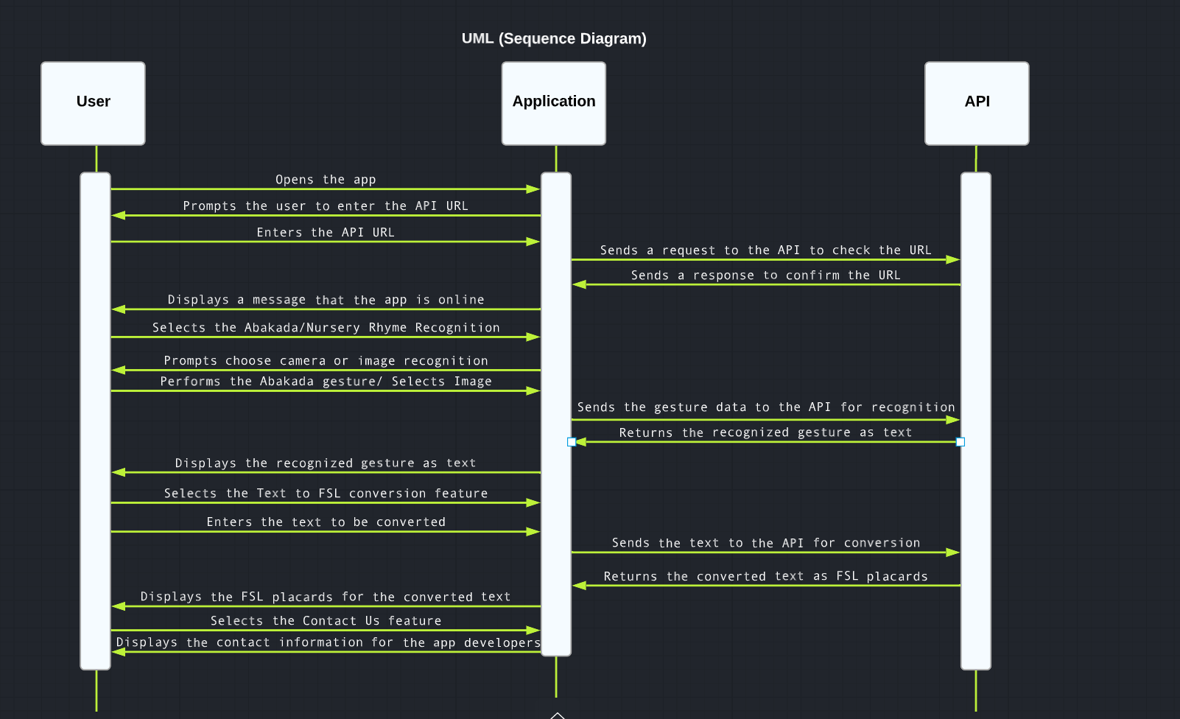

*Figure 34 Unified Modeling Language*

**APPENDIX B**

**Fishbone Diagram**

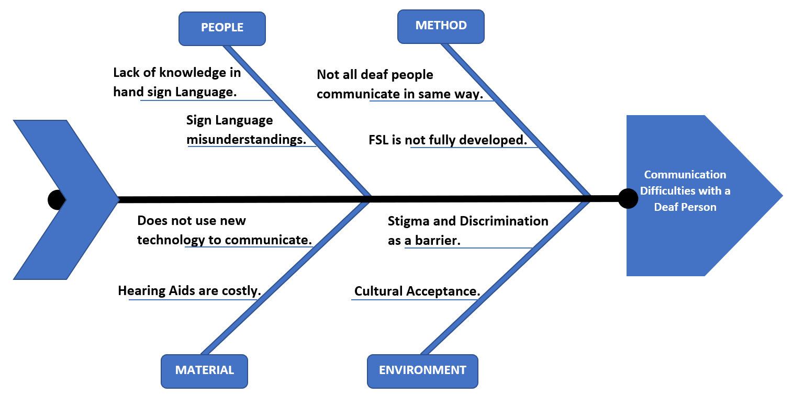The researchers formulate a Sequence Diagram to visually represent the flow of the system along with the users, the process between users and the system, and the system flow in order to understand and maintain the information within the system.

*Figure 35 Fishbone Diagram*

**APPENDIX C**

**Entity Relationship Diagram**

The researchers constructed an Entity Relationship Diagram (ERD) to further explain the system and to understand the flow of this study. ERD, or most commonly known as the Entity Relationship Diagram, is a relationship model that is a graphical representation that depicts the relationships among users and concept events within the system. (J.Biscobing)

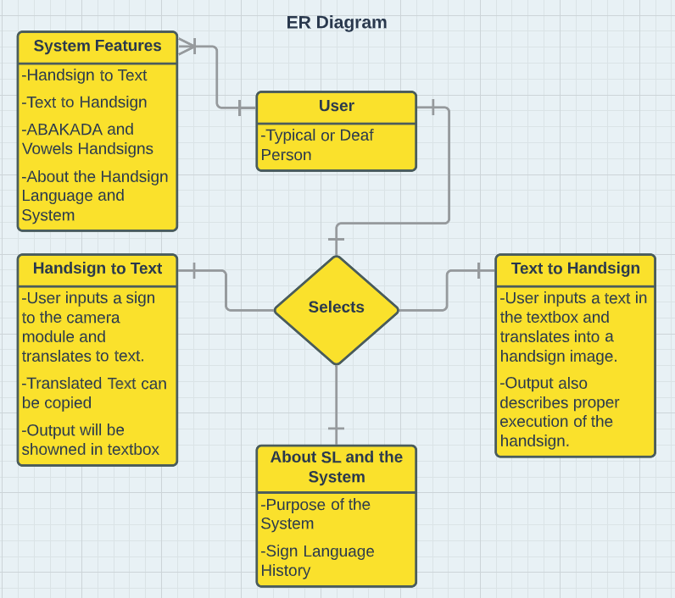

*Figure 36 Entity Relationship Diagram*

**APPENDIX D**

**Flowchart of the system**

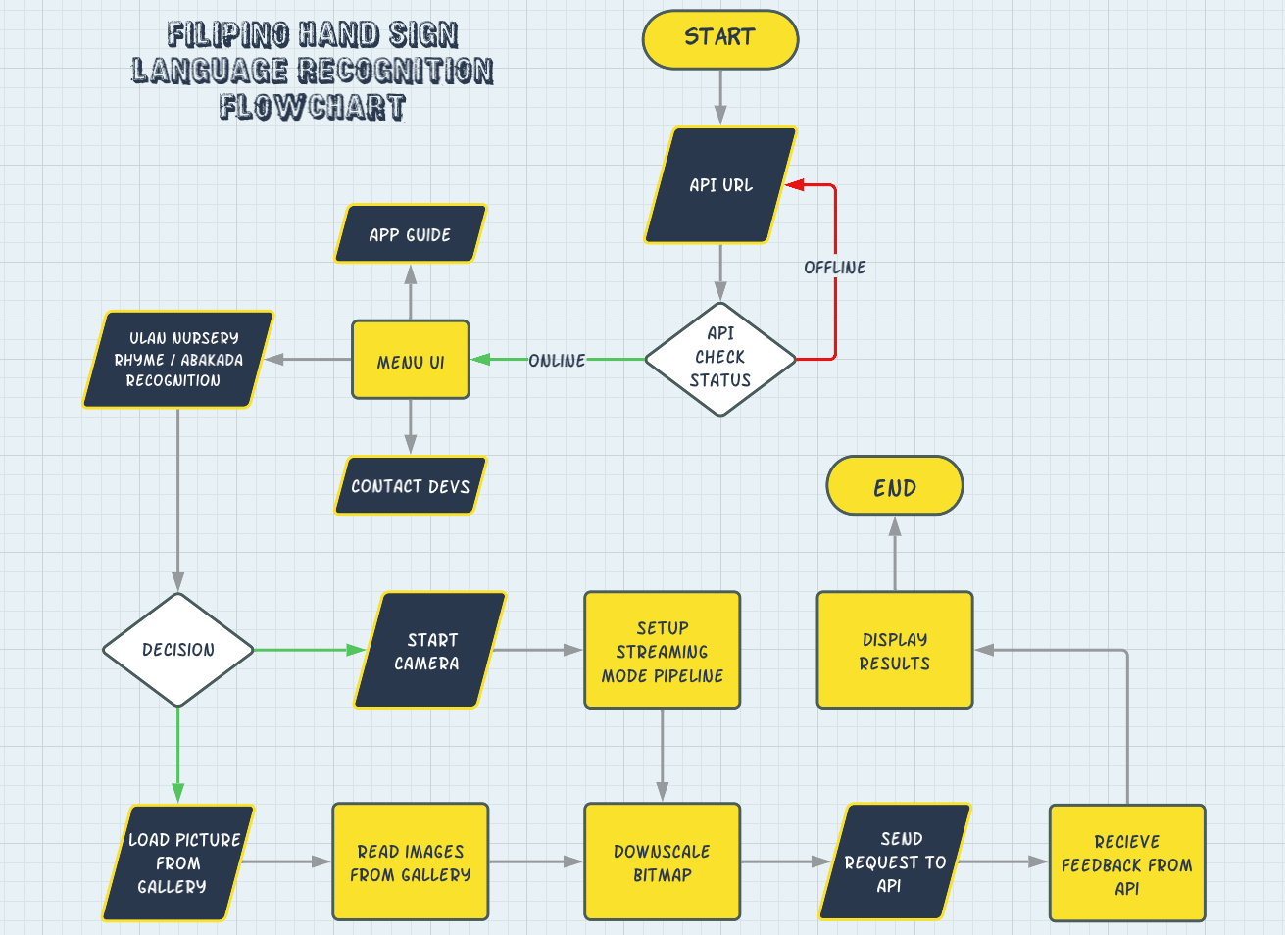The researchers constructed a Flowchart to explain the ongoing in the system and understand its flow. Flowchart is a type of diagram that represents a process. It can also be defined as a diagram representation of an algorithm, step-by-step approach of solving the tasks.

*Figure 37* *Flowchart of the system*

**APPENDIX E**

**Plagiarism Test Result**

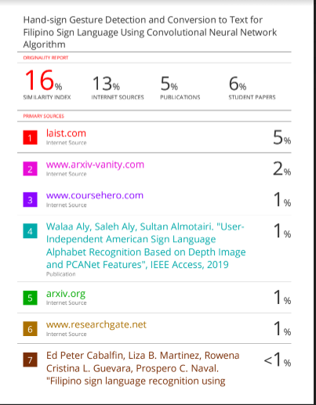

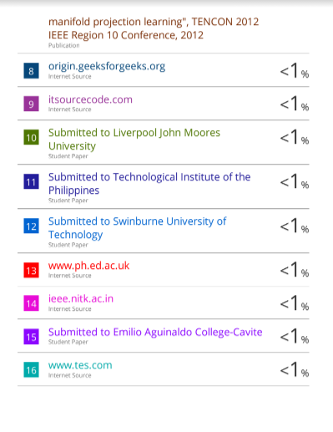

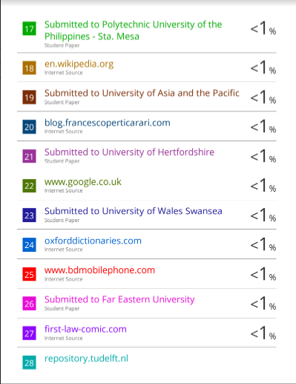

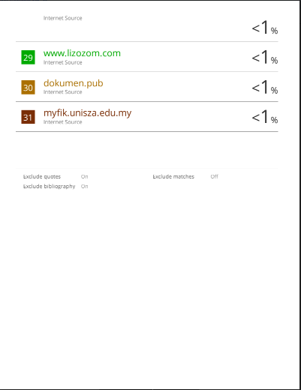

**APPENDIX F**

**Communication Letters**

February 5, 2023

**MR. EDMUND S. ALMAZAN**

ITE DEPARTMENT, CAS

Sir,

I would highly appreciate it if you could be of the final defense panel that will evaluate the research work.

Title Hand-sign Gesture Detection and Conversion to Text for Filipino Sign Language

Using Convolutional Neural Network Algorithm.

**Proponents : Arquelola, Shekinah Mae C.**

**Encarnacion, Ivanne Johanes D.**

**Macdon, Jhun Carlo F.**

**Orejenes , Angelo A.**

**Rasalan, Jerome B.**

**Date : January 30, 2023**

**Time : 1:00pm – 2:00pm**

Which is submitted in partial fulfillment of the requirements for the degree of Bachelor of Science in Computer Science.

I'm sending you a copy of manuscript in this regard. Please notify the undersigned at least two (2) days before the scheduled oral presentation. If you find any discrepancy would require a postponement of their oral presentation.

Respectfully Yours,

**Ms. HAZEL F. ANUNCIO**

Thesis Professor

CONFORME:

**MR. EDMUND S. ALMAZAN**

February 5, 2023

**MR. ERNANIE M. CARLOS JR.**

ITE DEPARTMENT, CAS

Sir,

I would highly appreciate it if you could be of the final defense panel that will evaluate the research work.

Title Hand-sign Gesture Detection and Conversion to Text for Filipino Sign Language

Using Convolutional Neural Network Algorithm.

**Proponents : Arquelola, Shekinah Mae C.**

**Encarnacion, Ivanne Johanes D.**

**Macdon, Jhun Carlo F.**

**Orejenes , Angelo A.**

**Rasalan, Jerome B.**

**Date : January 30, 2023**

**Time : 1:00pm – 2:00pm**

Which is submitted in partial fulfillment of the requirements for the degree of Bachelor of Science in Computer Science.

I'm sending you a copy of manuscript in this regard. Please notify the undersigned at least two (2) days before the scheduled oral presentation. If you find any discrepancy would require a postponement of their oral presentation.

Respectfully Yours,

**Ms. HAZEL F. ANUNCIO**

Thesis Professor

CONFORME:

**ERNANIE M. CARLOS JR.**

February 5, 2023

**JEFFERSON A. COSTALES**

ITE DEPARTMENT, CAS

Sir,

I would highly appreciate it if you could be of the final defense panel that will evaluate the research work.

Title Hand-sign Gesture Detection and Conversion to Text for Filipino Sign Language

Using Convolutional Neural Network Algorithm.

**Proponents : Arquelola, Shekinah Mae C.**

**Encarnacion, Ivanne Johanes D.**

**Macdon, Jhun Carlo F.**

**Orejenes , Angelo A.**

**Rasalan, Jerome B.**

**Date : January 30, 2023**

**Time : 1:00pm – 2:00pm**

Which is submitted in partial fulfillment of the requirements for the degree of Bachelor of Science in Computer Science.

I'm sending you a copy of manuscript in this regard. Please notify the undersigned at least two (2) days before the scheduled oral presentation. If you find any discrepancy would require a postponement of their oral presentation.

Respectfully Yours,

**Ms. HAZEL F. ANUNCIO**

Thesis Professor

CONFORME:

**JEFFERSON A. COSTALES**

**APPENDIX G**

**User Manual for the Mobile Application**

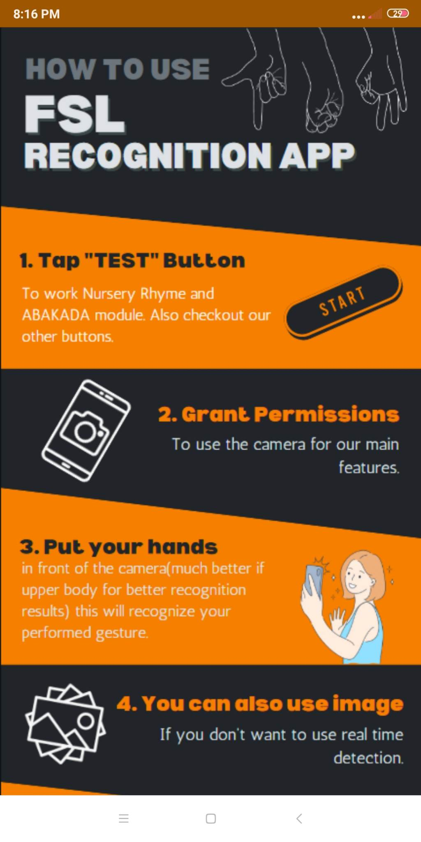

*Figure 32 how to use*

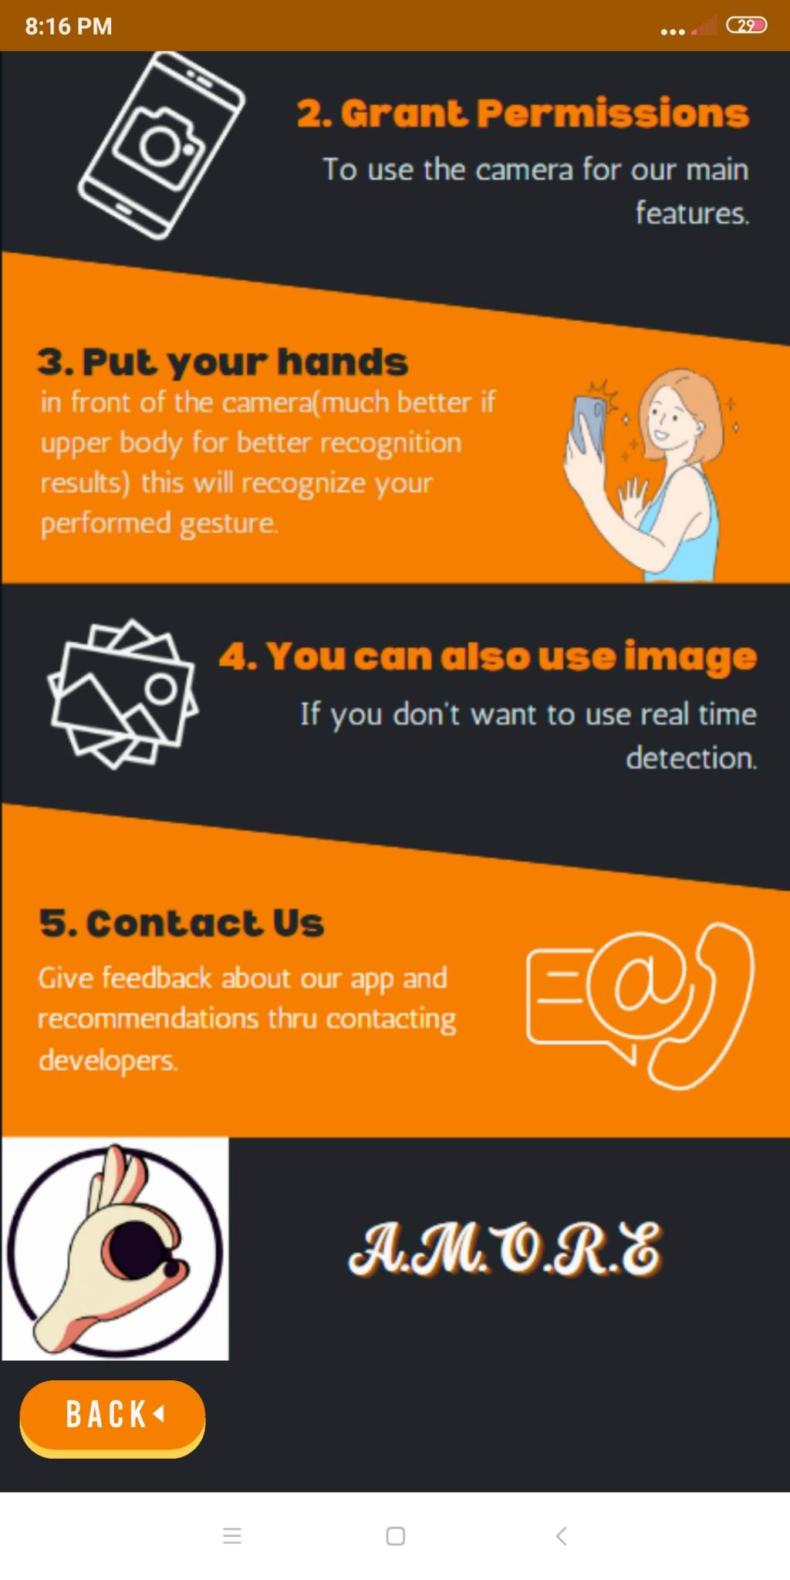

*Figure 33 continuation*

**APPENDIX H**

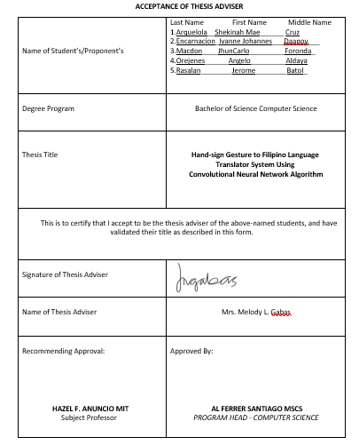

**APPENDIX I**

**ADVISER CONSULTATION FORM**

Students enrolled in the Thesis Writing are expected to meet with their Adviser several times. Take this sheet to the meetings with the adviser, and have them sign to acknowledge the meeting. Have the adviser sign the form after received a draft of report.

|  |  |
| --- | --- |
| **Name of the Researcher** | Last Name                First Name                    Middle Name  1.  Arquelola                Shekinah Mae               Cruz  2.  Encarnacion            Ivanne Johanes             Daanoy  3.  Macdon                   Jhun Carlo                      Fronda  4. Orejenes______Angelo______________Aldaya  5. Rasalan________Jerome_____________Batol |
| **Program** | **BSCS** |
| **Thesis Title** | **Hand-sign Gesture to Filipino Language**  **Translator System Using**  **Convolutional Neural Network Algorithm** |
| **Name of Adviser** | Mrs. Melody L. Gabas |

|  |  |  |  |  |
| --- | --- | --- | --- | --- |
| Date | Consultation Concern | Agreement | Date of Next Consultation | Adviser Signature |
| May 13 2022 | Insight of Mrs.Gabas. for the 6 Titles our group submitted | Only 3 titles among the 6 titles we submitted were accepted by Mrs. Gabas. She instructed our group to finalize the 2 titles left which concluded by determining the variable that will be ready for the presentation of the 3 titles by the next meeting. In Addition, Mrs. Gabas discussed the rule and regulations for the advisory | May 16 2022 |  |
| May 16 2022 | Discussed along with mrs. Gabas  the other information on the three filtered titles | Mrs. Gabas gives her ranking of the titles that we presented to her Our group decided to choose the Hand-sign Gesture to Filipino Language Translator System Using Convolutional Neural Network Algorithmto be our topic. She also wanted to add some information to the topic that we chose. | May 31 2022 |  |
| May 31 2022 | Our group discussed with Mrs.Gabas the Other information was settled again on our group discussion along with Mrs.Gabas related to our study. most especially, how we conducted our chapter 1-3 | Mrs. Gabas advised our group to read 10 local and foreign studies related to our study. She also added to send the chapter 1 to her and she will check it on Monday dated June 06, 2022. Lastly, regarding the deadlines of our paper, first send our paper to her before sending it to our subject professor and before the given deadline. | June 18 2022 |  |
| June 18 2022 | Our group discussed with Mrs Gabas the checking of the Chapter one and two | Mrs. Gabas offers a suggestion to find a beneficiary to gather specific data for our study entitled: "Hand-sign Gesture to Filipino Language Translator using Convolutional Neural Network." to improve and to add information in the said study. | July 01 2022 |  |
| July 01 2022 | Mock Defense | The team did an initial defense from chapter 1 to 3. In this defense, mrs. Gabas has given some pointers on what we should do during the defense and the way we speak. Mrs. Gabas also gave us some suggestions and improve our way of speaking. | August 01 2022 |  |
| August 01 2022 | Our group present  the flow of our system on our thesis adviser | The team did an initial defense from chapter 1 to 3. In this defense, mrs. Gabas has given some pointers on what we should do during the defense and the way we speak. Mrs. Gabas also gave us some suggestions and improve our way of speaking. | September 12 2022 |  |
| September 12 2022 | Our group present  the flow of our system on our thesis adviser | Mrs. Gabas offers a suggestion to find a beneficiary to gather specific data for our study entitled: "Hand-sign Gesture to Filipino Language Translator using Convolutional Neural Network." to improve and to add information in the said study. | January 28  2023 |  |
| January 28  2023 | Our group present the 50% percent  of our system  on our thesis adviser | Mrs. Gabasa suggestion to need to do the 70% of our system before the second week of february |  |  |
|  |  |  |  |  |

**APPENDIX J**

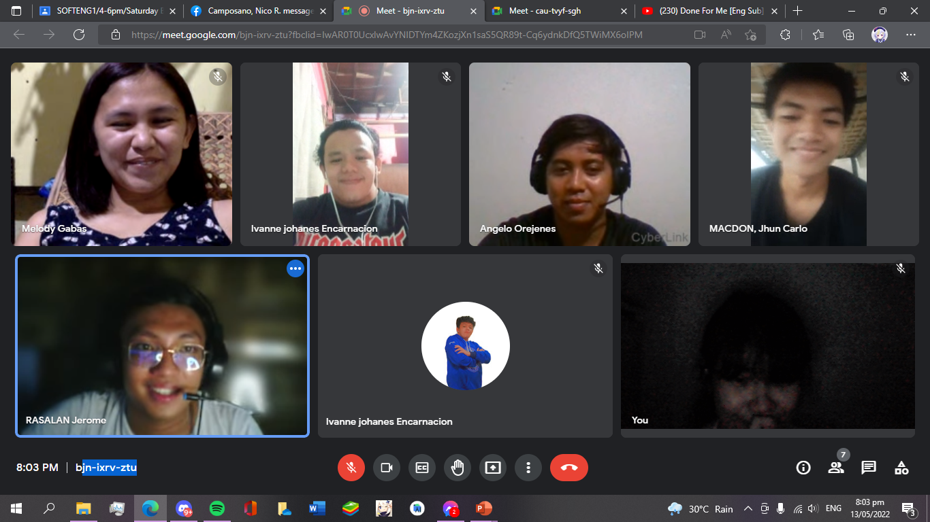**May 12, 2022 Proposal of Titles**

**May 16 2022**

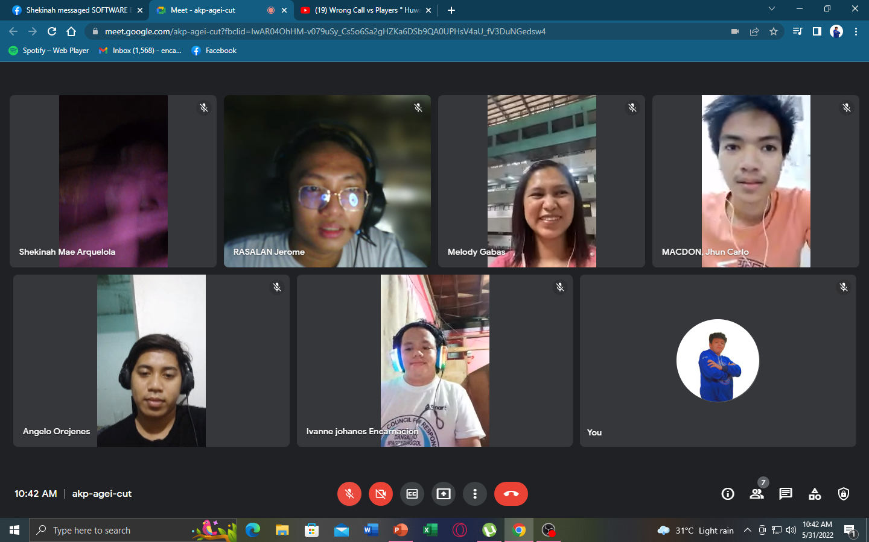

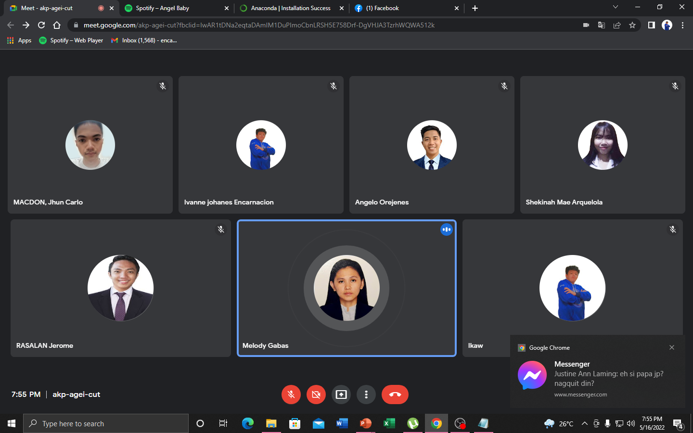**May 31 2022**

**June 18 2022**

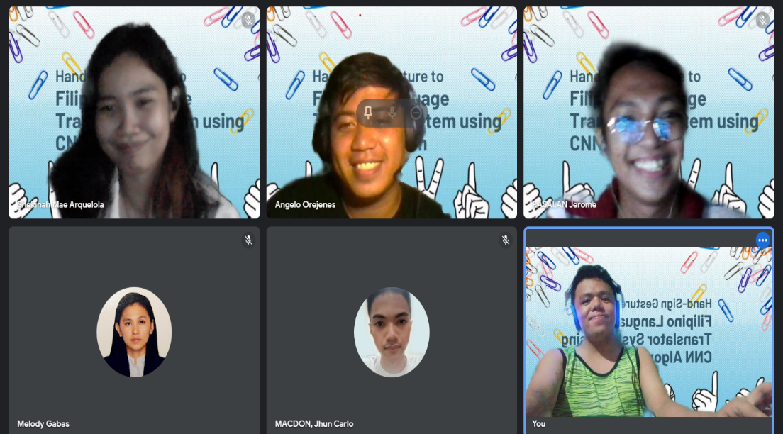

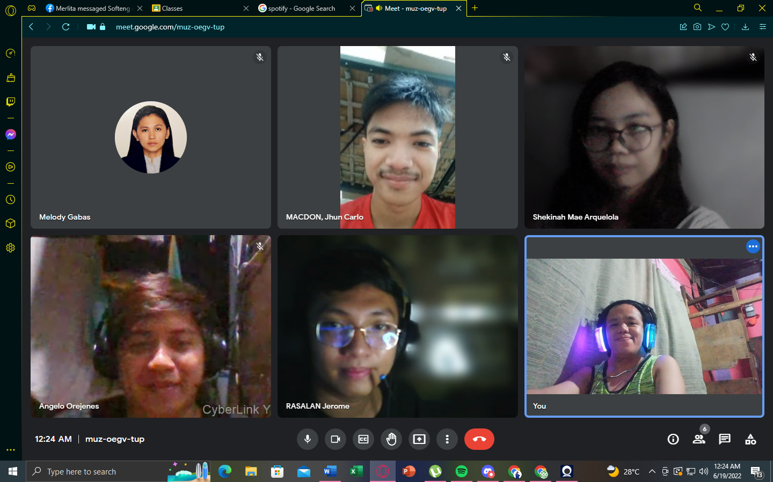**Mock Defense July 01 2022**

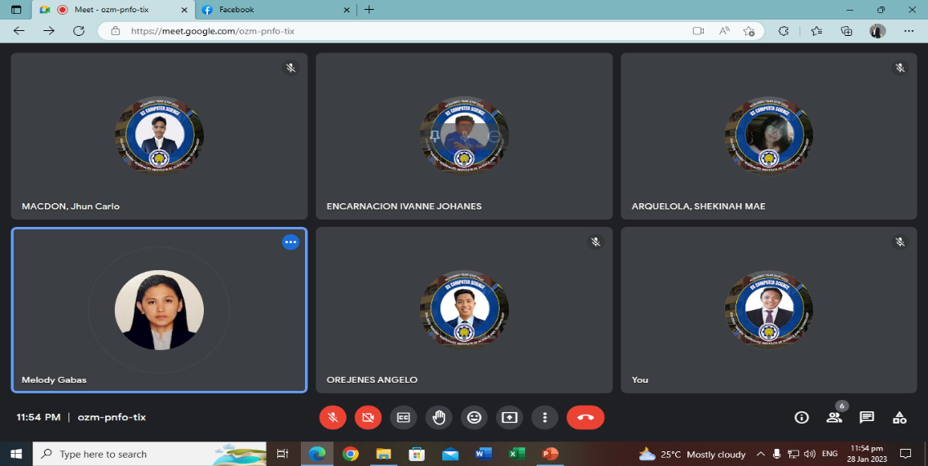**Mock Defense January 28, 2023**

**APPENDIX K**

**ENDORSEMENT FOR THESIS FINAL ORAL DEFENSE**

Date

The Dean/Program Chair

College of Arts and Sciences

Dear Sir/Ma’am:

This is to certify that Mr. / Ms. **Shekinah Mae Arquelola, Ivanne Johannes D Encarnacion, Jhun Carlo Macdon, Angelo Orejenes, Jerome Rasalan** are candidate for the degree of **Bachelor of Science in Computer Science** has been under my supervision, with their thesis proposal entitled: **Hand-sign Gesture Detection and Conversion to Text for Filipino Sign Language Using Convolutional Neural Network Algorithm.**

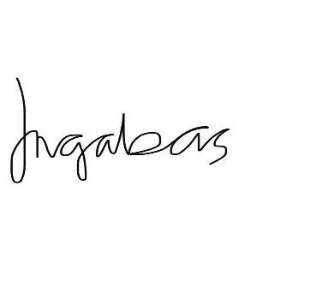This certifies further that I have assessed the above proposal and is found to be in conformity to the standards set by the College of Arts and Sciences through the Oral Defense Committee which evaluated the same on 30 day of January__________, both in form and substance, and is now ready for final evaluation / defense. Issued this 28 day of January, 2023 for record and reference purposes, at Eulogio “Amang” Rodriguez Institute of Science and Technology, Nagtahan Manila.

**Mrs. Melody L. Gabas**

Signature over Printed Name of Thesis Advise

**APPEBDIX L**

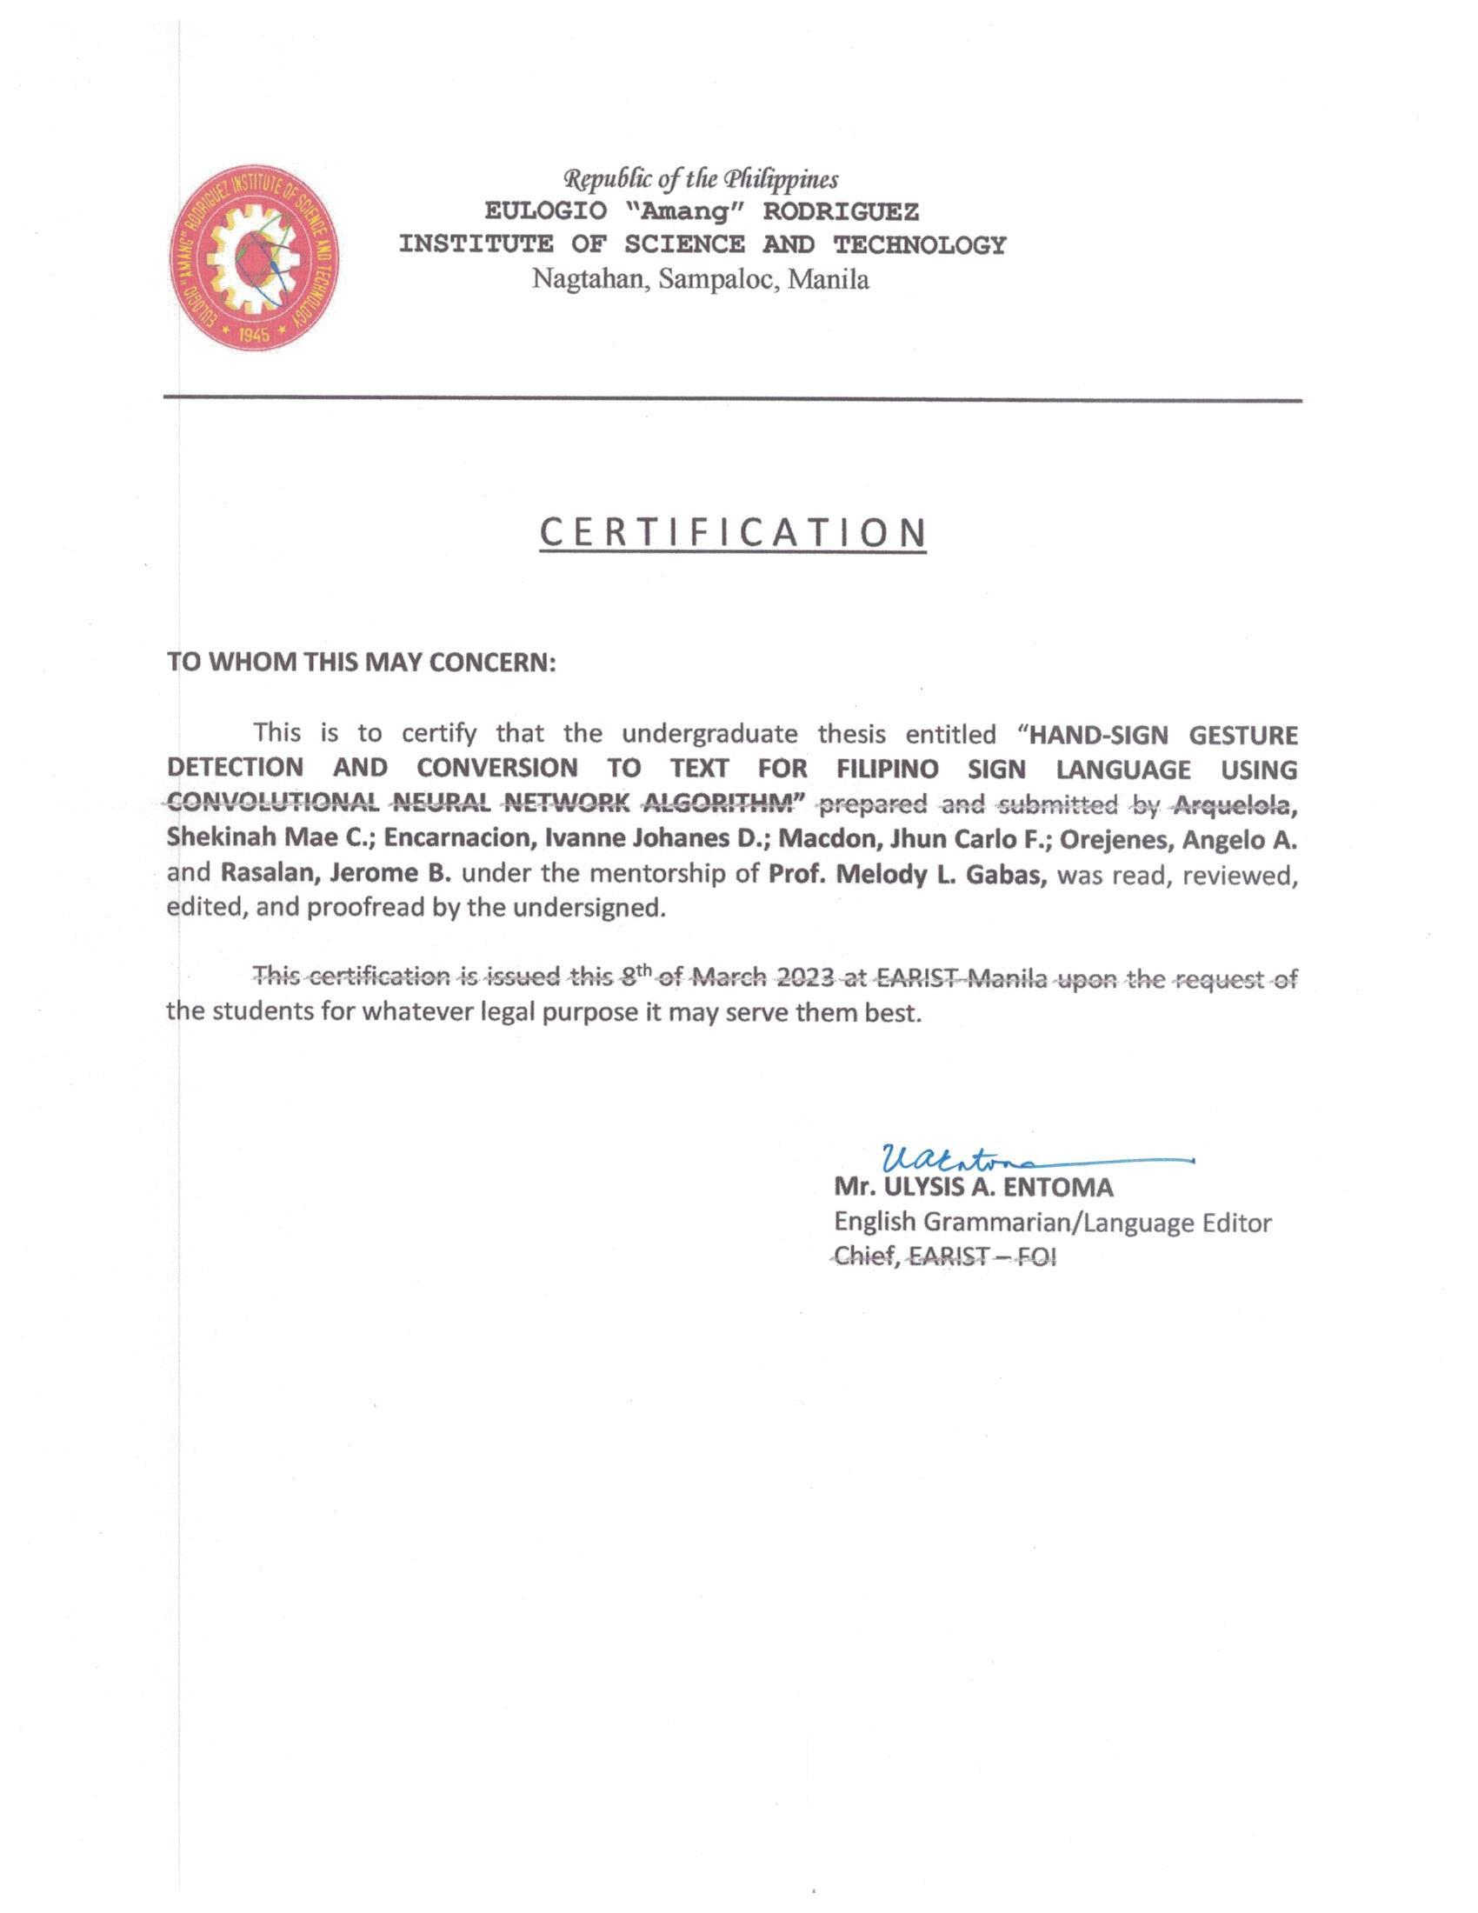**Certificate of Grammarian**

**APPENDIX M**

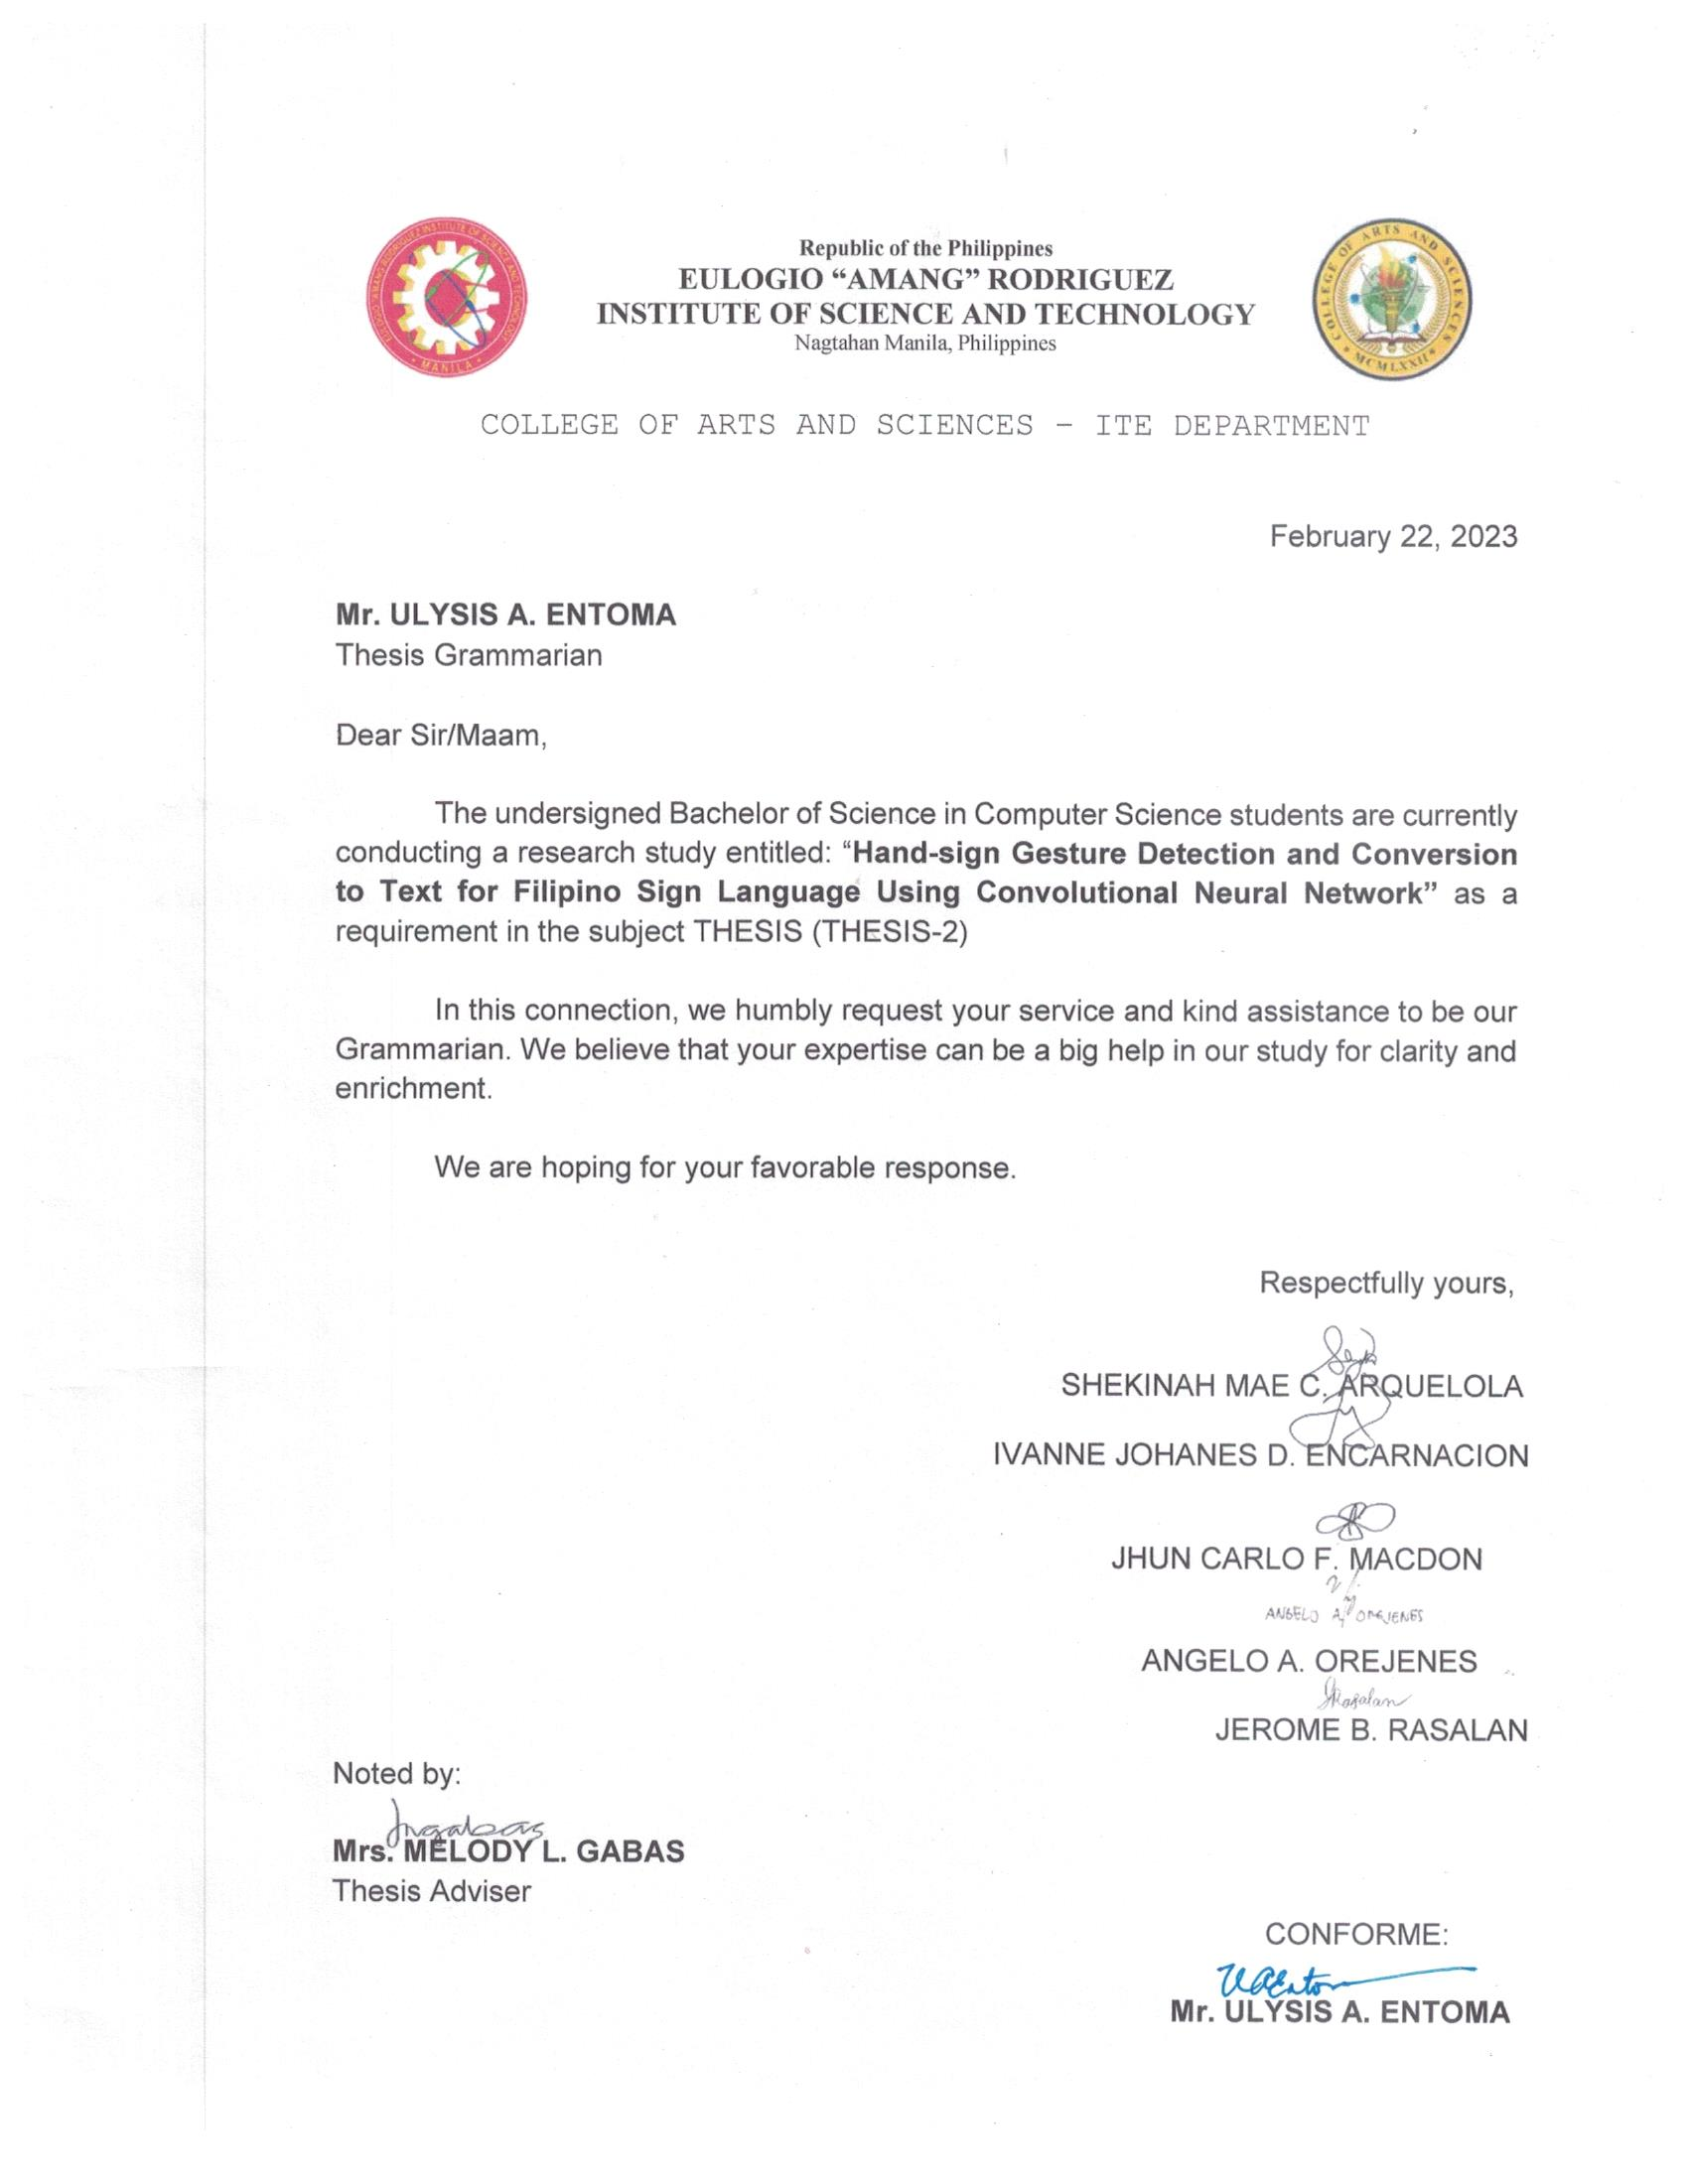**Grammarian Letter**

**APPENDIX N**

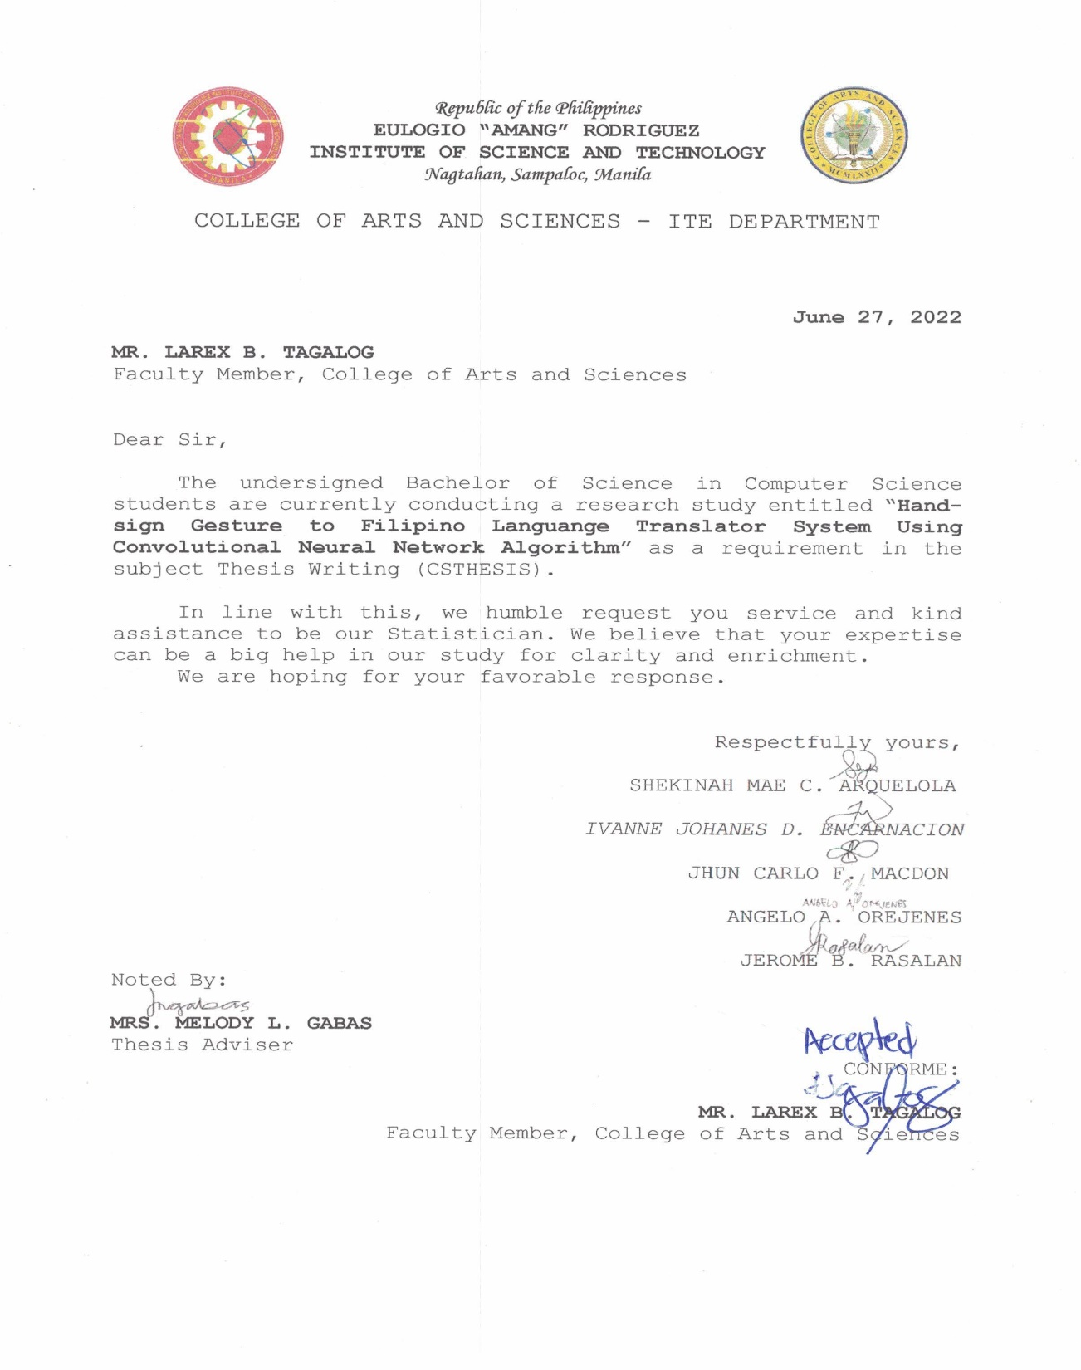**Statistician Letter**

**Curriculum Vitae**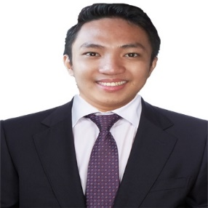

**Jerome B. Rasalan**

**2887 Clemente Street, Gagalangin Tondo Manila**

**09474761460**

**masterome.jr@gmail.com**

**Personal Information**

**Age: 23 yrs. Old**

**Date of Birth: May 15, 1999**

**Place of Birth: Manila**

**Gender: Male**

**Educational Background**

**College: Eulogio Amang Rodriguez Institute of Science and Technology Nagtahan St, Sampaloc, Manila (2019 – Present)**

**Senior High School: Arellano University 2017 – 2019**

**High School: Lakandula High School 2013 – 2016**

**Elementary: Francisco Benitez Elementary School 2005 – 2013**

**CO – CURRICULAR ACTIVITIES**

* **Industry Work Exposure at Topserve Service Solutions, Inc.- Aviation Department (Terminal 3) 2019**
* **17TH ITE Congress 2021**
* **16th ITE Congress 2020**
* **29 Founding Anniversary (5g Technology and Entrepreneurship)**
* **Former officers of Computer Science Association (COMSA AY-2021-2022)**
* **Active Participation Webinar entitled “ Your Mental health matters” June 22, 2022 at “Eulogio Amang Rodriguez Institute of Science and Technology”**
* **Active Participation Webinar entitled “ Online Classroom Netiquette in commemoration of the 49th CAS Foundation Day: Magkasama sa diwa ng Kasiyahan at Pagkakaisa ngayong Pandemya , “April 18, 2022**
* **Active Participation Webinar entitled Fundamentals and Introduction of Cloud Infrastracture (AWS Amazon Services) REST API “**
* **Active Participation Webinar entitled "Introduction to Machine Learning" held via Zoom, June 11, 2022 Manila**
* **Active Participation Webinar entitled SEO & SEM 101 – The Science of Search Series held via Zoom, June 11, 2022 Manila**

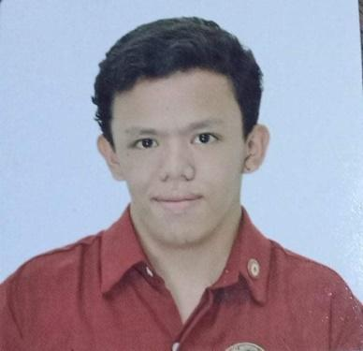**Ivanne Johanes D. Encarnacion**

**11 Lapu-lapu Drive Brgy. Tatalo Q.C**

**09957612015**

**encarnacion.ij.bscs@gmail.com**

**Personal Information**

**Age: 21 years.old**

**Date of Birth: August 12, 2001**

**Place of Birth: Quezon City**

**Gender: Male**

**Educational Background**

**College: Eulogio Amang Rodriguez Institute of Science and Technology Nagtahan St, Sampaloc, Manila (2019 – Present)**

**Senior High School: Arellano University (2017 – 2019)**

**High School: Carlos L Albert High school (2013 – 2016)**

**Elementary: G. Lopez Jeane Elementary school (2005 – 2013)**

**CO – CURRICULAR ACTIVITIES**

* **17TH ITE Congress 2021**
* **16th ITE Congress 2020**
* **13th youth leadership congress. 2020**
* **14th youth leadership congress. 2021**
* **15th youth leadership congress 2022**
* **Development of self-esteem seminar 2019**
* **Topserve service solution incorporation seminars 2019 Development of the youth and discussing about labor code and work ethics 2020**
* **The 25th business administration introducing the field on the youth at Arellano university 2019**
* **Commission of student election (AY 2021-2022)**

**Former Elected officers of Computer Science Association (COMSA AY 2021-2022)**

**Shekinah Mae C. Arquelola**

**073 Visayas St. Phase 4 Payatas B.**

**Quezon City**

**09102483775**

**arquelola.sm.bscs@gmail.com**

**Personal Information**

**Age : 22 years old**

**Date of Birth : November 10,2000**

**Place of Birth : Manila City**

**Gender : Female**

**Educational Background**

**College:** Eulogio “Amang” Rodriguez Institute of Science and Technology

**(2019-Present)**

**Senior High School:** ABE International Business College (Fairview)

**(2017-2019)**

**High School:** Justice Cecilia Muñoz Palma High School (Payatas Quezon City)

**(2013-2016)**

**Elementary:** Lupang Pangako Elementary School

**(2007-2013)**

**Co – Curricular Activities**

* Computer Science Association Committee in social media from 2022-2023
* Dean lister from 2021-2022
* One of the committees in documentation in webinar for Earist’s 19th Information Technology Education congress entitled “Web Development Trends in 2023”
* With honor from ABE International Business College Fairview – ABM Track

**Orejenes, Angelo A.**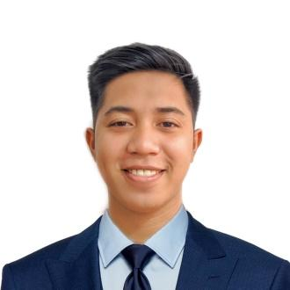

**Dp2 Lot 2, Block 6, Purok 14, South Daang Hari,**

**Taguig City**

**09070819313**

**orejenes.a.bscs@gmail.com**

**Personal Information**

**Age: 22 yrs. old**

**Date of Birth: October 24, 2000  
Place of Birth: Mandaluyong, Metro Manila**

**Gender: Male**

**Educational Background**

**College: Eulogio “Amang” Rodriguez Institute of Science and Technology  
 (2018 - Present)**

**Senior High School: STI College, Alabang**

**(2016 - 2018)**

**Junior High School: Bagumbayan National High School, Taguig City**

**(2012 - 2016)**

**Elementary: Bagong Tanyag Elementary School Annex-A,SDH, Taguig City**

**(2006 - 2012)**

**Co – Curricular Activities**



**Macdon, Jhun Carlo F.  
  
863 SIsa St. Sampaloc Manila  
  
09774249341  
  
macdon.jc.bscs@gmail.com**

**Personal Information**

**Age: 21  
Date of Birth: September 15, 2001  
Place oF Birth: Sta. Marcela Apayao**

**Educational Background**

**College:** Eulogio Amang Rodriguez Institute of   
Science and Technology Nagtahan St, Sampaloc, Manila, (Nagtahan, Manila) **(2019 – Present)**

**Senior High School:** Eulogio Rodriguez Vocational School 2017-2019  
Nagtahan Sampaloc Manila

**High School:** Eulogio Rodriguez Vocational School 2012-2016  
Mayon, Quezon City

**Elementary:** Legarda Elementary School 2005 - 2012  
Legarda, Sampaloc Manila

Co – **Curricular Activities**